**Save San Diego County Citrus**

**GROWERS, PACKERS, TRANSPORTERS, GLEANERS AND RESIDENTIAL CITRUS GROWERS**

* 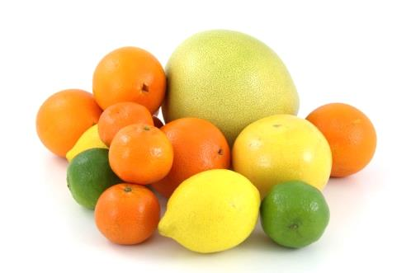Are you informed about the threat of **ACP** and **HLB** to California citrus?
* What is being done to save the citrus industry in California and **San Diego**?
* What will happen if an **HLB quarantine** is established in your neighborhood?
* What can you do to protect your business by preventing this threat from reaching your area?

**These questions and more will be answered by University, State and County representatives at the following events:**

* **Wednesday, Sept. 20 at 3-5 pm: Farm Bureau Office**

**1670 E. Valley Parkway**

**Escondido, CA 92027**

* **Thursday, Sept. 21 at 1-3 pm: Farm and Home Advisors Office**

**9335 Hazard Way**

**San Diego, CA 92123**

**This is a FREE EVENT, but please RSVP to save your seat!**

SD Co. Agriculture, Weights and Measures, (858)-614-7734 or (760)-752-4700

**Save San Diego County Citrus**

**GROWERS, PACKERS, TRANSPORTERS, GLEANERS and RESIDENTIAL CITRUS GROWERS!!**

**ACP/HLB Quarantine Regulations**

* **Wednesday, Sept. 20 at 3-5 pm: Farm Bureau Office**

**1670 E. Valley Parkway**

**Escondido, CA 92027**

* **Thursday, Sept. 21 at 1-3pm: Farm and Home Advisors Office\***

**9335 Hazard Way**

**San Diego, CA 92123**

**Agenda**

* Welcome and Introductions: **Priscilla Yeaney**, Deputy Agricultural Commissioner, Dept. of Agriculture, Weights and Measures, County of San Diego
* “Living with a Pest Invasion: Asian Citrus Psyllid and HLB”: **Sonia Rios**, Farm Advisor, UCCE Riverside/San Diego Counties
* “Update on Area Wide Management and the San Diego Citrus Pest Control District”: **Enrico Ferro**, Grower Liaison
* “Bulk Citrus Regulations and Preparing for an HLB Quarantine”: **Keith Okasaki**, Environmental Scientist, California Dept. of Food and Agriculture
* Questions and Discussion

**\*Free Parking available in structures entered from Chesapeake Dr. or Farnham St. (Thursday Sept.21 meeting)**

**This is a FREE EVENT, but please RSVP to save your seat!**

SD Co. Agriculture, Weights and Measures, (858)-614-7734 or (760)-752-4700