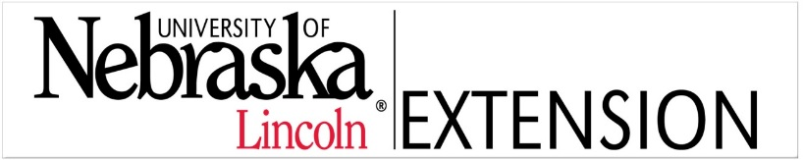

Enter Contact Information Here | 1127 Lombard Blvd. San Francisco, CA 59802 | phone 555.555.5555 | fax 555.555.5555

­

Weed science Extension Educator

University of Nebraska-Lincoln

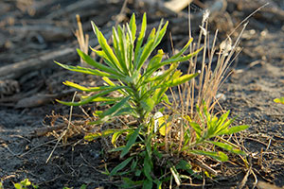

Do you have the drive to help top crop producers and agribusinesses discover, discern and implement practices that are based on applied research and science? Can you be a strong regional leader and develop focused, integrated comprehensive educational programs in Weed Management? University of Nebraska-Lincoln Extension is an organization that values individuals who excel, adapt easily, exhibit passion for helping others, and are excellent communicators. As a member of the UNL Extension team you will create and deliver world class, innovative learning experiences that empower Nebraskans to improve their lives around critical issues. We have an excellent opportunity for a full-time, 100% Extension, Non-tenure track position located in Lincoln, Nebraska and serving Southeast Nebraska. We want individuals who are self-directed and able to work in a flexible environment.

Required Qualifications: Master’s degree required; one degree in Agronomy, Crop Science, Weed Science, or closely related field or demonstrated experience in the focus area. Master’s degree must be completed by start date. Successful experience teaching in a formal or non-formal setting. Demonstrated ability to communicate (i.e. publications, web media, and presentations).

HIRING

Review of applications will begin on 12/01/14. Position will remain open until a suitable candidate is found or search is closed. Must meet driver standards according to UNL policy and have a valid Driver’s License. For a detailed job description, additional qualifications and how to apply, go to <http://employment.unl.edu> and search for requisition F_140192.

Contact Rick Koelsch at 402-472-3935 - [rkoelsch1@unl.edu](mailto:rkoelsch1@unl.edu) or Richard Ferguson 402-472-1144 [rferguson1@unl.edu](mailto:rferguson1@unl.edu)   
with questions about this position.

***The University of Nebraska-Lincoln is committed to a pluralistic campus community through affirmative action, equal opportunity, work-life balance, and dual careers.***