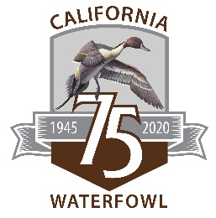
CALIFORNIA WATERFOWL DELAYED WHEAT HARVEST INCENTIVE PROGRAM
APPLICATION
The Delayed Harvest Wheat Incentive Program pays farmers $30-40 per acre to delay wheat +/or triticale harvest until July 1-15 in order to allow time for wild duck nests in their fields to hatch, and for the ducklings to get to water. For complete details, please go to www.calwaterfowl.org/wheat.
Application deadline: 4 p.m. March 25, 2020
Who’s eligible: farmers in Butte, Colusa, Sutter, and Yolo counties who have planted winter wheat +/or triticale close to a summer water source; i.e. planted rice, managed wetlands, creeks or irrigation canals.
Where to apply: Fax this form to 916-648-1665, or mail it to:
ATTN DELAYED WHEAT HARVEST PROGRAM
California Waterfowl
1346 Blue Oaks Blvd., Suite 100
Roseville CA 95678
Questions: Call Waterfowl Programs Supervisor Caroline Brady at 916-275-1018.
Date: _________________

Name of property: _________________________________________________________

Address of property: _______________________________________________________

Names of owner(s): _______________________________________________________

Type of ownership: ________________________________________________________
(sole, lease, partnership, corporation, etc.)

Wheat field details (if possible, please include a map of field locations):

Field (#) | Acres | Irrigated  (Y or N) | Dominant nearby crops/habitat | County | Cross-roads
1
2
3
4
- Form continues on next page.
Average date of harvest _____________________

Water source of proposed parcel: _____________________________________________
E.g., water district, groundwater etc.

Past Participant of CWA Egg Salvage Program (Y/N) ____

Please describe your participation in other partnerships or programs
________________________________________________________________________________________________________________________________________________
________________________________________________________________________
________________________________________________________________________
________________________________________________________________________
Name of person designated to sign contracts*: __________________________________
Title (President, Secretary, Owner, Lessor, etc.): _________________________________

Address: ________________________________________________________________
(street address, city, state, ZIP code)

Phone: __________________________ E-mail: _________________________________

Contact for property (if different than above): ____________________________________

Address: ________________________________________________________________
(street address, city, state, ZIP code)

Phone: __________________________ E-mail: _________________________________

Thank you for applying to the Delayed Wheat Harvest Incentive Program! We will be surveying applicants' properties March 10-30, 2020, and announcing awards April 10.

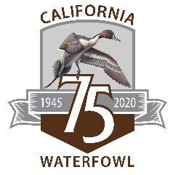

www.calwaterfowl.org

