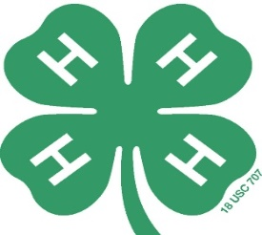

March 20, 2017

Dear Potential 4-H Sponsor:

My name is Patricia Wallace, and I am the Fundraising Coordinator for the San Diego County 4-H Management Board. This second annual 4-H Golf Tournament was created to raise funds to support the many programs offered thru the San Diego County 4-H youth organization. With public support limited for these programs, we find ourselves asking for your support.

On April 29, 2017, we will be hosting the 2nd Annual 4-H Golf Tournament at Castle Creek Golf Course. We are attempting to secure sponsors and donations in the following categories:

* **Tournament Title Sponsor ($1000)**
* Tournament name to include your company name.
* All tournament promotions and publications will include your company name &/or logo.
* **Tee / Special Event Sponsors ($200)**
* Eighteen tee sponsors, four closest-to-the-hole, and special event sponsorships available.
* Product trades with companies available (i.e., major prize items, etc.).
* Beautiful professionally manufactured signs on course on tournament day go home with you!
* **Awards & Door Prize Sponsors**
* Any item that can be used as an award or door prize
* Donor names included on program and at the banquet to acknowledge your support
* **Golf Cart Sponsors ($50)**

We ask that you consider supporting our event as a tournament sponsor. If you would like to participate as a player or sponsor and have questions, please contact me at (760) 807-1824. All donations are tax deductible and checks should be made payable to the San Diego County 4-H Management Board. Our federal tax ID # is 94-306778.

We appreciate your consideration.

Sincerely,

Patricia Wallace

Tournament Director

(760) 807-1824

Pawscout@yahoo.com