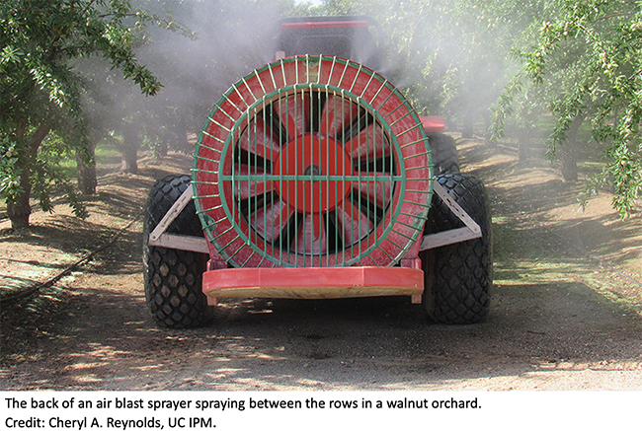  Time to renew your DPR license? Take a new online course on air blast sprayer calibration.  - You will learn the basic principles of spray calibration, take a close look at the basic components of a sprayer, perform calculations needed for calibration, and look at how factors such as droplet size, nozzle type, and weather conditions influence drift and spray coverage. This course also explains the conditions for pesticide applications under the 2018 Pesticide Use Near School sites regulation.  If you are a DPR license or certificate holder and your last name begins with the letters A through L, then 2020 is your year to renew.  DPR encourages all license holders to send in renewals November 1 to ensure license renewal by January 1, 2021.  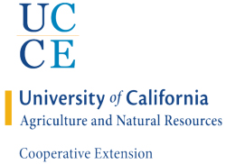 | Early-bird price until November 1st! Save an additional $20 by purchasing the 4-course bundle for only $85!  - Proper Pesticide Use to Avoid Illegal Residues (2 hours Laws and Regulations – early-bird price $40; full price $80)  - Proper Selection, Use, and Removal of Personal Protective Equipment (1.5 hours Laws and Regulations – early-bird price $30; full price $60)  - Pesticide Resistance (2 hours Other – early-bird price $20; full price $40)  - Pesticide Application Equipment and Calibration (1.5 hours Other – early-bird price $15; full price $30)  For More info & Online Registration Visit:  ipm.ucanr.edu/training/?src=092520sjc  Accredited by DPR, California Structural Pest Control Board, Certified Crop Advisor, the Western Chapter of the International Society of Arboriculture & Arizona Department of Agriculture.

