Determining Volume in a Small Pond with a Staff Gauge

Larry Forero—Livestock, Range and Natural Resources Advisor Shasta, Trinity
Josh Davy—Livestock and Range Advisor Tehama, Glenn, Colusa
Rick Satomi—Forestry/Natural Resources Advisor, Shasta County
Khaled Bali, Ph.D.—Irrigation Water Management Specialist
Daniele Zaccaria—Assistant Agricultural Water Management Specialist in Cooperative Extension
Allan Fulton—Irrigation and Water Resources Advisor

Determining stored water volume in stock water ponds has become a requirement for many landowners. Through SB588 the California State Water Resources Control Board (Water Board) requires the monitoring of water being diverted and put to beneficial use. Stock water ponds are part of this requirement. The water board’s deadline for installation of a monitoring method has already passed, meaning if not done, this should be completed immediately. The frequency of reporting stock water pond volume depends on the size of the pond. This could change, but as of 2019 the current reporting requirements listed by the water board are:

Pond size | Frequency of reporting
Acre feet
<10 | Once
10-49 | Monthly
50-199 | Weekly
100-999 | Daily
>1,000 | Hourly
https://www.waterboards.ca.gov/waterrights/water_issues/programs/diversion_use/water_use.html

Ponds over 100 acre feet require either the completion of a UC water measurement course by the land manager or measurement must be set up by a contractor, professional or engineer. Ponds under 100 acre feet require an individual with experience in measurement and monitoring. This article provides a method of determining the volume of these smaller ponds. This method is most practical for ponds under 50 acre feet, as the monitoring requirements of larger ponds will likely require some form of automation.

Since stock ponds aren’t flat bottomed, the simplest way to monitor water volume is with a pond curve showing the total volume stored as the water level changes throughout the season. While pond curves are available for some ponds in CA, it is not uncommon for ponds constructed decades ago to have never had a staff gauge installed or a pond curve developed. If your pond is registered with the Bureau of Dam Safety, was designed by the USDA NRCS or Resources Conservation Districts (RCDs), or was surveyed during an inspection by the Water Board, a pond curve may be available. Check with those agencies to see if they can provide it.

If a pond curve can’t be found, one will need to be developed. It can be accomplished by measuring the water and corresponding surface area of the pond for at least three or four different levels between full and empty. This can be accomplished by installing a staff gauge (Figs. 1). Because of the irregularity of many reservoir bottoms, the staff gauge needs to be installed in a location that represents the average ground level of the bottom of the pond. A handheld GPS unit (or smart phone with GPS capability) can then be used to determine surface area (Fig. 2)

Figure 1. Staff Gauge

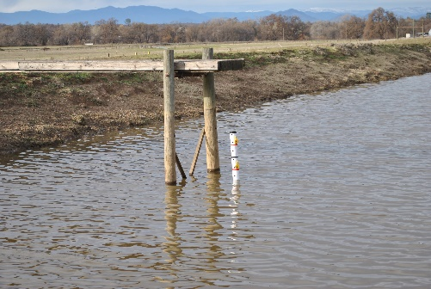

Figure 2. GPS Unit noting area
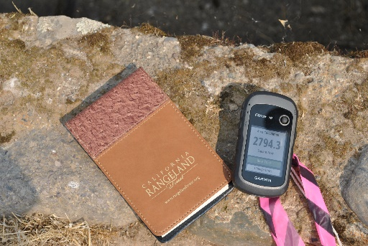

The timing for beginning this project is late summer/early fall when the pond is at its lowest elevation. Here are the steps for completing the measurement.
- Install the staff gauge in a location that represents the average ground level of the bottom of the pond. It must be plumb to get an accurate reading. If you have an existing staff gauge that is installed at an angle the App will not work until a relationship can be made between the demarcations on the angled staff gauge and actual pond depth.

- Note the level of the water on the staff gauge.

- With a GPS unit or smartphone app, set to “determine area” and walk around the water line (at water’s edge) of the pond to determine the surface area. Record the Surface Area in square feet and corresponding Depth in feet. Table 1 shows potential sources and cost for example types of equipment.

Table 1. Selected GPS equipment costs
Measuring Device | Cost | Compatibility
Garmin Etrex 10 | $110 | Standalone GPS Unit
GPS Fields Area Measure | Free | ios smartphone
Fields Area Measure | Free | android smartphone
Field Navigator | Free | android smartphone

- As the pond fills, repeat this process to establish the relationship between depth of the pond and surface area of the water. Table 2 is an example of measurements taken across four different days throughout the season.

Table 2
Date | Depth (ft) | Surface Area (square ft) | Surface Area (ac)
N/A | 0 | 0 | 0
8/31/2018 | 1.0 | 27,940 | 0.64
11/15/2020 | 3.5 | 230,860 | 5.30
1/31/2019 | 5.5 | 426,888 | 9.80
2/28/19* | 6 | 495,713 | 11.38
*Pond is at Capacity-overflowing

- Go to : https://ucanr-igis.shinyapps.io/PondCalc/ and follow the steps to generate a personalized pond curve. For full functionality, view this website using google chrome. Figure 3 is a screen shot of the App.
  - To familiarize yourself with the App, try entering the data from this article (Table 2) and compare the outputs. It is important that after entering each depth and surface area, you confirm your entry by clicking on the “add row” button.

Figure 3. Screen shot of the Pond Volume Calculator
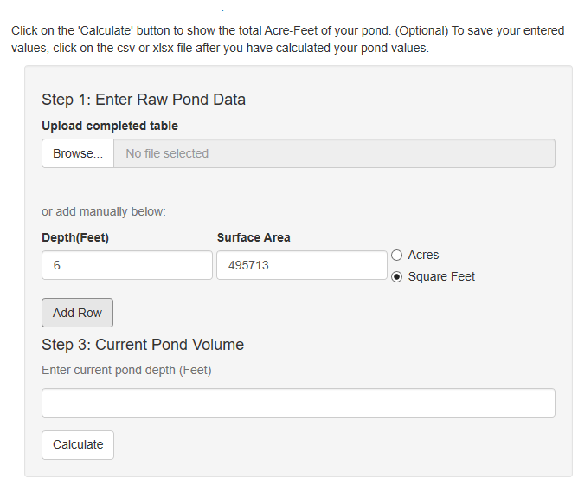
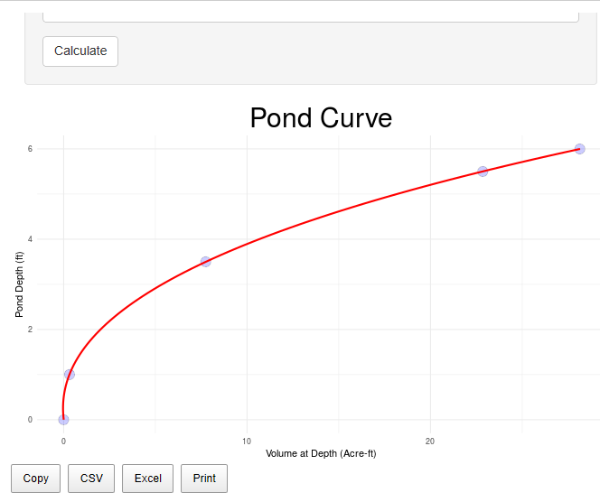
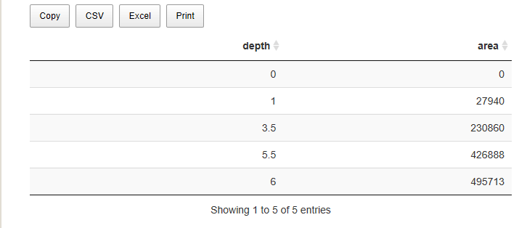

  - After you have entered all your collected data (depth and corresponding surface area), a pond curve will be automatically generated (Figure 4).
  - For incorrect values, click on the incorrect row and click “Remove selected rows”. The pond curve should adjust automatically.
  - The pond curve is calculated using a three-factor polynomial equation and is suitable for most ponds. To improve the accuracy of the curve, increase the number of data points (pond depth and corresponding surface area).
  - This App will not work for ponds with islands or channels cut into in the pond.

Figure 4. Pond Curve developed from depth and corresponding surface area data. Example provides relationship between pond depth and water volume (acre feet)
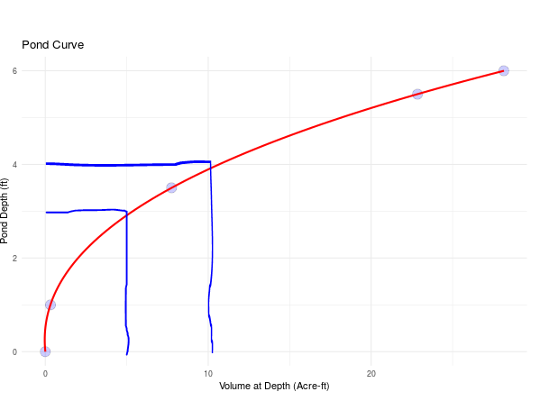
- After a pond curve is developed (Figure 4) it can be used to track changes in total volume using staff gauge readings. If you want to know the change in volume during the month of November, you would note the staff gauge reading on November 1. In this example, the staff gauge read 3’. The corresponding volume is five acre-feet. You read the staff gauge again on November 30th and it reads 4’. The corresponding volume is ten-acre feet. The increase in volume is 5-acre feet. Table 3 outlines this change.

Table 3-Volume change data based on pond curve.
Date Staff Gauge Read | Staff Gauge Reading | Corresponding Volume
November 1 | 3’ | 5 acre feet
November 30 | 4’ | 10 acre feet
Change |  | Increase of 5 acre feet

Once the curve is established, the App can also be used to calculate pond volume. Step 3 in the App will let the user key in a value and “Calculate” the pond volume at that depth.
Figure 5.
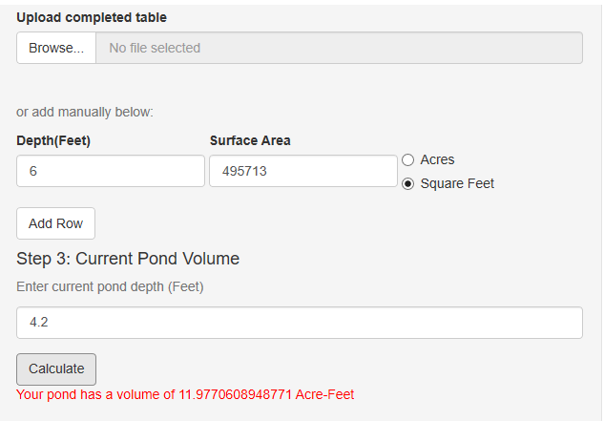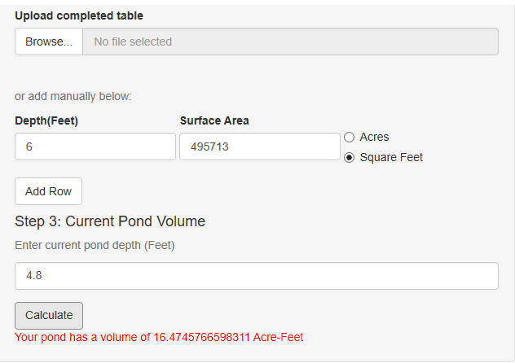

- This function can also be used to determine volume change in a month. Assuming that a water level of 4.2 feet (Figure 5, Left) was collected in Jan. 1, we calculate a volume of 11.98 acre-feet. On Jan. 31, the depth moved to 4.8 feet (Figure 5, Right) to calculate a volume of 16.45 acre-feet. The increase in volume for the month is therefore 4.7 acre-feet. Table 4 summarizes this approach.
Table 4
Date | Depth | Acre Feet Storage (from App)
Jan. 1 | 4.2 ‘ | 11.98
Jan. 31 | 4.8’ | 16.45
Change in Jan. |  | 4.47 (increase)

- To save your inputs so that you do not have to manually enter all the individual values, select one of the export options (CSV, Excel) using the buttons above the table. This generated file can be modified and uploaded to the app as more information is collected.

