

University of California Cooperative Extension

NEWS RELEASE

Kern County • 1031 S. Mt. Vernon Avenue • Bakersfield, CA 93307 • 661-868-6200

October 5, 2007 Joe Nunez, Farm Advisor

Vegetable Crops/Plant Pathology
661-868-6222

OFF-COLORED VEGETABLES ARE GOOD FOR YOU — NO JOKE

Most Kern County residents know that Kern County is a major almond, table grape, and cotton growing region. But are they aware that this is also a major carrot and potato production region? In the 1950s and 60s Kern was a famous potato growing area when there was nearly 55,000 acres of potatoes in the county. Kern County produced the earliest crop of potatoes in the nation and was able to beat everyone else to the market place. While Kern growers were harvesting, the rest of the nation’s potato growers were just starting to plant. That advantage was lost when others figured out how to store potatoes for up to 12 months. Now that big beautiful baking potato you just bought from the store may be 9 to 10 months old if it came from Washington or Idaho. Today Kern annually produces about 23,000 acres of potatoes and is still known for their freshness because Kern growers do not store their potatoes. When potatoes were “King of Kern County Vegetables”, carrots were just small potatoes (pun intended) with less than 100 acres of carrots being grown. Carrots didn’t come to their own until the 1980s and really exploded in the 1990s with the introduction of baby carrots that have become so popular with consumers. Today Kern County leads the nation with the production and processing of carrots.
While the rich sandy loams soils and abundant sunshine are responsible for carrots and potatoes doing so well here, there is always room for change. Consumers want more variety and healthier choices in the food they eat. Growers of course want to meet those demands, especially if there is a market to sell to: hence the recent growth of the organic food industry.
But there are other ways to provide more variety and healthier vegetables. Today researchers are learning about the many benefits of eating vegetables that are of different colors. As it turns out the pigments that give color to fruits and vegetables act as antioxidants and cancer fighting chemicals. Plant breeders are taking this new information and adding colors to vegetables, including carrots and potatoes. Although it is still at a small scale, Kern County potato and carrot growers are helping lead this revolution by planting colored carrots and potatoes.
Carrots are thought to be naturally orange in color, but actually they come in many colors in the wild. Carrots were originally purple or red, with a thin root. The species didn’t turn orange until the 1500s when Dutch growers used a mutant yellow carrot seed from North Africa to develop a carrot in the color of the House of Orange, for the Dutch Royal Family. But now breeders are going back to old varieties because of the health benefits of the different pigments in plants. Carrots can be found in purple, red, yellow, white, and of course orange. Besides the health benefits of the pigments, chefs and consumers like adding color to the dinner plate.
Research at the University of Wisconsin-Madison suggests that pigments in these colorful carrots, which taste just like regular carrots, may help prevent heart disease and cancer, and reduce cholesterol. Studies examining the health benefits of fruits and vegetables are revealing the disease-preventive powers of the pigments that give plants their distinctive colors.
Carrots are a well-known source of vitamin A. Just a single, full-size carrot more than fulfills an adult's daily quotient of the essential vitamin. But the carrot hasn't always been the vitamin A powerhouse that it is today. Over two decades ago, scientists in the USDA Vegetable Crops Research Unit at Madison, Wisconsin, began a quest to breed carrots packed with beta-carotene—an orange pigment used by the body to create vitamin A. Thanks largely to this work, today's carrots provide consumers with 75 percent more beta-carotene than those available 25 years ago.
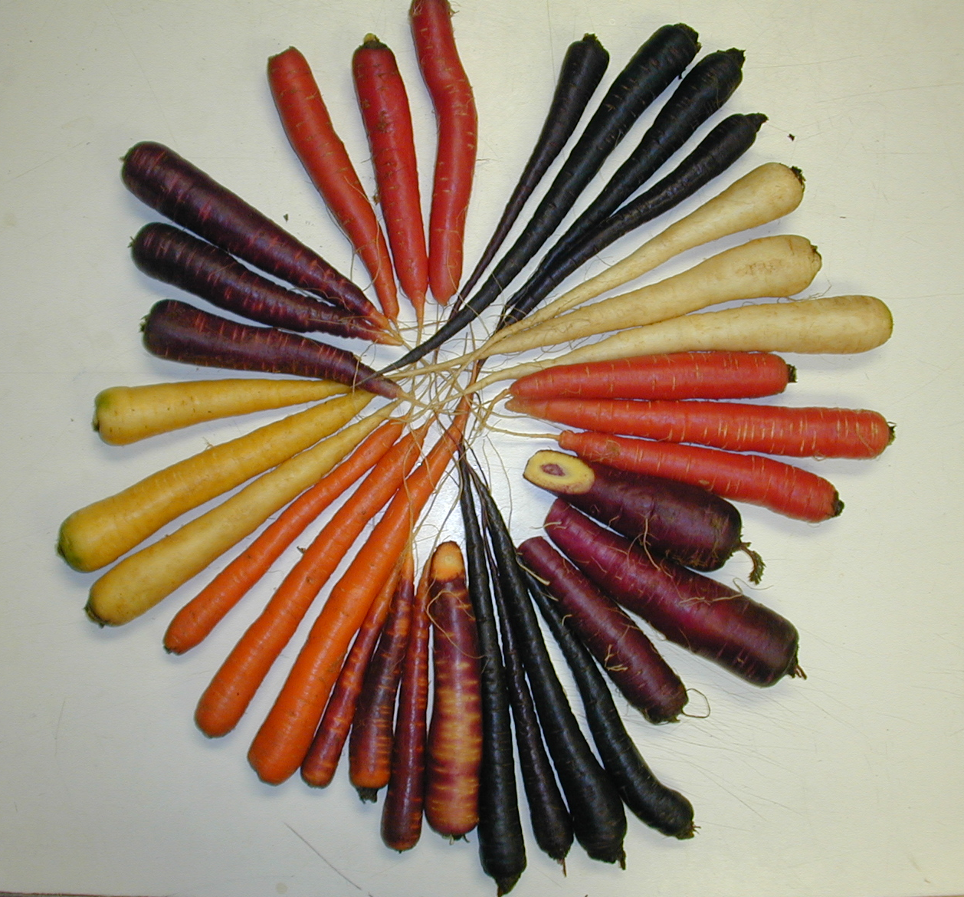
Red carrots derive their color mainly from lycopene, a type of carotene believed to guard against heart disease and some cancers, especially prostate cancer. Yellow carrots accumulate xanthophylls, pigments similar to beta-carotene that support good eye health. Purple carrots possess an entirely different class of pigments— anthocyanins—which act as powerful antioxidants.

Red colored fruit and vegetables: Red foods contain the pigment lycopene, which may help prevent certain diseases such as prostate cancer.
Purple colored fruit and vegetables: The pigment anthocyanin and phenloics is what gives these foods their rich purple color which promotes a healthy heart, have antioxidant and anti-aging benefits.
Yellow colored fruit and vegetables: The yellow pigment is a hydroxy carotenoid which is an excellent source of lutein which is good for healthy vision and a healthy cardiovascular system.
Blue colored fruit and vegetables: Blue colored vegetables contain a wide variety of anthocyanins, the oxidation-fighting pigments that combine to give them that unique color.
White colored fruit and vegetables: Are colored by pigments called anthoxanthins. They may contain health-promoting chemicals such as allicin, which may help lower cholesterol and blood pressure and may help reduce risk of stomach cancer and heart disease. Some members of the white group, like bananas and potatoes, are good sources of the mineral potassium, too.
Orange colored fruit and vegetables: Are usually colored by natural plant pigments called carotenoids. Beta-carotene in sweet potatoes, pumpkins and carrots is converted to vitamin A, which helps maintain healthy mucous membranes and healthy eyes. Scientists have also reported that carotenoid-rich foods can help reduce risk of cancer, heart disease and can improve immune system function. One study found that people who ate a diet high in carotenoid-rich vegetables were 43 percent less likely to develop age-related macular degeneration, an eye disorder common among the elderly, which can lead to blindness.

Carrot Breeders are not the only ones looking to add color to crops. Potato breeders have also begun to look at the health benefits of eating colored potatoes. Like carrots, in the wild potatoes naturally come in many different colors. There are purple, blue, red, and yellow fleshed potatoes and of course the white fleshed types we are used to seeing. Actually most people in the world eat yellow fleshed potatoes. The consumption of white fleshed potato is a more North American phenomenon, although yellow fleshed potatoes are just starting to become popular here.
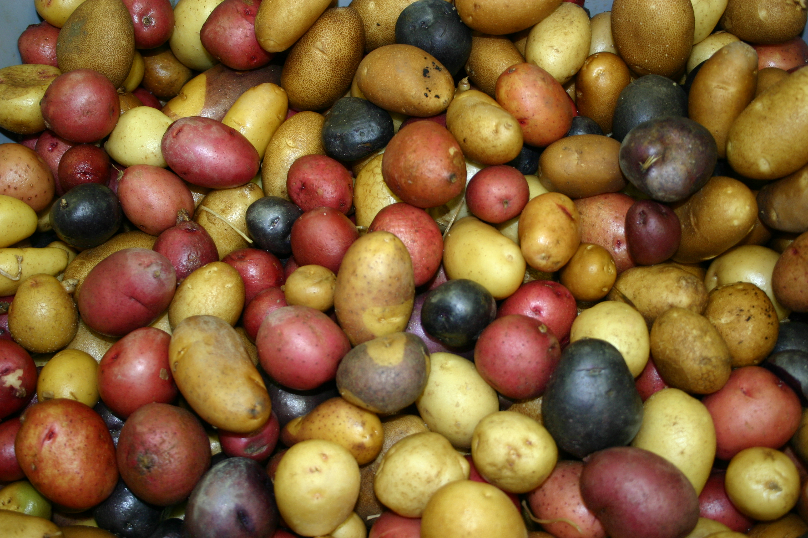
Potato breeders working with human physiologists have found that many colored potatoes have cancer fighting properties. The pigments in red and purple flesh potatoes are anthocyanin and the one in yellow flesh potato is zeaxanthin. Each pigment has found to cause induction of apoptosis in human cancer cells. Apoptosis is the orderly death of a cell, which is good if it is a cancer cell.
Today plant breeders are looking at these health properties of carrots and potatoes and trying to incorporate them into high quality and high yielding varieties that can be grown in a commercial scale. Kern County being a major growing region for these two crops could be in the forefront of a new trend. Try some of these new varieties next time you are at the grocery store and you see a bag of colored carrots or potatoes. Besides being appealing, tasty, and nutritious, they may also have some anti-illness properties too.

• • •

