
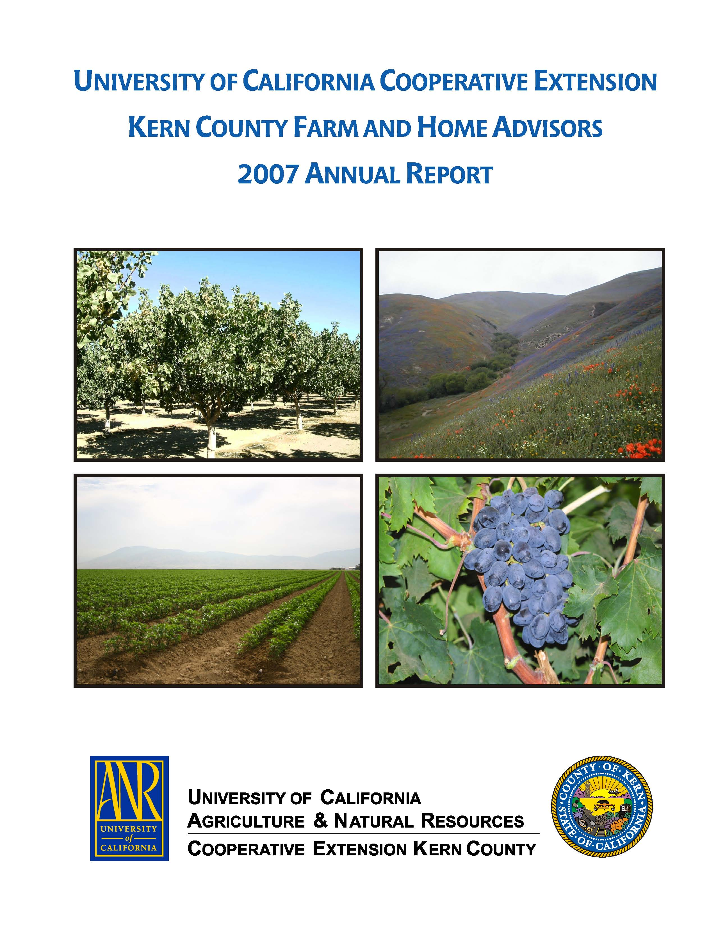
University of California Cooperative Extension – Kern County
NEWS RELEASE
1031 S. Mt. Vernon Avenue • Bakersfield, CA 93307 • 661-868-6200 • http://cekern.ucdavis.edu

July 9, 2009 Margaret Johns, Advisor

Nutrition, Family and Consumer Science
(661) 868-6217

Use Your Crock Pot to Save Time and Money This Summer

Summer is here and cooking can seem to be more of a chore than at other times. Now is the time to take out your crock pot. A crock pot is just as useful in summer as in winter to save time, money, and energy.

Crock pot cooking is easy but takes a little bit of planning. Food safety is a concern. Never place frozen meat in the crock pot. Crock pots cook at low temperatures and there is a serious danger that frozen meat placed in the pot could stay at an unsafe temperature for too long of a time period. During the unsafe temperatures bacteria could grow, multiply and cause sickness. There are several ways to combat this problem, either thaw your meat in the refrigerator, use freshly purchased meat or thaw the meat in the microwave. If you thaw your meat in the microwave it is important to use it immediately.

There are many recipes on-line, modify your own favorite recipes or create new ones. Here are some suggestions to save time and money this summer:

- Place meat in the pot with your favorite soup mix. You can top with medium potatoes cut in half. If adding the potatoes always place on top of the soup and meat mixture otherwise they cook too fast.
- Add chicken and your favorite Italian dressing to the pot and serve with rice and a vegetable or salad.
- Make a pot roast of onion soup mix, 1 cup of water and your favorite cut of beef.
- Cook dry beans and freeze to use later in other recipes.
- Try beef, sliced bell peppers and canned tomatoes to make a great pepper steak.
- Place boneless, skinless chicken, beef or pork in the pot and add barbeque sauce. The barbequed meat is great for sandwiches when the temperatures rise.
- Deep-pit meat in the pot. Choose less tender cuts of beef or pork with some fat on the meat, or a small turkey. Add the following seasonings to taste; liquid smoke, ground Cumin, garlic and onion powder, season salt and pepper. Cook until meat is tender and shreds.

You are only limited by your imagination when using your crock pot. Canned soups, salad dressings, and store-bought marinades, added to your favorite meat are just some of the ingredients that take the heat and work out of cooking this summer.

◆  

