**Collaboration Station:**

**Helping Youth Navigate Group Activities with Defined Roles**

By Allison Keaney, Program Representative

Marin County 4-H

**Introduction**

Simply telling students to work together doesn’t always lead to productive collaboration and can sometimes create frustration. Teachers and program leaders need to guide youth to be good group members through modeling, role playing, discussion, and facilitating. Collaboration can be taught and learned by guided organization and practice.

Collaboration is a bit like a train at a station. The train (team) waits at the station to be given its load (mission or task). Each car on the train has a job to do. The engine leads the way, the coal car provides the power, the passenger cards and freight cars carry the load, and the caboose provides a lookout for anything that might go wrong. A train needs all those cars to complete its journey successfully, just as a good team needs all its team members performing their role so they can achieve their goal.

The facilitator loads the train (explains the mission or the task), makes sure all the cars are in place (each person has their role and understand it), and sends the train out of the station (lets the team get to work). Planning the make-up of the train based on the load can get the train out of the station quicker and on to its destination.

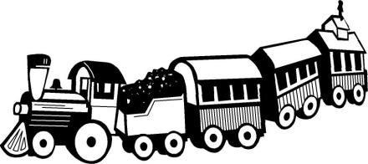

**Why Cooperative/Collaborative Learning?**

Cooperative learning is increasingly used in classrooms and afterschool settings. Once limited to group projects and reports, cooperative learning methods have added depth of understanding to students’ learning experience in across grade level, subject matter, and type of content. There is a growing understanding that students need to think, solve problems, and integrate and apply knowledge and skills to different situations. Cooperative learning provides an excellent opportunity for students to develop these skills. Research supports many positive interpersonal outcomes of cooperative learning including improved intergroup relations, acceptance of handicapped students, and better relationships between students of different ethnic backgrounds (Slavin, 1995).

Participating in a cooperative/collaborative learning experience take some practice and skill for the participants. Students need varying levels of guidance, direction, and support to successfully participate in a cooperative learning experience and be full contributors. Program leaders help youth develop these skills by providing a structure for the collaborative work to take place through thoughtful group formation and role definition that supports the learning activitiy.

**Forming Groups**

Working in teams gives youth the opportunity to share ideas, prioritize, compromise, and divide work. Teams of two to six members can be selected in a number of ways that support STEM concepts and process skills such as classifying, comparing, and using technology (see Appendix A for some creative ways to form teams and work groups). If one allows teams to form around existing friendships and familiarity, be aware of the possibility that some students may feel excluded. Be sure to balance enthusiasm and energy levels of the larger group among the teams, and be open to re-grouping the students if groups are not working out (Hutchison, 2002).

**Defining Roles**

The authors of the **Design It! Projects** afterschool STEM curriculum recommend assigning specific roles to each child. Benefits to assigning specific roles to youth include:

* Each child knows what is expected and how to share the work with others.
* Introverted and timid children are able to have equal access to materials as more assertive children do.
* Children who are inclined to disengage or withdraw are given important roles and tasks; the success of the group depends on their involvement too.
* Tasks that are inclined to be forgotten or undesirable to complete are accounted for.

Examples of roles often used in collaborative group work include:

* Leader or Captain: someone who helps keep the group on track and makes sure that everyone participates.
* Note Taker or Scribe: someone who does the writing and record keeping for the group.
* Spokesperson: someone who talks for the group when reporting out or sharing to the larger group.
* Gatekeeping: someone who watches the time for the group.

The roles used may vary depending on the type of activity and size of the group. Teachers and facilitators should chose roles appropriate for skill level of the children in the activity. In Appendix B, there are three sets of role cards that can be used for collaborative activities. Chose a set, or create your own, taking into account:

* The number of students in the group. If groups are smaller, what roles can be eliminated for the activity?
* Roles that seem a logical, natural connection to the activity. For example, science activities with roles such “researcher” and “tester” help mimic the real world of science and scientific inquiry for the student and expand his or her vocabulary.
* The complexity of the role. Younger students will require simpler tasks and fewer duties than older ones.

**Assigning Roles**

Cooperative learning works best when there are team goals and individual accountability (Slavin, 1995). The task or goal given to each group is the team goal, and the fulfillment of the duties for each role is the individual accountability. Facilitators will want to make sure that students are equipped to fulfill their roles successfully. In assigning and clarifying roles, consider:

* The assignment of roles vs. self-selection. Assigning roles can give students developmental opportunities they may not otherwise have while allowing students to self-select their roles allows them to participate in a way in which they are most comfortable and feel they can most effectively contribute. Self-selection can provide the opportunity for conflict management when multiple students wish to fill the same role.
* Giving students plenty of time to read role descriptions and understand their individual commitment to the group.
* Allowing the same roles from multiple groups the opportunity to meet and discuss their roles, or the opportunity to move to other groups and talk to the student with the same role. Here students turn to each other for clarification and ideas.

**Implementing the Activity**

To help student with their roles, facilitators should move from group to group, checking in with each student to ensure they are fulfilling their role and understand their contribution to the team goal. When participants ask questions that can be answered by another, redirect the question to the student who has responsibility for that role in the group. For example:

*Question: “How much time do we have left?”*

*Facilitator: Turns to the Gatekeeper or Captain, “Gatekeeper, how much time does the group have left?”*

When debriefing the activity and guiding the students in reflection, facilitators should include discussion about the collaborative process. Ask students to reflect on the process and how they managed conflict if any arose. How did each person contribute to the goal? What will you do next time? With time and practice, students will become more proficient at collaborative and cooperative work.

**References**

Cohen, E.G. (1994). Restructuring the classroom: conditions for productive small groups. *Review of Educational Research, 64*(1), 1-35.

Hutchison, C. (2002). *Design It! Projects*. Farmington, NY: Education Development Center, Inc.

Slavin, R. E. (1995). *Cooperative Learning: Theory, Research, and Practice*. Needham Heights, MS: Allyn & Bacon.

<http://learninginhand.com/collaboration/>

<https://www.cte.cornell.edu/teaching-ideas/engaging-students/collaborative-learning.html>

<http://www.edweek.org/ew/articles/2012/12/01/kappan_quinn.html>

**Appendix A**

**Forming Groups and Teams**

**Some Ideas from Genia Connell, Guest Blogger and Teacher at Scholastic.com**

Students work collaboratively in our classroom several times throughout the day, with partners and in small groups. There was a time when the mere mention of the word “partner” meant best friends shooting knowing looks across the room at one another. These days, however, my students look towards me, anxious to find out how their partner or group will be unveiled. (Downloadable materials to use for these grouping methods may be found at <http://www.scholastic.com/teachers/top-teaching/2013/11/15-quick-and-creative-ways-group-and-partner-students>

## 1. My Favorite: Team Shake

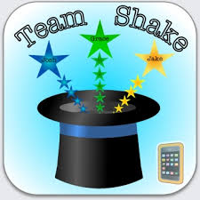 [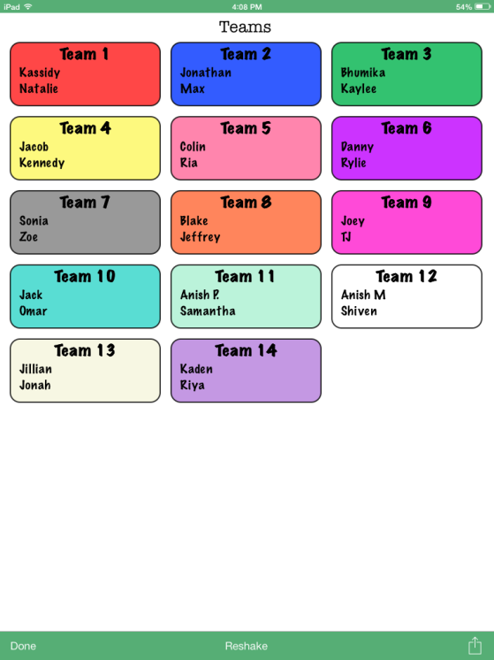](http://www.scholastic.com/teachers/sites/default/files/posts/u133/images/photo_1.png)

My absolute favorite way to group students is with the app [Team Shake](https://itunes.apple.com/us/app/team-shake/id390812953?mt=8). Simply enter your students’ names, select the number of groups you would like, give your tablet or smartphone a couple of shakes, and voilà, your teams have been created. Team Shake has settings that allow you to take gender and/or ability level into account when you group.

## 2. iPartners on Speed Dial

This is by far, my students' favorite way to work with a partner. I captured images of the keypad and contact list off of my phone and printed them for the students. They glued them onto their own 4" x 12" piece of construction paper phone that they personalized with their own designs.

To set up their contact (partner) list, students move about the room mutually agreeing to be partners with six other people. When it’s time to partner up for an activity, I’ll tell students to take out their phones and ". . . work with contact number two."  We normally “update” contact lists once a quarter.

[[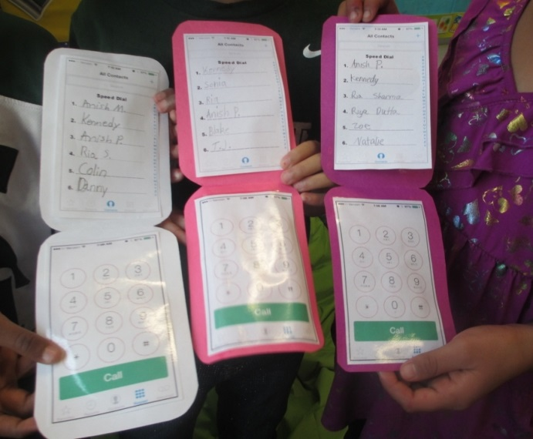](http://www.scholastic.com/teachers/sites/default/files/posts/u133/images/phones_on_table_0.jpg)](http://www.scholastic.com/teachers/sites/default/files/posts/u133/images/phones_on_table_0.jpg) [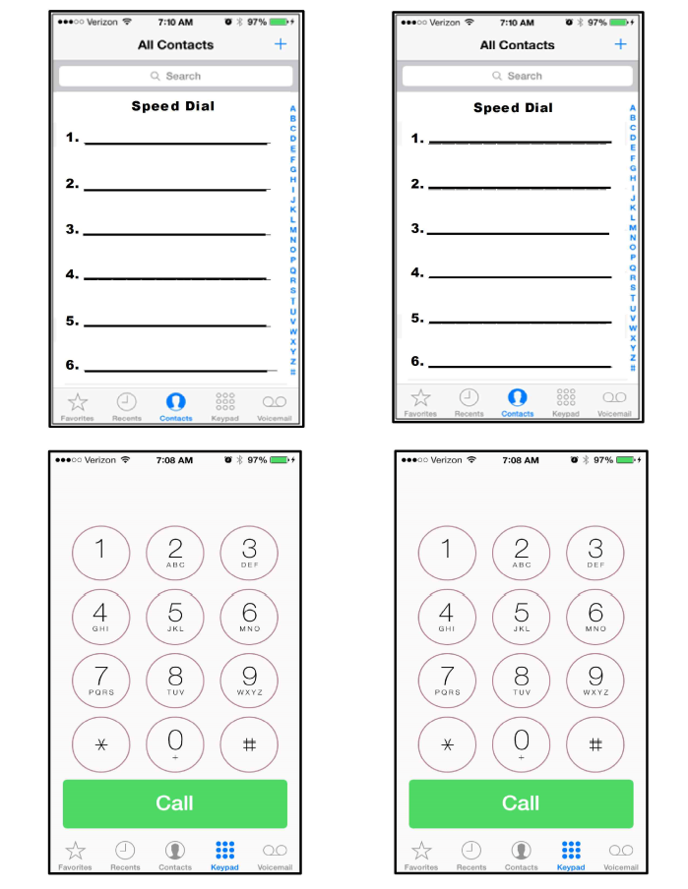](http://www.scholastic.com/teachers/sites/default/files/posts/u133/pdfs/iphone_template_for_partners2.pdf)

## 

## 3. Compass Partners

We use [**compass partners**](http://www.scholastic.com/teachers/sites/default/files/posts/u133/pdfs/compass_partners.pdf) in social studies. Just like the speed dial partners above, my students find four different partners to work with, writing their names on the north, south, east and west lines. My students change their directional partners with every new unit in our book. [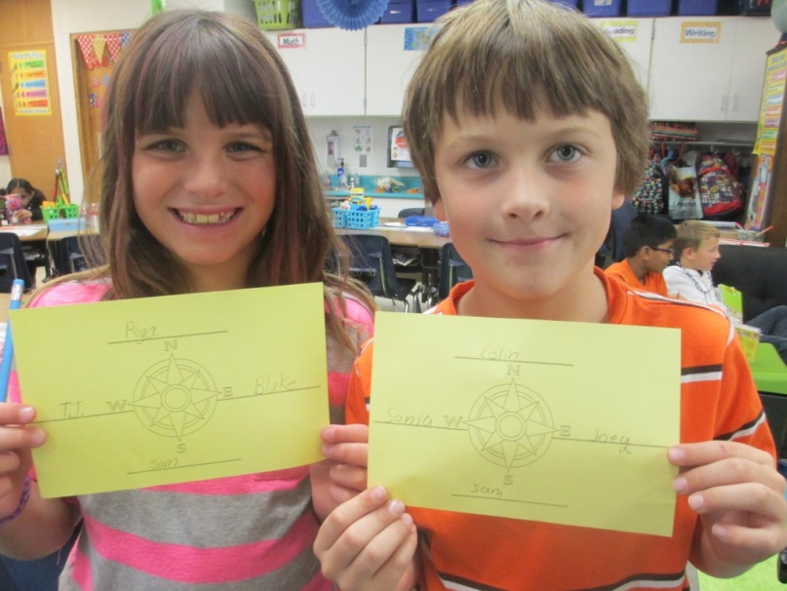](http://www.scholastic.com/teachers/sites/default/files/posts/u133/images/compass_partners_2_0.jpg)

## 

## 4. Clock Partners

Read how my friend and Troy colleague, Beth Newingham uses [**partner clocks**](http://www.scholastic.com/teachers/top-teaching/2012/11/partner-clocks-great-way-students-find-partners-quickly) to establish a set of 12 different pairings.

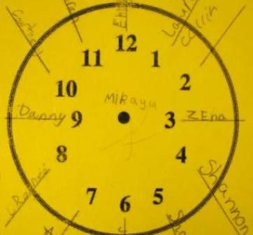

## ****Random Pairs****

In each of the following groupings, I pass out or have students select their own card, however they can easily be adapted to create teacher-selected partners. These activities are not only a fun way to find a partner, they help build and practice fundamental skills.

## 

## 5. Commutative Property Partners = Dollar Store Flashcards

Using addition or multiplication flash cards from the dollar store, students look for the partner that has the “flip flop” of their fact. Because the cards are two-sided, with different facts on each side, I put a dot on the side I want the students to use.

[[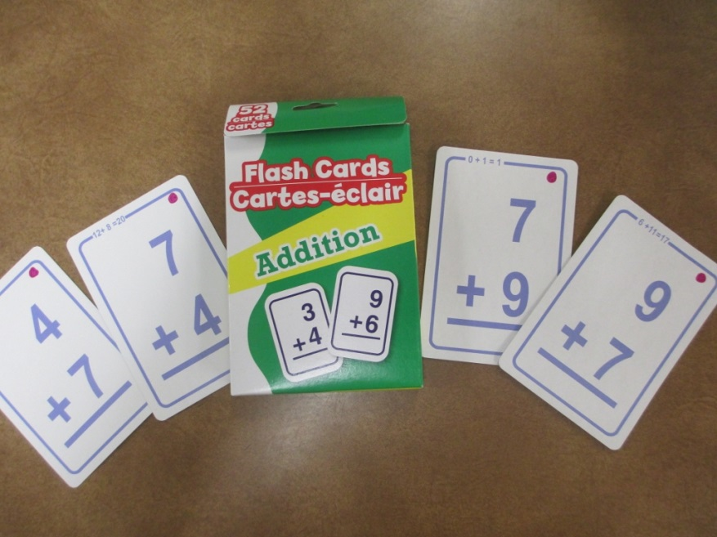](http://www.scholastic.com/teachers/sites/default/files/posts/u133/images/commutative_property_0.jpg)](http://www.scholastic.com/teachers/sites/default/files/posts/u133/images/commutative_property_0.jpg)

### 

### ****Partnerships that Enhance Vocabulary:****

I use the synonym and antonym cards for pairings, but I also use them throughout the year when we are doing word study activities. You may even be able to use them in one of vocabulary games Rhonda Stewart wrote about in her post [Fun and Easy Vocabulary Games](http://www.scholastic.com/teachers/top-teaching/2013/10/fun-and-easy-vocabulary-activities).

## 

## 6. Synonym Roll Partners

Students find the partner that has the synonym of their word. Download a set of [**42 synonym cards**](http://www.scholastic.com/teachers/sites/default/files/posts/u133/pdfs/synonym_partners.pdf) you can use for partnering and so much more.

[[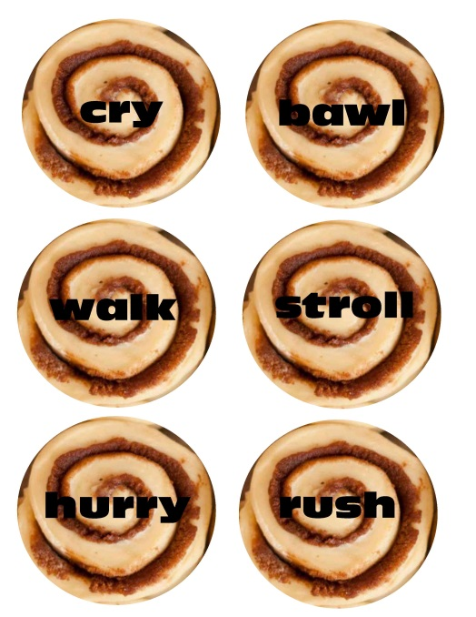](http://www.scholastic.com/teachers/sites/default/files/posts/u133/pdfs/synonym_partners.pdf)](http://www.scholastic.com/teachers/sites/default/files/posts/u133/pdfs/synonym_partners.pdf) [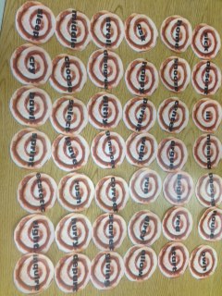](http://www.scholastic.com/teachers/sites/default/files/posts/u133/images/synonym_rolls_on_table.jpg)

## 

## 7. Antonym Partners

Students find the partner that has the antonym of their card.

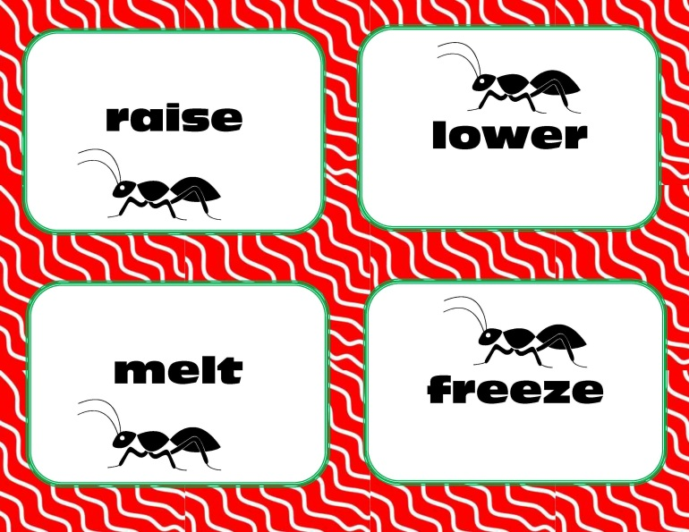

## 8. Famous Book Pairs

I randomly pass out the cards and students look for a classmate who has another character from the same book. Although I use characters that most my students know well, a classmate is always willing to help out if someone is unfamiliar with a name. Download the [**famous book pairs**](http://www.scholastic.com/teachers/sites/default/files/posts/u133/pdfs/famous_book_pairs.pdf) for your class to try.

## [http://www.scholastic.com/teachers/sites/default/files/posts/u133/images/img_3684_1024x768.jpg](http://www.scholastic.com/teachers/sites/default/files/posts/u133/images/famous_book_pairs.pdf)

## 

## 8. Old Maid Partners

Old Maid cards work well for pairing students. In years when I have an odd number of students, whoever gets the old maid card gets to work with the pair of their choice. This particular pack came from Walmart.

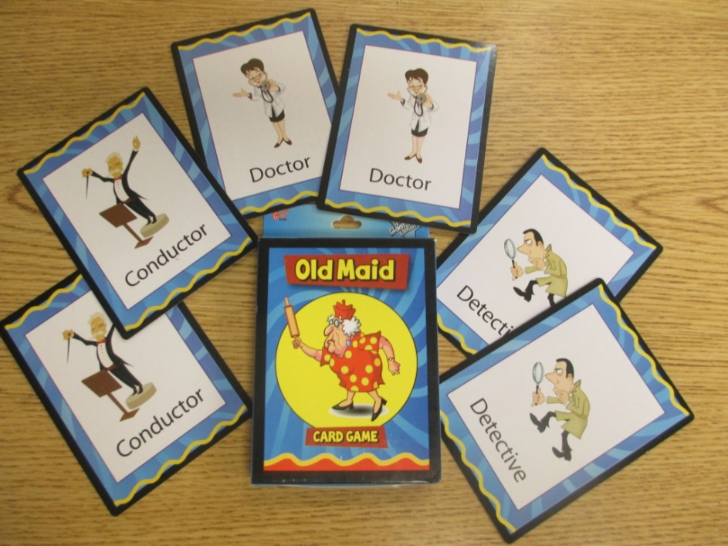

## 9. Clothespin Partners

Brightly colored clothespins from the dollar store work well to keep track of who is partnering with who.

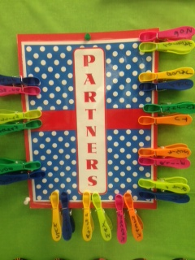

## Grouping Students

## 10. Book Cover Puzzles

Each year I scan several different favorite[**book covers**](http://www.scholastic.com/teachers/sites/default/files/posts/u133/pdfs/book_covers_for_puzzles.pdf) that I print, laminate and cut into puzzle pieces.  Students search the room looking for classmates that have matching pieces to the puzzle. In the past I have also used the pages from old calendars to create the puzzles as well as U.S. landmarks.

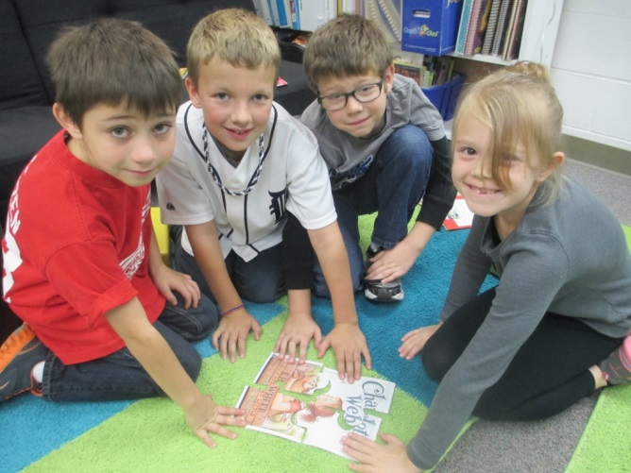 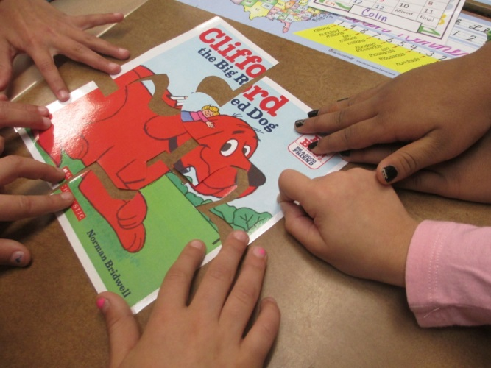

## 

## 11. Super Teacher Tools Website

Simply visit the website, [Super Teacher Tools](http://www.superteachertools.com/instantclassroom/group-maker.php) and type your students name into a roster and see the results. You can create groups of any size, or use it as a random name generator.

[](http://www.superteachertools.com/instantclassroom/group-maker.php)

## 

## 12. Go Fish for Your Group

Students find the four matching cards to make up their group. I love that these cards (from Walmart) are four different colors which helps in assigning students roles within the group.

[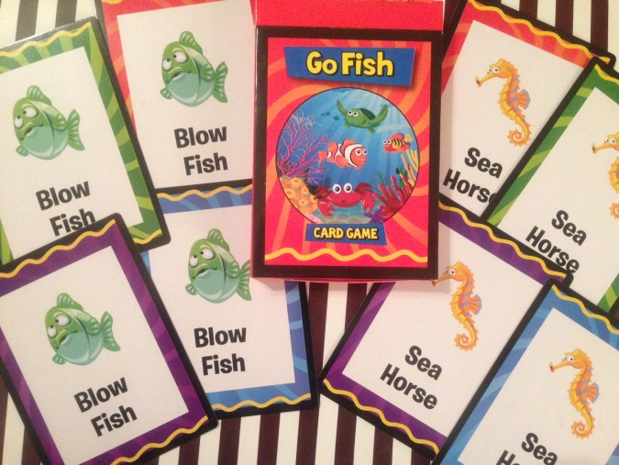](http://www.scholastic.com/teachers/sites/default/files/posts/u133/images/go_fish.jpg)

## 13. Dollar Store Décor Groups

The teacher aisle of Dollar Tree always has brightly-colored cutouts that come in packs of fifteen with three different designs. I purchase two packs and have a quick way for students to make groups.

[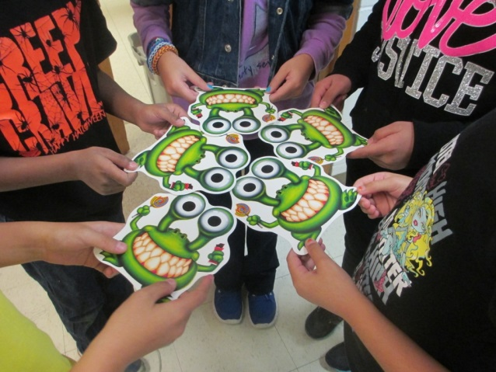](http://www.scholastic.com/teachers/sites/default/files/posts/u133/images/commutative_0.jpg)

## 

## 14. Playing Cards

A standard deck of playing cards is perfect for making pairs or groups of four.

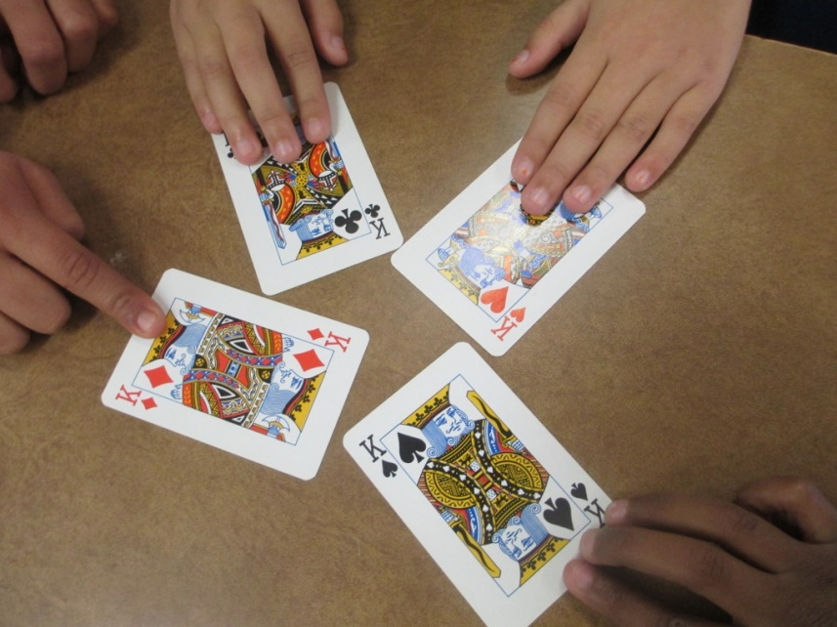

## 15. Magnets

These large magnets are perfect for forming or tracking group members. They are very easy to move and they stick to any magnetic surface.

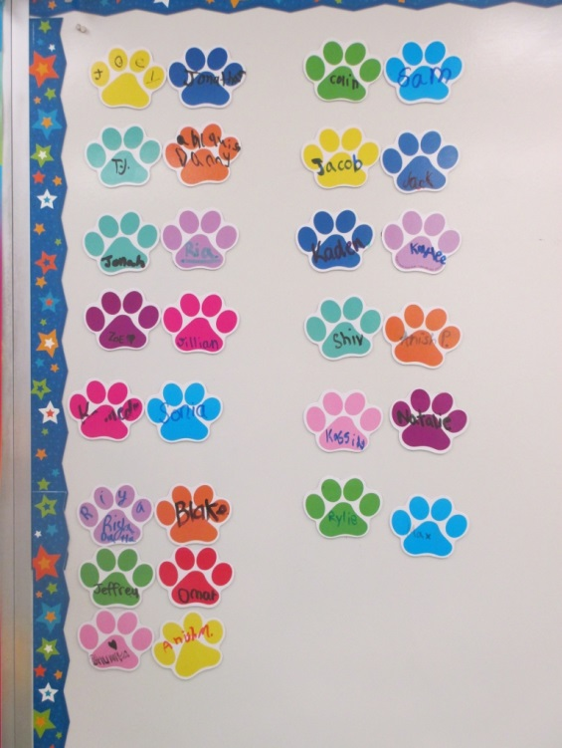

## Storing it All

I keep my partner cards and puzzles in an expandable file with labeled pockets. The different cards are stored in zip-sealed plastic bags labeled with the number of cards and groups that can be made from them.

[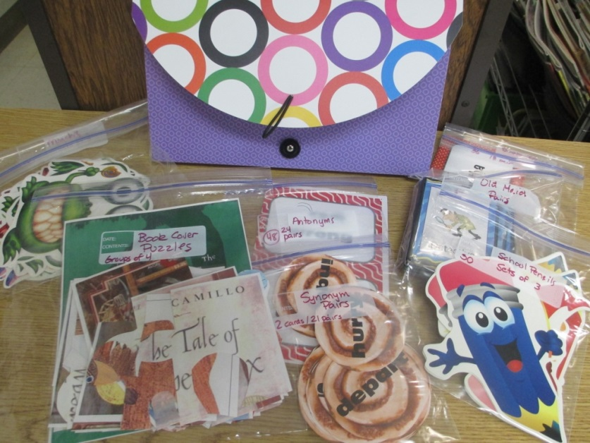](http://www.scholastic.com/teachers/sites/default/files/posts/u133/images/img_3831_1024x768.jpg)

I hope you have gotten an idea or two for new ways to partner or group your students.

**Appendix B**

**Sample Roles for Group Members**



***Badges for Group Roles***

*Print, laminate, hole-punch and safety pin or lanyard*

