2023 MENDOCINO COUNTY 4-H FASHION REVUE - CATEGORY ENTRY FORMS
submit one set of forms for each category entered
Category Entry Forms are DUE: Friday, April 21st, 2023, 11:59PM
Category Forms must be printed and brought or mailed to the 4-H Office. They must arrive before 4pm, April 3.
Note: The online Participant Entry Form survey is DUE Friday, March 20
Name: |  |  |  |  | Age as of 12/31/22:
Category: |  |  |  |  | Years in a Clothing & Textiles or Sewing project:
Age Division:  (as of 12/31/22) | Primary (5-8) |  | Intermediate (11-13) |  | 4-H Club:
 | Junior (9-10) |  | Senior (14-18)
Total cost of all supplies (including fabric, pattern, notions, etc.)  ($50 Purchased: enter total cost of outfit, excluding tax) |  |  |  |  | $
Value of a comparable commercial made item(s)  ($50 Purchased: enter value of complete outfit) |  |  |  |  | $
Estimated value of leftover and reusable supplies  ($50 Purchased: $0) |  |  |  |  | $
What is your entry? Describe the item(s) you created for this entry. Include its fabric or material content
($50 Purchased: list each purchased item with its fabric or material content)

List other garments and accessories that you will be wearing (Nothing for $50 Purchased)
For non-wearable entries: Describe an outfit you would wear while using your entry.

Describe how you made your entry. Also, include what pattern you used and describe any pattern changes, embellishments, and sewing, crafting, or other skills used to create your entry.
For $50 Purchased: Describe how you shopped and purchased your outfit.
What new skills did you learn while creating this entry?
For $50 Purchased: What did you learn during your shopping experience?
Where will you (or your animal) use this entry and how often will you use the item(s) in this entry?

How does this entry coordinate with your existing wardrobe?
For non-wearable entries: Why did you choose the colors and materials used to create the entry?

For Make It with Wool: How does this entry fulfil the wool requirement and the guidelines at https://makeitwithwool.com/the-facts?
For Costume Challenge: Was the costume created for you or for someone else?

For Make It for Your Animal: What kind of animal (cat, dog, lamb, etc.) will use this entry?
How will you clean and care for this entry?

All questions should be answered by the member. If needed, an adult can type or neatly write the answers while the member dictates the answers. Information in this packet will be used by the evaluators during your entry's evaluation.

Embellished “Before” Photo Page

Submit this page for Embellished category only

Due April 3, 2023 Note: Entries missing info & photos will lose points!
Name:
Category: | Embellished

Embellished: attach color picture of garment(s) before you made modifications

Consumer Science $50 Purchased – Cost/Value Page

Submit this page for $50 Purchased category only. Due April 21st, 2023

All visible garments & accessories must have a receipt from July 1, 2022, to April 21st, 2023
Name:
Category: | Consumer Science $50 Purchased

List information for all items in your purchased outfit, including accessories and shoes.

Description of Item (include type of clothing or accessory, description, and brand name) | Where Purchased | Cost  (without tax) | Full Price or  Estimated Value

Total Cost & Estimated Value:

Consumer Science $50 Purchased - Receipt Page

Submit this page for $50 Purchased category only. Due April 21st, 2023

All visible garments & accessories must have a receipt from July 1, 2022, to April 21st , 2023
Name:
Category: | Consumer Science $50 Purchased

Attach copies of your receipts here. Garage sale receipts may be handwritten. Date must be visible.
If you purchased other items on the same receipt, label the items that are part of your Purchased entry.

Completed Entry - Photo Page

Submit 1 of these pages for each category entered.
Due April 21st, 2023, 8:00AM (The morning of the event) - Make It for Your Animal due 4/3

Note: Entries missing a photo of the completed entry will lose points!
Name:
Category:

Attach 1-2 color photos here: For wearable entries include full body, head-to-toe picture of outfit.

For non-wearable entries show the entire item(s).

You may also include a close-up photo of any handmade accessories.

For Make It for Your Animal: Also include a picture of your animal using the entry.

Fashion Show Commentary Page

Submit 1 of these pages for each category entered. Due April 21st, 2023
Name:
Club: |  |  |  |  |  | County: | Sonoma
Age Division: | Primary (5-8) |  | Junior (9-10) |  | Intermediate (11-13) |  |  | Senior (14-18)
Category:

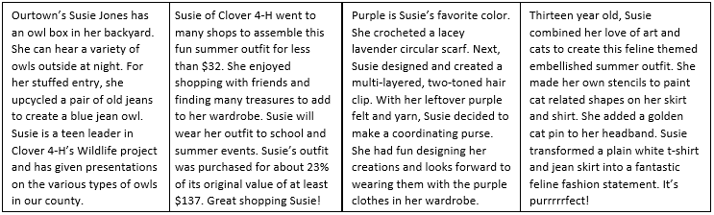
Write a short description of your entry to share with the public during the Fashion Show. Please only include a few sentences with a maximum of 60 total words. Long commentaries will be edited.
For ideas, see: https://www.uvm.edu/sites/default/files/4-H-and-Youth/stateday/stateday-fashionrevue-commentary.pdf
and https://extension.unh.edu/sites/default/files/migrated_unmanaged_files/Resource000944_Rep1039.pdf
Other topics you may include are: cost & estimated value, why you made it, favorite or least favorite part of making it, etc.
S
A
M
P
L
E
S

