Easy Native Annual Wildflowers for Santa Cruz County
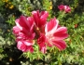
Clarkia rubicunda – Farewell-to-spring, Clarkia purpurea - Godetia
Blooms in June – July after many spring wildflowers. Makes fabulous long-lasting cut flowers.

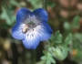
Nemophila menziesii – Baby Blue Eyes
Baby Blue Eyes are a low-growing plant and one of the earliest annuals to bloom. Grows virtually throughout California. A garden favorite. Birds relish its black seeds.
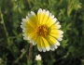
Layia platyglossa – Common Tidy Tips
The flowers of tidy tips have a yellow center surrounded by a ring of white-tipped yellow ray flowers. They are lovely planted in drifts with lupines and gilias.
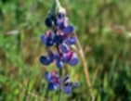
Lupinus nanus – Sky lupine, Lupinus bicolor – Miniature lupine
As nitrogen fixers, our annual lupines can also be used as a cover crop. Both have flowers that are generally blue and white. Stored seed benefits from scarification or a hot water treatment.
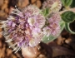
Phacelia californica – Rock Phacelia
There are over 100 species of phacelias and it is best to use our most local varieties. It is a great pollinator plant and food source for the endangered Mission blue butterfly. Some people are allergic to it.
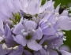
Gilia Capitata – Bluehead Gilia
Very popular, variable in size. Ranging from 6-24”. Widespread and grows in many habitats. Likes sandy and rocky soils.
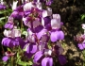
Collinsia heterophylla – Purple Chinese Houses
Named for their flowers resembling pagodas. Plants are 6-15” when in bloom.

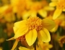
Lasthenia californica – California goldfields
Low growing showy yellow flowers. Another widespread plant that grows in many habitats.

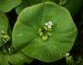
Claytonia perfoliata – Miner’s Lettuce or Indian Lettuce
Common in moist and shaded places. Disappears after the rains end.

