Easy Native Plant Species for Santa Cruz County – Perennials
*Plants can be viewed in the UCMG Demo Garden
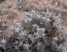
Eriogonum latifolium – Coast Buckwheat *
One of California’s most important pollinator plants. Creamy white to pink flowers. It is a favorite nectar plant for the federally endangered Smith’s dotted-blue butterfly.
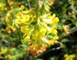
Acmispon glaber – Deerweed
A pea family plant with clusters of small yellow flowers that become reddish with age. It used to be called Lotus scoparius and may be sold under that name. Host plant for many butterflies.
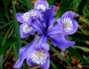
Iris douglasiana – Douglas Iris *
Our famous Douglas Iris is vigorous and durable. Clumps will slowly expand and they can be divided when the rains return in the fall and new white roots begin to grow.
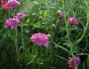
Armeria maritima – Sea Thrift, Sea Pink
Attractive small coastal perennial. Pink flowers on mounding plants up to 3’ wide.

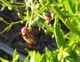
Scrophularia californica – Bee Plant *
Under the radar but unfussy, easy important pollinator plant with small rounded red flowers. Deer resistant. Great for bees, hummingbirds and host plant for butterflies and moths.
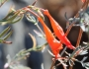
Epilobium canum – California fuschia *
A late summer- fall bloomer very useful for extending bloom in the garden. Loved by hummingbirds. Vigorous and easily grown.
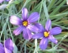
Sisyrinchium bellum – Blue-Eyed Grass *
A relative of irises. Takes heavy soils. Naturalizes. Can fill in bare areas and narrow beds. Nice for edging. Small, 4-12” high.
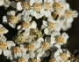
Achillea millefolium - Common yarrow *
Very easy and popular. Can also be grown from seed. Spreads by rhizomes. Also useful as a groundcover.
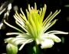
Clematis lasiantha - Chapparal clematis
A climbing vine that can grow fast up to 15’. Prefers part shade and like to have trees or shrubs to climb up.

