Easiest Native Plant Species for Santa Cruz County – Groundcovers
*Plant can be viewed in the UCMG Demo Garden
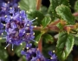
Ceanothus thyrsiflorus var. griseus – Carmel Creeper *
Fast and easy. One of the most commonly planted groundcovers in California. Can also spread up to 15’.
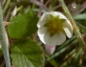
Fragaria chiloensis – Beach strawberry *, Fragaria vesca – Wood strawberry
Beautiful dark glossy leaves, it is the parent of commercial strawberries whose genes provide vigor. Prefers sandy soils. Wood strawberry is great in shade and under trees. Has tasty fruit.
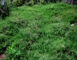
Baccharis pilularis – Coyote Brush
The prostrate forms of coyote brush make an excellent groundcover that stays bright green all year. It is also highly beneficial to wildlife and some forms can even be mowed.
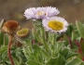
Erigeron glaucus – Seaside daisy *
Loves our coastal climate, very showy, in bloom almost all year, deer resistant. Up to 2’ spread.
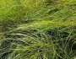
Carex pragraecilis – Clustered Field Sedge *
This sedge has a soft texture and is often used to replace turf as it can be mowed and uses significantly less water.
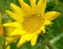
Grindelia stricta – Gumplant
Long-flowering, can spread 6-10’, takes salt spray and supports a wide diversity of bees. Deer resistant. Used to treat poison oak and as an adhesive.
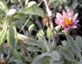
Corethrogyne filangifolia – California aster
Formerly called Lessingia filangifolia, a long-flowering butterfly plant that prefers well-drained soils. Silvery foliage, light purple to pink flowers.
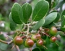
Arctostaphylos hookeri ssp. hearstiorum and Monterey Carpet– Hooker’s manzanita. Rare, threatened or endangered in the wild.
These 2 subspecies are very low growing approx. 1 ft tall X 6 ft wide
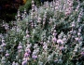
Salvia species - Sage
Our native sages, largely like dry conditions and tend to thrive on neglect. Many forms are prostrate creepers. Extremely fragrant, beneficial to wildlife, medicinal.
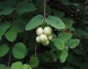
Symphoricarpos mollis – Creeping Snowberry
Works especially well under coast live oaks. It can withstand heavy root competition. It willspread by rhizomes and layering stems.

