Native Plants for Containers
*Plants can be viewed in the UCMG Demo Garden
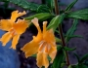
Mimulus species – Monkeyflowers *
A widely variable species with large showy flowers. They have many garden uses and are great in containers. Diplacus aurantiacus [Mimulus aurantiacus] – Sticky monkeyflower is a local favorite.
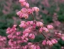
Heuchera species – Alumroot, Coral Bells *
A favorite garden plant with attractive rosettes of leaves and showy flower stalks. There are many choices that are widely available. They are easily increased through division.
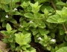
Clinopodium douglasii – Yerba Buena, The Good Herb *
A low trailing plant with dainty, oval mint-scented leaves. It would make a great “spiller” in a pot. It is edible and makes a great tea. Encourage branching with light pruning.
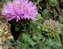
Monardella villosa – Coyote Mint
A small perennial herb that is wonderfully fragrant, medicinal and loved by butterflies. Great to enjoy up close.
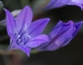
Triteleia laxa – Ithuriel Spear
Easy care bulbs with umbels of white, purple or blue-violet flowers. An important food source, digging of parent bulbs dispersed bulblets and ensured an abundant food supply.
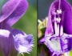
Prunella vulgaris – Self heal *
Easily grown by seed, division or by planting stolons. Leaves and flowers are edible. Has many medicinal uses and could also be used as a small groundcover due to its spreading habit.
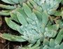
Dudleya species – Live Forevers
Reputed to live 50-100 years. Some of the most rewarding California succulents to have in the garden. UCSC is at the forefront in saving highly prized species that are rare in the wild.
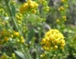
Solidago velutina – California goldenrod *
One of the late blooming perennials with masses of yellow flowers. Great for birds, butterflies and bees or as a groundcover.
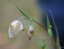
Calochortus albus – White Globe Lily or Fairly Lantern
This lily will send up a 1-2’ branched flower stalk with pearly white nodding flower orbs. It is sometimes available at nurseries.

