Popular Non-Local Native Plants
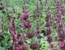
Salvia spathacea – Hummingbird sage
Fabulous flowers and fruity fragrance. Spreads slowly by rhizomes and can be used as a groundcover. Also a nice container plant.
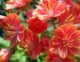
Lewisias – Cliff Maids
A small succulent with flowers that come in different colors. Native to northern California and southern Oregon. Subalpine rocky areas. Edging, containers.
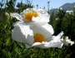
Romneya coulteri – Matilija Poppy
A tall perennial with large showy flowers. Can reach 6’-10’ high and can spread aggressively. Great for erosion control. Native to southern California.
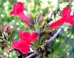
Gambelia speciosa – Island Snapdragon
Native to the Channel Islands. A long bloomer loved by hummingbirds. Flowers are clustered at the tips of its branches. A nice cut flower and hedging option.
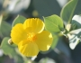
Dendromecon harfordii – Channel Islands Tree Poppy
Flowers almost year-round with clean, blue green leaves. Be gentle planting as its roots are brittle. Mature plants can be pruned hard to rejuvenate
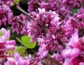
Cercis occidentalis – Western Redbud
A beautiful four-season small tree. Flowers in spring and has yellow to orange leaves in the fall. An important basketry plant that was regularly pruned to produce straight stems.
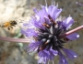
Salvia clevelandii – Cleveland Sage
One of our most popular and fragrant sages. Best in a hot, dry fast-draining site. From southern California. Culinary sage substitute.
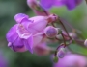
Penstemon species
Penstemons are highly prized ornamentals. California has 50 species and a great many more varieties. Penstemon rattanii var. kleei is our only local species listed as rare and threatened. Endemic to the Santa Cruz mountains.
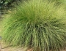
Muhlenbergia rigens – Deergrass
A large perennial bunchgrass that looks attractive year-round. Easy to maintain, deer resistant, erosion control. Often used in commercial landscapes.
