Easy Native Plant Species for Santa Cruz County – Shrubs
*Plant can be viewed in the UCMG Demo Garden
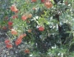
Heteromeles arbutifolia – Toyon (named by the Ohlone)
Beautiful, easy, adaptable, deer resistant, erosion control, bright red berries. 8-15’ or more. Can be pruned even coppiced to rejuvenate or control size. Long-lived.
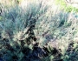
Artemisia californica – California sagebrush
One of our most aromatic shrubs nicknamed “Cowboy cologne”. Soft silvery foliage. Deer resistant. Additional local artemisias: Artemisia pycnocephala – Coastal Sagewort
* and Artemisia douglasiana – Mugwort.
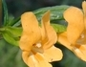
Mimulus aurantiacus – Bush monkeyflower *
Thrives in many soils, hummingbird favorite as well as bees and butterflies. Can grow up to 5’but can be pinched back to maintain a compact form.
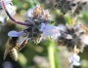
Salvia mellifera – Black sage
The most common sage of California. Can get large. One of the best for supporting wildlife.

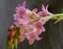
Ribes sanguineum var. glutinosum – Blood currant *
Pendulous clusters of flowers. Benefits from more sun in our coastal area but a shade lover. Will grow 5-12’ high.
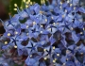
Ceanothus thyrsiflorus – Blueblossom ceanothus
Blueblossoms vary throughout the state so it is best to choose a local variety. After 2 years you should not need to water it at all. Comes in many varieties.
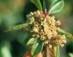
Frangula californica – Coffeeberry
Easy to grow in a wide range of soils and conditions. Fire and deer resistant, attractive berries, leaves, stems. Erosion control, up to 15’, takes pruning well. A good choice for a hedge.
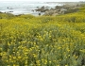
Eriophyllum stachaedifolium – Seaside wooly sunflower, Lizard-tail *
Showy yellow flower clusters are a great nectar source for native insects. This species prefers sand. Use Eriophyllum confertiflorum- Golden Yarrow, similar for inland locations.
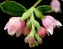
Symphoricarpos albus var. laevigatus – SnowberryA beautiful shrub 4-6’ high with lovely white berries loved by birds. Prefers woodsy locations.

