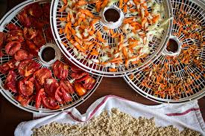
Basics of Dehydrating
Do you have all the jelly and jam you might need for the next year, including holiday gifting. You just can’t make any more marinara sauce or can any more tomatoes. You love giving my children and grandchildren fruit rollups as a snack but dislike the volume of sugar and high fructose corn syrup! Want to learn how to make your own jerky?

As a Master Gardner or just one who loves their backyard herb garden, learn how to dehydrate and preserve your herbs. Also learn to make some of your own favorite spices.

You want to learn something new or a new reason to use your dehydrator. We live in an area where the next “big one” could happen at any time, are you prepared for 3-6 days of meals for you and your family?

Are you a backpacker? Learn how to make your own meals for your trips and save money in the process.

You have no more freezer space, or no freezer at all and want to learn how to save nature’s bounty from our San Joaquin Valley agriculture.
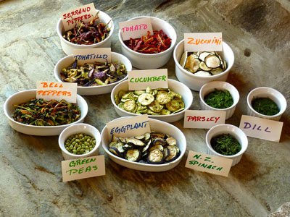
Dehydrating is an easy way to do all these things. Having a dehydrator, and using it, can give you the opportunity to preserve fresh fruits and vegetables for use in the off season. Come join us for a demonstration on how to dehydrate.

Class will be held on August 27, begins at 10 am and ends at 12 Noon. Cost for the class is $10, includes all materials, and registration is limited to the first 30 who register.

Come join us for an exciting demonstration workshop

