**Nutrition Policy Institute, University of California, Division of Agriculture and Natural Resources logo** 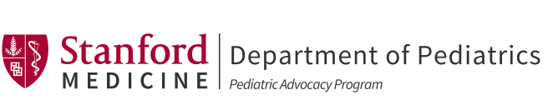 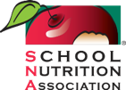

**Calling all Districts! USDA Summer Meals Can Keep Kids Healthy**

Despite COVID-19 school closures, schools can continue to serve meals over the summer with support from USDA’s extension of waiver flexibilities.This resource will help you get started and provide tips for running successful and sustainable programs.

**The Critical Importance of School Meals This Summer**

School Food Heroes

[95% of school districts have stepped up to provide school meals after closures due to COVID-19](http://schoolnutrition.org/uploadedFiles/11COVID-19/3_Webinar_Series_and_Other_Resources/COVID-19-Impact-on-School-Nutriction-Programs-Part2.pdf).

Schools have played an indispensable role in keeping children and families healthy. We can apply lessons learned since March to set up a robust summer program that serves our communities during a time when it’s needed most.

With unprecedented levels of unemployment, far higher than at any time since the Great Depression, hunger is likely to look very different in your neighborhoods. Families whose children never before needed free and reduced-price school meals will need free, healthy food this summer.

**How to Operate While School is Closed**

All schools may be approved to operate under the NSLP’s Summer Seamless Option (SSO). Schools that have been approved to operate the Summer Food Service Program (SFSP) during the previous two years may select that option. Your state may require you to submit a request to operate either program.

Refer to your state agency’s COVID-19 guidance for complete and updated information on how to provide school meals during the COVID-19 pandemic.

**Who is Eligible for Summer Meals?**

Under the SFSP and SSO, **any child** 18 years or younger (and students of any age who are disabled) may receive meals. USDA’s flexibilities during COVID-19 currently waive area eligibility requirements for schools with fewer than 50% of students eligible for free and reduced price meals. With state agency approval, all meals may be provided for free through [August 31, 2020](https://fns-prod.azureedge.net/sites/default/files/resource-files/COVID19%20Area%20Eligibility%20Extension%20Nationwide%20Waiver.pdf).

**What Meals or Food Assistance Can Be Offered?**

With State agency approval, **meals may be provided every day including weekends, holidays and previously scheduled non-instructional days**. Schools can apply to provide meals all summer long, regardless of whether summer activities or programs would have taken place.Meals may be offered daily or for [multiple days](https://fns-prod.azureedge.net/sites/default/files/resource-files/SSOCOVID.pdf) (up to 5 days) at one time. Depending on programs you are operating, allowable meals include up to three meals per day or two meals and one snack. Food items may be offered [in bulk](https://fns-prod.azureedge.net/sites/default/files/resource-files/SSOMultipleMealsCOVID.pdf) such as gallons of milk, loaves of bread, or whole fruits and vegetables. School sites that are eligible for the Fresh Fruit and Vegetable Program (FFVP) and CACFP At-risk Afterschool Meals may continue to offer program foods during school closures until June 30, 2020. Reimbursement rates vary by program. Visit your state agency’s website for the current Child Nutrition Program reimbursement rates.

See [FAQs from USDA](https://fns-prod.azureedge.net/sites/default/files/resource-files/SP14-2020s-a.pdf) and more [Team Nutrition infosheets](https://www.fns.usda.gov/tn).

**How to Take Advantage of Flexibilities Provided by Waivers**

[USDA’s Child Nutrition Program waivers](https://www.fns.usda.gov/disaster/pandemic/covid-19/cn-waivers-flexibilities) provide many flexibilities to ease operations during COVID-19. Some waivers are automatic but for others, your state may require operators to submit an online application. Operators must update their State agency child nutrition information system and maintain all applicable records during this time period.

* Waivers confirmed through August 31, 2020 for all states:
  + Meal service time flexibility (and extended to Sept. 30 for SFSP/SSO)
  + Non-congregate meals
  + Parent/guardian meal pick-up
  + Area eligibility
* Make sure to check whether you need state approval to, for example
  + Serve meals under the SSO/SFSP with USDA flexibilities
  + Provide home meal delivery
  + Provide multiple days’ worth of meals at one time
  + Let parents pick up meals without children being present
  + Manage food shortages or supply chain issues with the Meal Pattern Waiver
* Check this resource for updates, [COVID-19 Child Nutrition Program Nationwide Waivers](https://drive.google.com/file/d/1s1-R6S63gH33rTHvZOkwpswsW5GF0WhN/view)

**More Support for Children:**  **Pandemic-Electronic Benefit Transfer (P-EBT)**

You can build P-EBT public awareness!

* Every state has a different plan to implement P-EBT. To see the status of P-EBT in your state, click on your state’s link in [this map](https://frac.org/pebt).
* In most states, families that are directly certified (enrolled in SNAP, Medicare or Foster Care benefits) will automatically be issued benefits to the family’s SNAP card or receive a P-EBT card in the mail.
* If your state has an application, there may be a deadline to apply. Make sure to include this in your outreach materials.
* Assure families that the program is real and that it is recommended they participate. No income information is required. Participation in P-EBT does not impact immigration status and public charge.
* If your state has an application, provide links for your state’s online application and other materials; help line phone number; and other information.
* Check out this [communication toolkit](https://frac.org/wp-content/uploads/PEBT-Comm-Toolkit.pdf) for resources you can tailor to get the word out in your community!

Most [states](https://www.fns.usda.gov/snap/state-guidance-coronavirus-pandemic-ebt-pebt) now offer P-EBT! Created through the “Families First” Act, the P-EBT program helps families with funds for breakfast and lunch for up to five days per week for each week that school was closed because of COVID-19. P-EBT is another way to support households containing children who are eligible for free or reduced-price school meals (and **all children** who attend CEP or Provision 2 schools). **Families in the program are eligible for P-EBT benefits AND may still receive meals from their schools during SFSP/SSO meal services.** Check your State’s administering agency for more information.

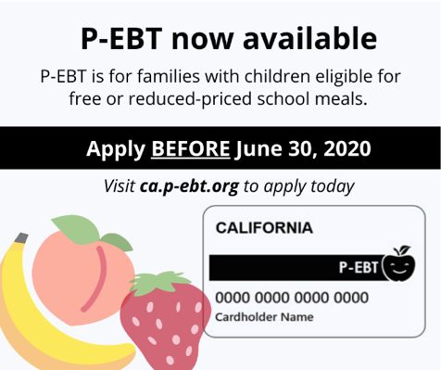

*Example of P-EBT graphic (California)*

**Innovation & Success – Tips from districts**

Staff Safety and Well-being

**Free COVID-19 Meal Service Resources:**

* [Safety Precautions Toolkit](https://s3.amazonaws.com/kajabi-storefronts-production/sites/91734/themes/1815492/downloads/r73ENmbsSI2VBgOK6XB2_COVID-19_School_Food_Service_Safety_Precautions.pdf)
* [Social distancing meal service signage cards](https://s3.amazonaws.com/kajabi-storefronts-production/sites/91734/themes/1815492/downloads/uqT9n3CQYOk44ynVM1Jg_Social_Distancing_Cards_English_Spanish_.pdf)
* [Safety tip sheets in English and Spanish](https://s3.amazonaws.com/kajabi-storefronts-production/sites/91734/themes/1815492/downloads/bIPs4EHTQYmtuYbLuMfg_Tip_Sheet_Safety_Precautions_English_Spanish_.pdf)
* [Mask use tip sheets in English and Spanish](https://s3.amazonaws.com/kajabi-storefronts-production/sites/91734/themes/1815492/downloads/qn25fGtBSvG81HQr3R59_Tip_Sheet_Face_Masks_English_Spanish_.pdf)
* Find all these and more, [here](https://www.lunchassist.org/covid-19)
* Create safety protocols and train staff on the protocol
  + Proper use of personal protective equipment (PPE).
  + Worker safety in food prep and cooking
  + “No contact” handoffs at drive throughs, walk up stations, and delivery sites
* Consider staffing strategies such as alternating shifts or designated teams
* Make time for check-ins and recognition to build trust and cohesiveness with your team

Food Supply and Meal Provision

* Increase quality, reduce labor and food waste by providing items such as fresh fruit, vegetables and milk [in bulk](https://fns-prod.azureedge.net/sites/default/files/resource-files/SSOMultipleMealsCOVID.pdf)
* Consider using some of your USDA Foods commodities entitlement to purchase otherwise expensive local fruit and vegetables through USDA’s DOD Fresh Program
* Leverage emergency procurement and micro-purchasing to support local farms
* Schedule meal pickup times that work for parents who are essential workers and work long hours
* A [School Nutrition Association survey](https://schoolnutrition.org/news-publications/press-releases/2020/sna-survey-reveals-covid-19-school-meal-trends-financial-impacts/) shows how districts across the country are distributing food:
  + 64% of districts utilize multiple meal distribution methods
  + 81% have drive through pick up sites
  + 58% allow students/families to walk up to feeding sites
  + 42% deliver meals directly to student homes
  + 32% utilize bus routes for distribution
  + 13.5% partner with local food banks/organizations to provide meals/food assistance

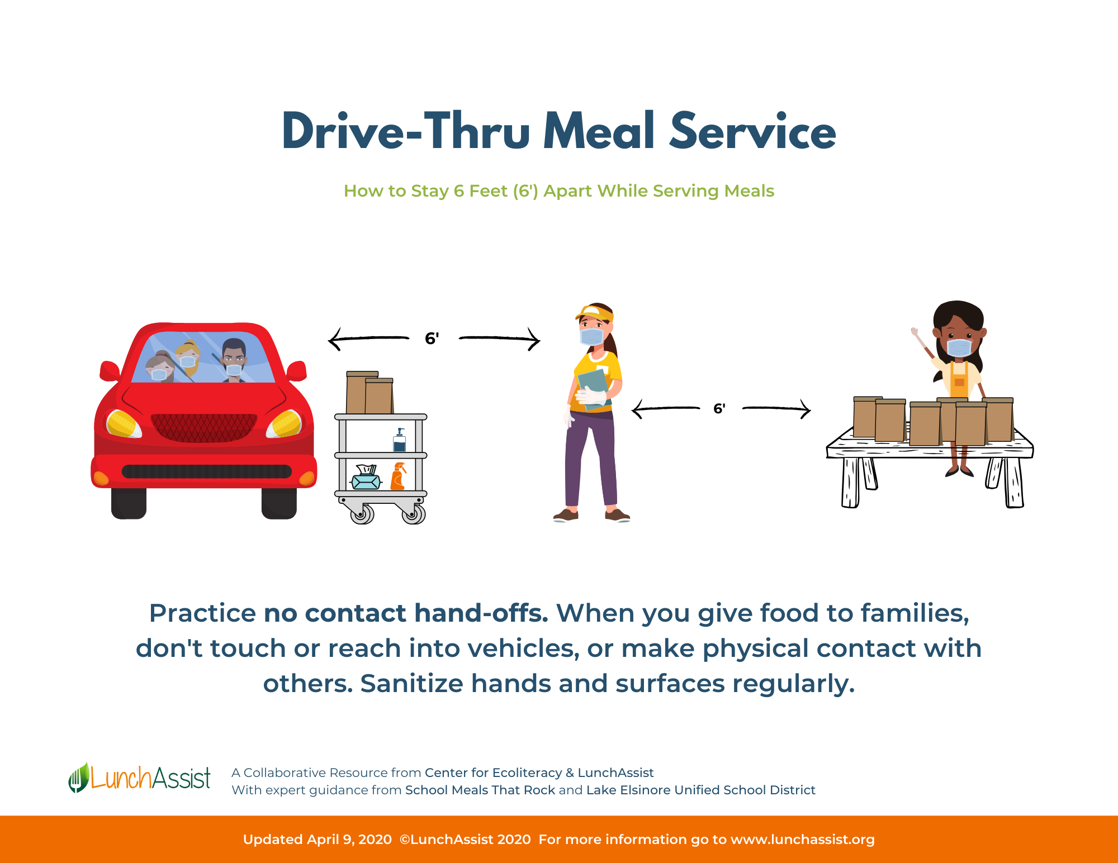

Financial Considerations

* Be sure to use up your Fresh Fruit and Vegetable Program (FFVP) funds by the end of June
* If you were previously approved to operate a CACFP At-risk Afterschool Meals program, send supper meals home for up to seven days per week between now and June 30
* Apply or re-certify for [Community Eligibility (CEP)](https://fns-prod.azureedge.net/sites/default/files/resource-files/COVID19-CEPDeadlinesNationwideWaiver.pdf?eType=EmailBlastContent&eId=323a47c2-eed7-4965-8eb5-02bc0bc8a3d6) by August 31, using 4/1-6/30/20 ISP data
  + Check for your district in the [Food Research and Action Center database](https://frac.org/community-eligibility-database/)
* Reduce packaging costs by sending foods in bulk rather than in individual portions
* If supply chain or staffing issues are making it difficult to source program foods, apply for the Meal Pattern waiver to give you more flexibility in menu planning
* Source seasonal produce directly from local farms to support the local economy and save money by purchasing direct
* Remember that providing summer meals allows you to continue providing employment and continue supporting your suppliers and your local community

Communications and Community

Boost Participation with Outreach!

* Public announcements on radio or TV
* Email blasts
* Social media messages
* Automated phone calls
* Website announcements
* Newspaper notifications
* Community partner newsletters (e.g. food banks, mayor’s office, YMCA)
* Provide program information:
  + Communicate as widely as possible and in multiple languages to ensure that parents, guardians, and children are aware of the availability of meals
  + Let families know about social distancing and mask use so they know what to expect at sites
  + Provide information about preparing and storing meals at home. This is required for meals sent in bulk
  + Update families on program changes or new opportunities at your site (e.g. visit from the food bank)
* Use meal distribution sites to:
  + Distribute curriculum materials
  + Offer other important information to families (e.g., health, unemployment, housing and food assistance programs)
  + Distribute donations of additional food and other necessities to families through partnerships with local food banks and businesses
  + Connect with local community stakeholders such as the library, farmers, or social services
* Connect with your local Cooperative Extension for nutrition education resources
* Qualify as a pick-up location for USDA Farmers to Families Boxes (program currently operates until August 30, 2020)

The authors wish to thank the Center for Ecoliteracy and LunchAssist for providing information on food service innovations and successes, and to SNA, FRAC, the Center for Ecoliteracy and LunchAssist for resources and review. All the authors of and contributors to this publication are members of the ad hoc COVID-19 School Nutrition Implications Working Group, jointly supported by Healthy Eating Research, a national program of the Robert Wood Johnson Foundation, and the Nutrition and Obesity Policy Research and Evaluation Network (NOPREN). NOPREN is supported by the Centers for Disease Control and Prevention’s Division of Nutrition, Physical Activity, and Obesity Cooperative Agreement No. 5U48DP00498-05. The findings in this publication are solely the responsibility of the authors and do not necessarily represent the official views of HER, RWJF, CDC, SNA or FRAC.

**Nutrition Policy Institute, University of California, Division of Agriculture and Natural Resources logo**  