**University of California**

**Agriculture and Natural Resources**

**2801 Second Street, Davis, CA 95618-7774**

**Meeting Rooms**

*Conference room names are reflective of the bioregions throughout California*. For more information see the information provided in the back of the employee handbook.

Please be sure to cancel reservations as soon as possible if you no longer need to use a room.

**Valley Conference Center**

Sacramento Valley and San Joaquin Valley rooms are handled through a survey reservation system. Submit requests via the survey at <http://ucce.ucdavis.edu/survey/survey.cfm?surveynumber=11283>

**Meeting Rooms and Work Space**

Instructions on how to add meeting rooms to your Outlook calendar and how to make reservations are posted on the building’s website.

**Room Seating Floor**

Bay Room 8 first floor

Coast Room 16-18 first floor

Modoc Room 4 second floor

Sierra Room 8 second floor

Klamath-Workroom Table 1 second floor

Klamath-Workroom Table 2 second floor

*Additional 4 quiet rooms that are available on drop-in basis*

**Contact for further assistance**

ANR Program Support Unit, [anrprogramsupport@ucanr.edu](mailto:anrprogramsupport@ucanr.edu)

Sherry Cooper 530-752-1581 Angela Oates 530-752-2442

Lauren McNees 530-752-6996 Alex Zabelin 530-752-3932

**Valley Conference Center**

*200 person maximum*

*42 feet wide and 69 feet long*

The Valley Conference Center is located on the first floor on the north side of the building and is a flexible room which can be divided by an air wall into two sections:

* San Joaquin Valley: East section is 42 feet x 39 feet, 112 person maximum
* Sacramento Valley: West section is approximately 42 feet x 30 feet, 88 person maximum

Each room has its own foyer space and is reserved with each room and is a great place to set up buffets or coffee stations.

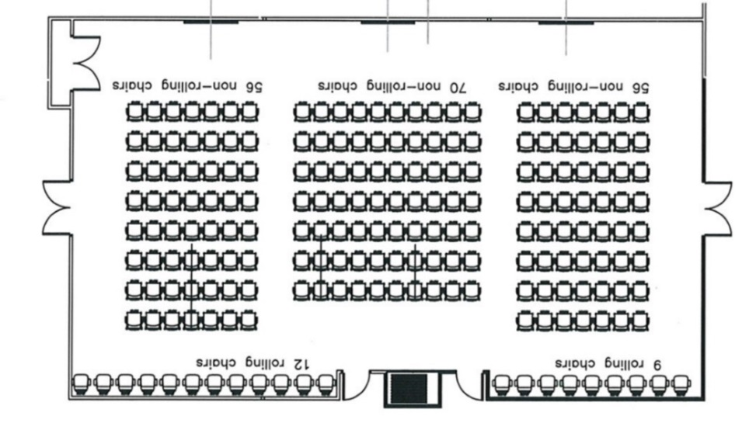Tables are rectangular, 24” wide and 60” long.

*Diagram portrays entire Valley Conference Center set in theater which is the maximum seating arrangement.*

## Features

* This conference room can be divided as two independent rooms, or as a single room with all 3 screens. San Joaquin Valley will have two screens and Sacramento Valley will have one screen.
* Rolling podium provided for each room.
* **Video**: 3 90” monitors, mounted on south wall which can be split between sub-rooms or all screens display the same image.
* **Audio**:
  + 8 channel audio system
  + 3 hand-held microphones
  + 3 lapel microphones
  + Ceiling mounted speakers
  + Ability for two phone lines to be mixed into built-in audio system
* **Controls**:
  + 2 touch panels (one in each room) with pre-set configurations (A,B,C, etc.)
  + 8 floor mounted access points for power/data
  + 3 floor mounted access points for HDMI feed to monitors
  + 3 podium positions, with floor access points
  + Access for 3rd party connection to audio system (XLR)

**Coast Room**

*Seating for 16-18*

*Asymmetrical conference room on first floor on the south side of the building*

Fixed, oval table with access to outside, covered patio which is reserved with this room.

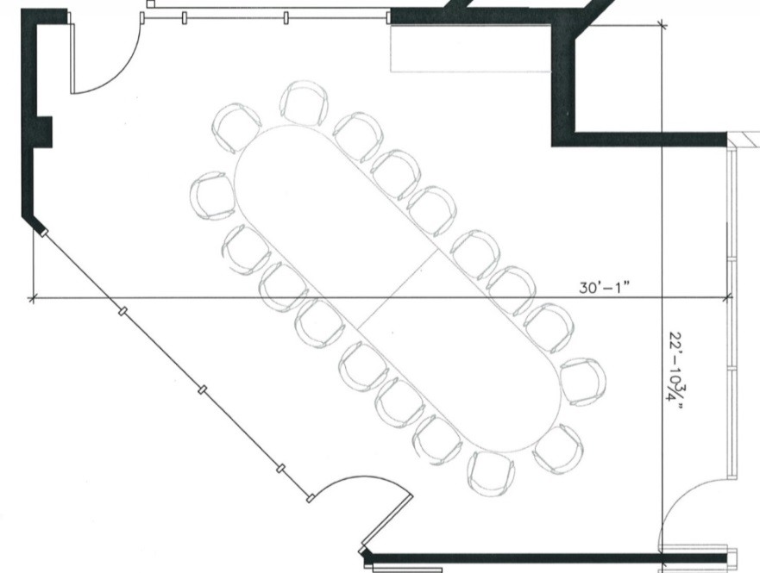

## Features:

* 70” touch-screen monitor on south wall- mounted on articulating (moveable) arm
* Computer is attached to the monitor
* Physical control panel mounted on wall
* Access port panel below television (plug in laptops, etc.)
* Access to file-server from room
* Videoconferencing

**Bay Room**

*Seating for 8*

*First floor on the south side of the building*

Meeting room with fixed, oval table with access to outside, covered patio which is reserved with this room.

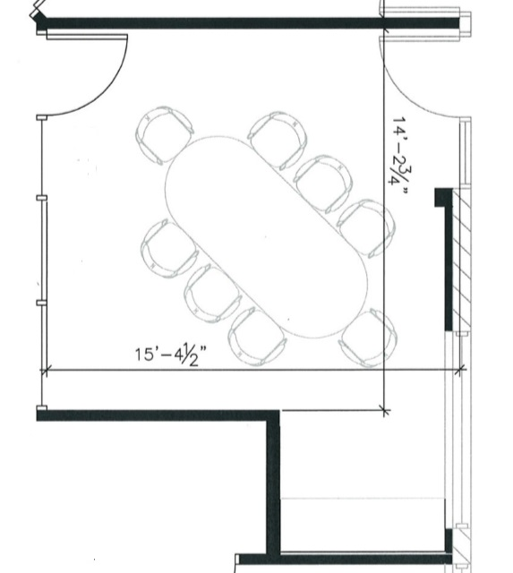

## Features

* 55” touch-screen monitor on North wall- mounted on non-moving arm
* Computer is built into the monitor
* Physical control panel mounted on wall
* Access port panel below television (plug in laptops, etc.)
* Access to file-server from room
* Videoconferencing

## Notes

Non-articulating arm is used because this monitor will be directly in the walking path through room.

**Sierra Room**

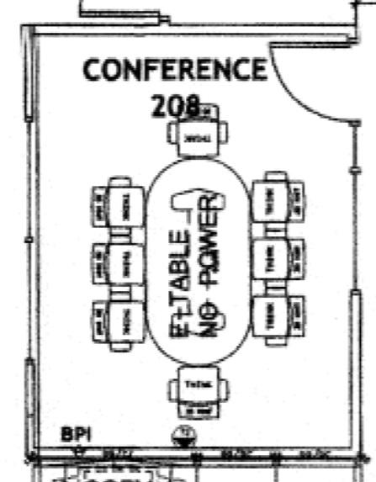*Seating for 8*

Fixed, oval table in the south side.

## Features

* 55” touch-screen monitor on East wall – non-articulating arm
* Computer is part of monitor
* Physical control panel mounted on wall
* Access port panel below television (plug in laptops, etc)
* Access to file-server from room
* Videoconferencing
* Apple TV + iPad – display tablet on monitor
* Monitor/computer also acts as a white-board

**Modoc Room**

*Seating for 4*

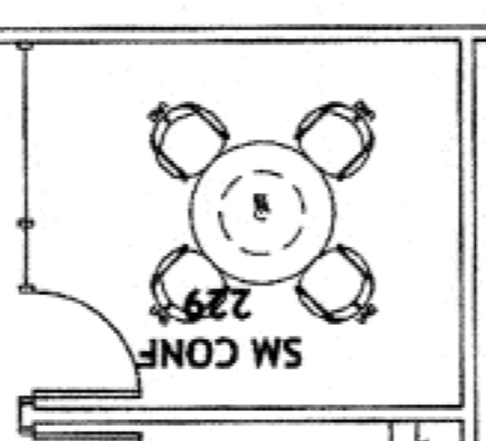Fixed, round table in the northwest corner. No audiovisual installed in this room. White board is installed in this room.

**Additional Space**

**Workroom Table Space (Klamath)**

Referenced as “ANR-Workroom Table 1” and ANR-Workroom Table 2” on the Outlook reservation system.

Two tables in the center of the room can be reserved for projects requiring space to assemble. It is located on the second floor on the southeast side of the building. This is also one of the file storage rooms, so the files will be accessible to others during reserved periods.

**Quiet Rooms and Offices**

The following rooms are available on a drop-in basis. They cannot be reserved in advance.

***Mojave (Room 160):*** Quiet room meeting space with a fixed, round table for 4 people located on the first floor on the northwest side of the building.

***Colorado (Room 161):*** Quiet room meeting space with a fixed, round table for 4 people located on the first floor on the northwest side of the building.

**Room 129:** Office with two rectangular tables with 4 chairs located opposite the center stairwell. Flexible seating which can be moved about.

**Room 180:** Office with two rectangular tables with 4 chairs located opposite the center stairwell. Flexible seating which can be moved about.