Stanislaus County 4-H Poultry Showmanship
Level 1 & 2

Showmanship Procedures:
Step 1. Holding and carrying your bird.
Participants in the class carry their birds to the position designated for them in the judging arena. They should remain at this position holding their bird until they receive instructions. The judge will ask each member to make a complete examination of his/her bird. During this phase of the competition, members will be scored on personal appearance and the techniques displayed while holding, carrying, and examining their bird.
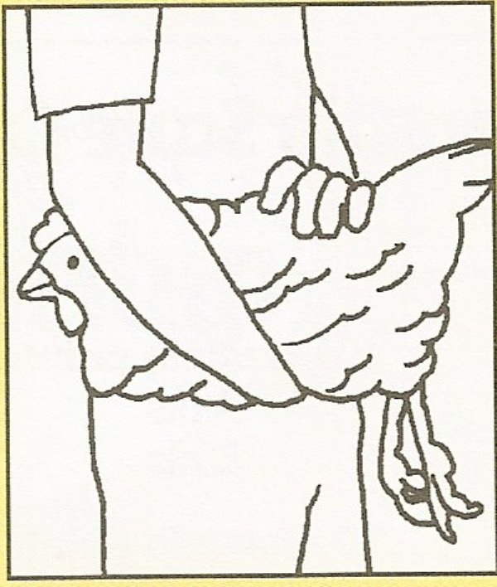
- Carrying the bird: Bird kept balanced and upright on the palm of the hand with head between the arm and body or if small against the carrier’s body. The other hand rests on the bird’s back.
- Holding your bird. Your bird should be held upright in front of you for the judge to have a good side view of the body. The bird should rest comfortably on the palm of the holder’s hand. The strengths of the bird should be emphasized: tails fluffed, head and beak raise, feathers smoothed, and wings tucked in a normal position.
Step 2: Posing your bird.
Bird shown on table in alert position with tail fluffed, head and beak raised., feathers smooth, wings in normal position. Strive to show the bird’s strongest characteristics. Maintain control of the bird at all times.

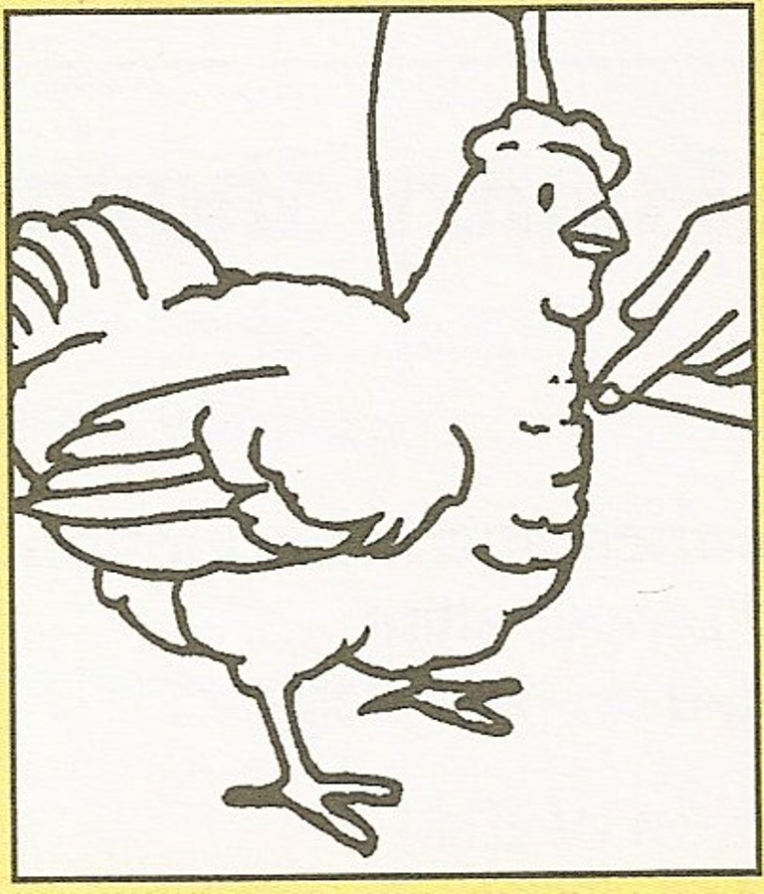

Step 3: Examining your bird
- Examining head: Raise bird to shoulder height. Turn bird so that head and face can be examined. The hand supporting the bird should remain in place, while the free had moves the head. Complete the examination by turning the bird to examine the other side of the head and face. Always wait for the judge to acknowledge you before moving onto the next step.

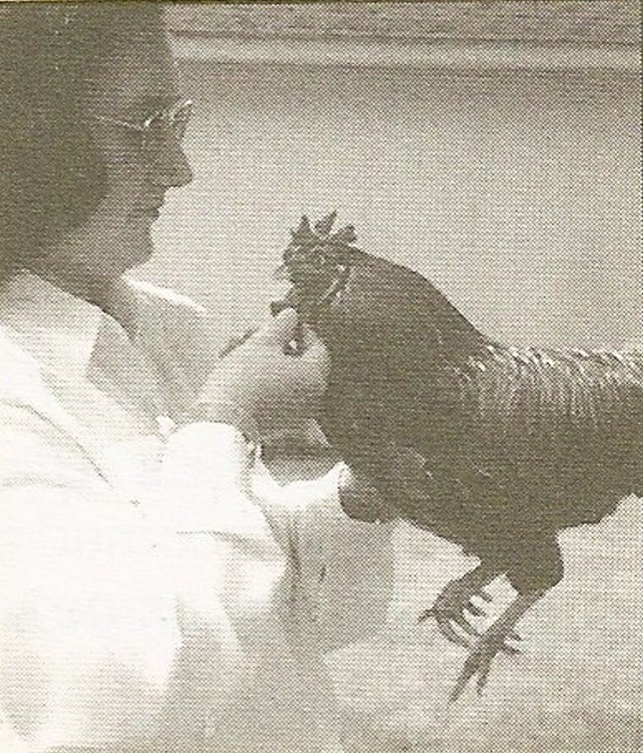

- Examining wings:
Spread wings to examine condition and pattern of feathers. To extend the first wing grasp wing tip with free hand and pull. To examine second wing place free hand across body of the bird and apply pressure to last wing joint with thumb and fingers of free hand to extend the wing. Always showing the judge the step you are performing.

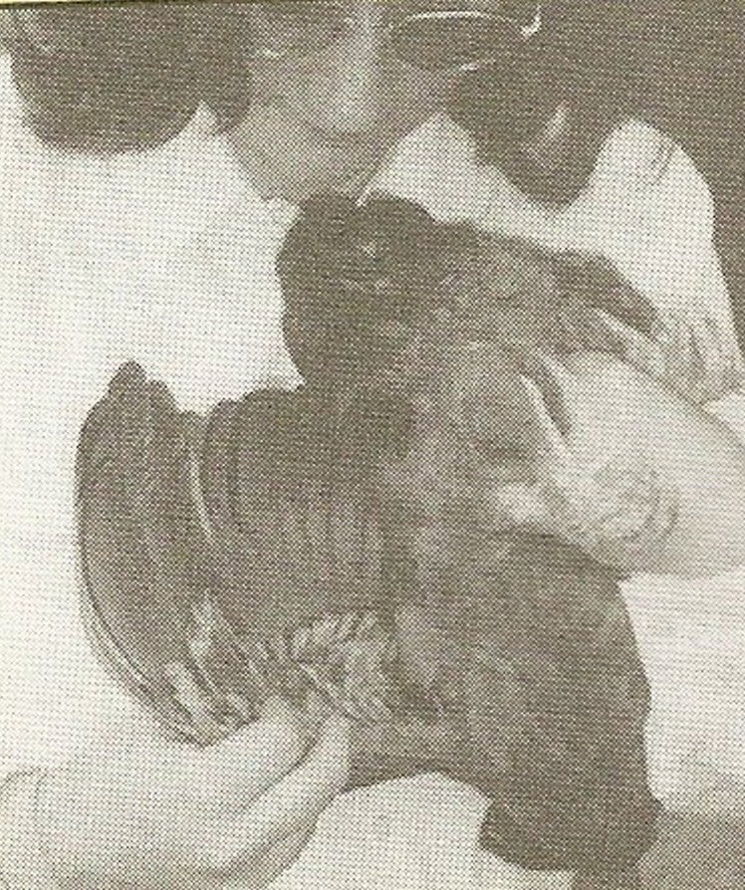

- Examining Undercolor:
The undercolor of both the back and body of the bird should be examined. Using finger tips gently pull tops of feathers “against the grain” This action exposes portions of feathers normally hidden from view. Make sure your judge has seen you doing this step.

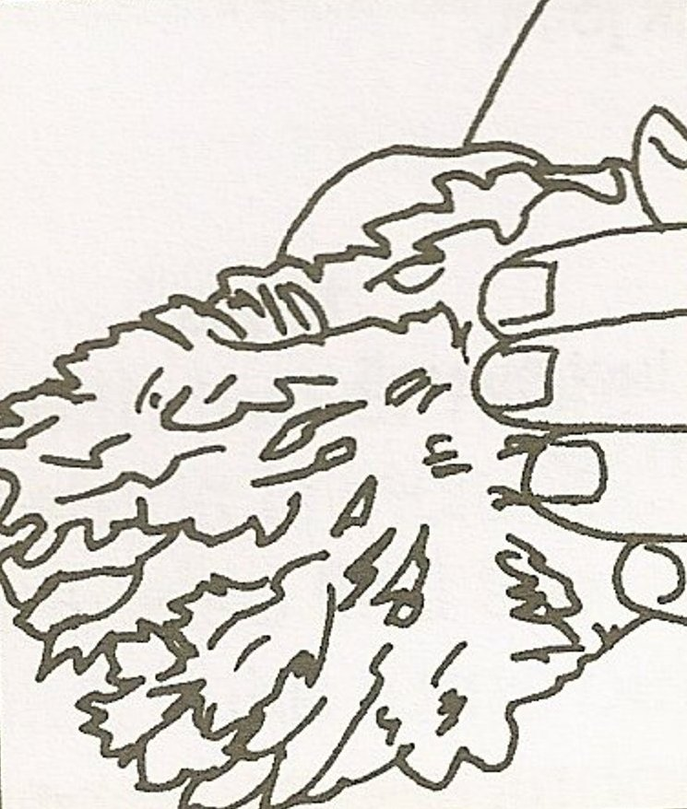

- Showing width of body
Using your thumb and index finger of free hand placed across the bird’s body directly behind the base of the wings to determine width and shape of the body. Show the judge the width of body using your fingers.

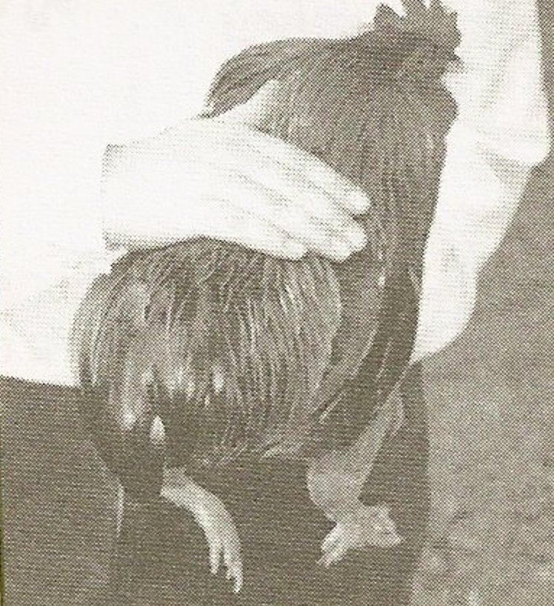

- Checking the breast
Bird’s head held downward with its back against showperson. Free hand used to measures breast bone and examine the keel for straightness, breast blisters, indentations or other defects. Make sure your judge has seen this step before moving onto the next step.

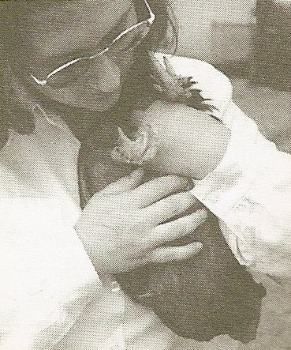

- Vent:
To examine the vent area, tilt the bird forward so that the abdomen can be observed easily. Using the thumb and fingers of the free hand, expose the vent and note its color, moistness and pliability.

- Depth of abdomen:
After examining the vent, measures the depth of the abdomen by placing as many fingers of the free hand as possible between the tip of the keel and the pubic bones.
- Pubic bones:
The width between the pubic bones is determined by placing as many fingers of the free hand as possible between the tips of these bones.
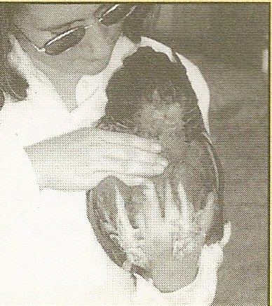

- Examining the feet and legs:
To examine the feet and legs, the bird is held against the showperson’s body. The free hand should be used to manipulate feet and legs so that all parts can be examined. Swivel the bird to examine the front of the feet and legs. Making sure the judge has seen the legs and feet.

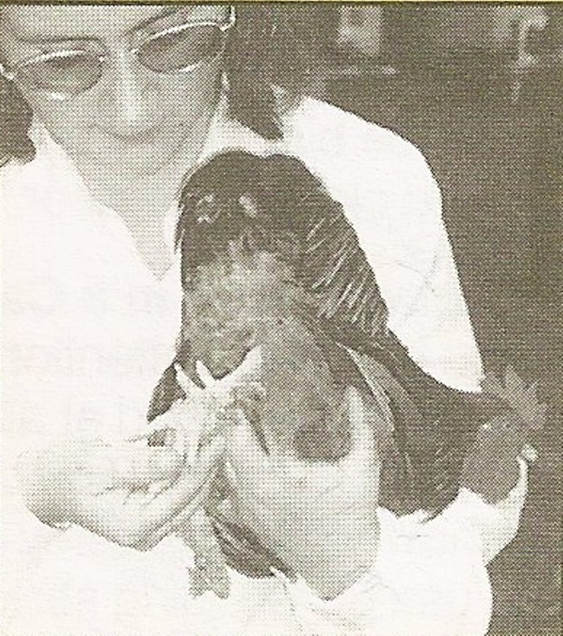

- Posing and walking your bird:
Gently place the bird on the table so that the judge can observe the side of the bird. Straighten the feathers and place the head and tail in the natural position. Strive to show the bird’s strongest characteristics. Maintain control of the bird at all times. Always watching your judge, when your judge tells you walk your bird to the end of the table waiting for the judge to tell you when to turn your bird and walk it back.

- Cooping and un-cooping your bird:
Place your bird in a coop by putting it in head first releasing your bird gently and posing your bird shut coop door and lock it. Putting your hands behind your back, step away from the coop and wait for your judge to instruct you to un-coop your bird. Once you judge has instructed you to un-coop your bird. You remove your bird by reaching across bird’s back, grasp far wing and turn bird so that it faces cage door. Slide second hand beneath bird’s body, placing one or more fingers between bird’s legs and grasping them so that the bird, when lifted, can be balanced on the palm of that hand. Place first hand on bird’s back. Remove bird from cage, head first, closing door of cage and latching once the bird has been removed. Wait for the judge’s instruction.

