Swine
TEST # ___________
SCORE: __________
Swine – Level II 2009
Level 2
CONFIRMATION TRAITS
Circle the correct answer on these 5 multiple choice questions.
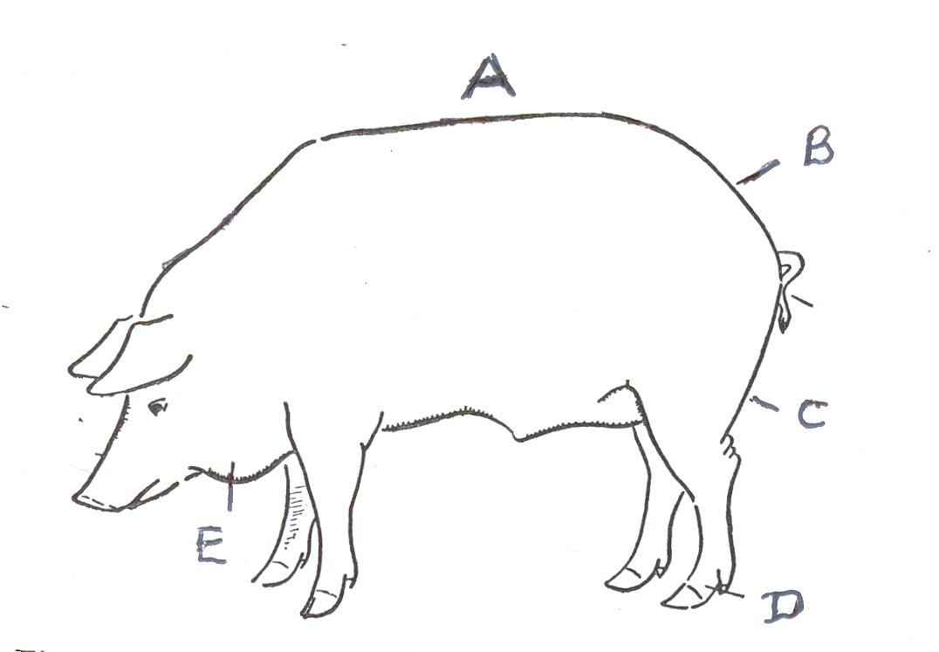

1. In the drawing above, which letter shows the lack of arch over
the top ?

A. B. C. D. E.

2. In the drawing above, which letter shows the weak pasterns?

A. B. C. D. E.

3. In the drawing above, which letter shows a heavy jowl?

A. B. C. D. E.

4. In the drawing above, which letter shows a steep rump?

A. B. C. D. E.

5. In the drawing above, which letter shows the shallow ham?

A. B. C. D. E.

