Test # ________

Score_________
Beef Test Level 3 2016

PARTS OF THE ANIMAL

Beef Level 3
Name_________________ Club_________________

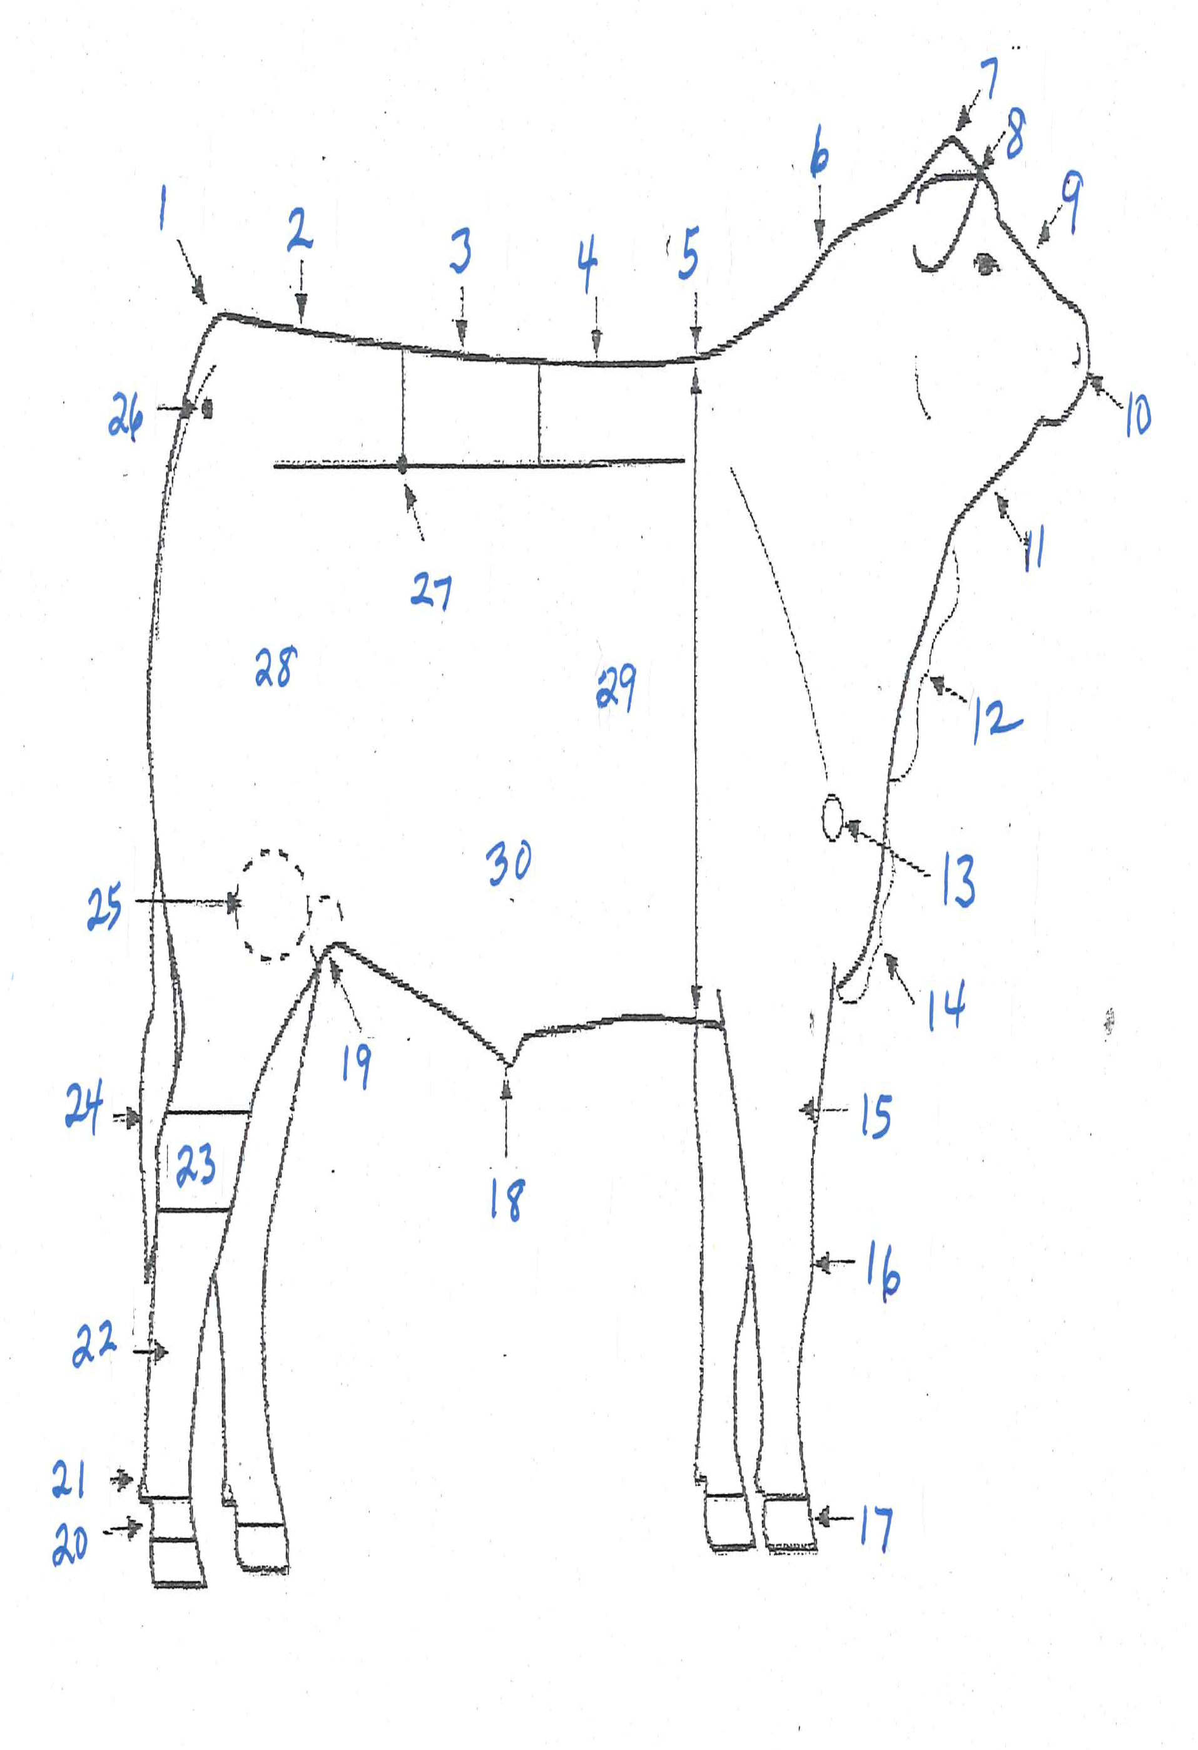
Put the number next to the name. Identify as many as you can. You will not be penalized for incorrect answers. Level 3 score 25 parts.

- _________________________
- _________________________
- _________________________
- _________________________
- _________________________
- _________________________
- _________________________
- _________________________
- _________________________
- _________________________
- _________________________
- _________________________
- _________________________
- _________________________
- _________________________
- _________________________
- _________________________
- _________________________
- _________________________
- _________________________
- _________________________
- _________________________
- _________________________
- _________________________
- _________________________
- _________________________
- _________________________
- _________________________
- _________________________

30. _________________________

