4-H Stanislaus County Favorite Foods Day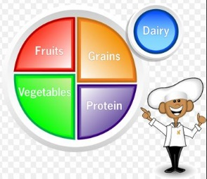
Entry Form
Event Date: Saturday, February 24, 2018
Check in 8:45-9:15 a.m. Judging starts promptly at 9:30 a.m.
People’s Choice tasting & Awards immediately after

Entry Form due in 4-H office by February 16, 2018

Notes: *Limited to ONE entry per member.
*Participants are NOT required to be in a Food Project.

Division: Check ONLY One (age on December 31, 2017)

____ Primary Member (5-8 years old: not competitive) ____ Junior (9-10 years old)

____ Intermediate (11-13 years old) ____ Senior (14-19 years old)

Name: _____________________________________ Club: _________________________________

Grade: _____ Age on December 31, 2017: _______ Phone #: ______________________________

Address: ____________________________________________ City: _________________________

Zip: _____________ Email: _________________________________________________________

Name of Dessert: ____________________________________________________________________

**Please be sure to read the Information & Rules Handout manual concerning Favorite Foods Day for more information and requirements about food safety and handling, table setting etiquette, meal planning,
and tips on the questions that the judges may ask.

Want to Volunteer to help out?

__ Set Up __ Clean Up

===================================================================
Entry forms due no later than February 16, 2018 by 4:15 p.m. at the County 4-H Office, Ag Center.
3800 Cornucopia Way, Suite A, Modesto CA 95358 ~ Phone: (209) 525-6801
Forms may be mailed, emailed, or delivered in person.
Late or incomplete forms will not be accepted.

