4-H Favorite Foods Day Information

**February 24, 2018**

**Entry Forms Due: February 16, 2018**

**Sign In/Set Up 8:45-9:15am**

**Judging 9:30am**

**People’s Choice & Awards to follow**

**What is Favorite Foods Day?**

Favorite Foods Day is an annual 4-H event open to all Stanislaus County 4-H Youth. The member does not have to be enrolled in a Food Project to participate in this event. Favorite Foods Day includes favorite dessert presentations, judging, and a People’s Choice contest that takes place during this one-day county event.

**Reasons to participate in Favorite Foods Day:**

1. This event is a “LEARN BY DOING” competition.
2. A member will actively participate in a fun experience involving food nutrition, cooking, etiquette, and table decorating.
3. A member improves basic skills in food preparation, safety, planning, and display.
4. This event encourages a member to be original and creative.
5. A member will develop leadership talents and self-confidence.
6. A member will gain showmanship experience and nutritional knowledge.

**What do you need to do?**

1. Select a theme or an occasion and choose your favorite dessert recipe to match the theme.
2. Turn in an entry form before due date.
3. Review the [Favorite Foods Day Handout](http://ucanr.edu/sites/Stanislaus4-H/files/187686.docx), which contains guidelines on food safety and table setting etiquette, so you will have all the information you need to be successful.
4. Plan a healthful menu that is appropriate for your theme. Write or print your menu.
5. Gather items for your table setting that shows your theme.
6. Be prepared to answer questions based on your level of expertise. Expect to be judged against a set of criteria including appearance, presentation, and knowledge.
7. Make your dessert at home and prepare your recipe card.
8. Practice your set up, introduction, and answers to questions. Get feedback from your family.
9. Get a good night’s sleep and eat a nutritious breakfast before the event.
10. Bring your dessert, dessert recipe card, menu, and table setting on Favorite Foods Day and set it all up on your own.
11. Tell the judge about your dessert and theme. Answer the judges’ questions based on your division level.
12. Participate in the People’s Choice tasting contest and enjoy sampling all the entries.
13. Just have fun doing everything!

**Age Divisions:**

There are four divisions so that a member can compete with others in the same age range or experience level. The divisions are based on your age as of **December 31, 2017**. Judging is done independently.

**Primary Members:** 5-8 years (Non-Competitive)

**Junior:** 9-10 Years

**Intermediate:** 11-13 Years

**Senior:** 14 and Up.

**Rules:**

* + 1. Participant does not have to be a part of a Food Project to enter.
    2. Dessert Recipe must be suited to the age of the member. Older members will be expected to prepare a more challenging dessert.
    3. Participant must do all the dessert preparation and cooking himself or herself, with age appropriate supervision as needed.
    4. Recipe should serve up to 4-8 people.
    5. Participant is only allowed to enter one dessert.
    6. Finished dessert will be displayed at a place setting for one person:
       1. Space provided is 24 inches wide by 18 inches deep.
       2. Dishes, glasses, flatware, decorations, etc. should fit your theme. These can be items you already have available, borrowed items, goodwill shopping, or low cost shopping. (**Going to buy expensive silverware and plates defeats the purpose of creativity for this event**.)
       3. At the event, no further food prep other than final assembly shall take place. Entry should be ready when you arrive.
       4. Participant must set up the dessert and table setting himself or herself.
       5. Primary Members are only required to set a place setting for the Dessert.
    7. This is a showmanship event. 4-H uniform or theme related outfit is encouraged but not required. Competitor should dress neat and clean and **long hair should be pulled back** as a health consideration.
    8. Participant should be prepared to answer questions from the judges about how his or her dessert recipe was prepared, how his or her menu was selected, what food group each dish belongs in, and other questions.
    9. Parents, leaders, and others guests and members will not be allowed in the judging area at any time during the judging or tallying.
    10. Parents and other members will be allowed to see the table settings after the judging has finished. Parents and others should not assist participants with setting up their display.
    11. Bring some dessert to be placed in the People's Choice Award tasting contest.

All participants must exercise safety when handling and preparing food. We never want to serve food that contains harmful bacteria or other germs. Always wash your hands and utensils when cooking and serving food. You should not prep, cook, or serve food to others when you are feeling ill. Refer to the guidelines below under Food Safety.

Awards are based off the Danish System, which allows for each participant to be judged independently against set criteria. Primary Members will receive participation awards.

All judging results and awards are final and based on the participant’s presentation and display at the time of judging.

**Menu Selection:**

1. The menu selection should be well balanced nutritionally. You can refer to the USDA Recommended Daily allowances at MyPlate.gov.

<http://www.choosemyplate.gov/food-groups/>

2. Select a dessert for the menu that is easy to transport and will retain its attractive appearance.

Be sure to consider whether or not your dessert needs refrigeration or freezing. (You will need to provide your own ice chest or cooler, as these items will not be available.)

3. The entire menu should be comprised of items that you could prepare on your own. The judge may ask you to describe how you would prepare any item on the menu.

4. Your menu should have a theme. Themes can be ethnic, festive, holiday, sports, hobby, popular TV show, special occasion, etc.

**Basic Menu Pattern Example:**

Appetizer

Salad

Main Course

Starchy Vegetables Other Vegetables

Bread

Dessert

Beverage

This pattern can be followed for all meals. However, you may leave certain parts out that do not fit your theme. For example, you would not necessarily be served salad for breakfast. **Alcoholic beverages are not appropriate on a 4-H Menu**.

**Writing Your Menu:**

Dishes on the menu should be listed in the order in which they are served. Menus should be handwritten or printed in an attractive appearance. Capitalize all words except articles and prepositions like “and”, “of”, and “with”. You can decorate your menu however you like and it must be a part of your table setting. You can reflect your theme with your menu. Titles before the menu are optional.

Designate your favorite food in parenthesis on your menu. Example: (Favorite Food)

**Sample Menu for a Spring Wedding Theme:**

Fresh Fruit Slices

Cesar Salad

Baked Chicken with Herbs

Steamed Broccoli

French Bread with Butter

**Bread Pudding (Favorite Food)**

Lemonade

**Dessert Recipe Selection:**

Use scratch ingredients instead of using a prepared mix unless you transform the mix into something unique. Rather than using just a basic recipe, consider using a recipe that involves a unique ingredient, imaginative garnish, or a unique way of preparing the recipe. For example, add a different flavor extract or chopped nuts into a basic cake recipe. Be prepared to tell the judges what you learned.

**Preparing the Dessert Recipe Card:**

1. It should be clear, accurate, and simple.
2. List all the ingredients in the order of use.
3. Give exact measurements in easiest form. For example, ¼ cup and not 4 tablespoons.
4. Try not to abbreviate.
5. Use weight for fluid measurements like for canned foods. For example, 12 ounces of pineapple juice, not one can of pineapple juice.
6. Use clear, short, descriptive sentences.
7. Give exact words that describe like foamy, glossy, and thick.
8. Give specific pan sizes.
9. Give an example on how to test if dessert is ready, if possible. For example, “stick a toothpick into cake and expect it to come out clean”.
10. Include baking temperature and time.
11. Give total number of serving size.
12. Dessert Recipe Card must be exhibited for judges to review. It should be typed or printed legibly on a 3x5 or 5x8 card or 8 ½x11 printer paper. **2 copies must be provided to the judges.** Include the name of dessert on your card. On the back, include name, age, and club.

**Sample Recipe Card:**

**Lemon Raspberry Pound Cake**

**Serves 10**

**Ingredients:**

2 ¼ cups cake flour, sifted

1 teaspoon baking powder

½ teaspoon baking soda

½ table salt

5 tablespoons unsalted butter, softened

1 cup sugar

1 large egg

2 large egg whites

1 teaspoon vanilla extract

1 teaspoon lemon zest, finely grated

1 cup fat-free vanilla yogurt

**Directions:** Preheat oven to 350F. Coat a 6-cup tube pan or Bundt pan with cooking spray. Sift together flour, baking powder, baking soda, and table salt; set aside.

In a large mixing bowl, beat butter until creamy; gradually beat in sugar, about 2-3 minutes until mixture is light in color. Gradually beat in egg, egg whites, extract, and lemon zest.

Beat in flour mixture and yogurt, alternating each, beginning and ending with flour mixture. Fold in raspberries. Pour batter into prepared pan and bake until a wooden toothpick inserted near the center comes out clean, about 30-40 minutes.

Cool in pan, on rack, for 10 minutes. Slide a thin knife around the edges of cake to loosen, invert pan onto rack, and cool completely. Slice into pieces and serve.

**Preparing the Table Space:**

**You will be preparing an individual table setting. Your provided space will be 24 inches wide by 18 inches deep**. Primary Members need only place a setting for Dessert with a Beverage.

**The Table Cover**

The table covering is the background for your food and table items placed on it. It protects the table and makes for less noise.

1. Participant should prepare only one table setting with a table cover.
2. Participant must use only 24 inches wide x 18 inches deep for the table cover.
3. Tablecloths, placemats, or fabric may be used for table cover. It should be clean and wrinkle free. Also, be creative! For example, using a beach towel or bamboo for a beach theme.
4. Choose table cover and arrangements that are appropriate for the theme of your menu. You may match or blend colors and textures in the dishes or use something quite different for contrast. A spring theme might use a green or flowered pattern cloth with a straw placement and matching or contrasting dinnerware.

**Place Setting**

1. Put the plate in the center of the cover, 1 inch from the edge of the table.
2. Place the knives and spoons on the right side of the plate, the forks on the left. Both should be 1 inch away from the plate and 1 inch away from the edge of the table. For the knife, turn the cutting edge towards the plate. If there will be more than one silverware used, the one that will be used first is placed outside the other one.
3. The napkins are usually folded into oblongs and placed next to the forks. The fold of the oblong should be to the left so it opens like a book. Or the napkin can be placed in the glass or have a napkin ring.
4. Beverage glass is placed 1 inch above the tip of the knife.
5. If coffee or tea is served, the cup is placed on the saucer and set to the right of the spoon, 1 inch away from the edge of the table.
6. Salad and dessert bowls may be placed left of the forks and napkins or at the tip of the fork.
7. **Do not include serving dish like the cake dish or pie pans etc. on the table.** After displaying your single serving on your plate setting, place the remaining dessert on the People's Choice tasting table. Items that need refrigeration may be stored in an ice chest that you provide until time of judging or serving.
8. Small table decorations are optional but the height is limited to 15 inches in height and proportioned to the place setting. **Decorations should not touch the food** unless they are edible like edible flowers or decorated caramel on the plate, etc. Examples of things that should never touch the food are bud vases, floral basket, statue, candles, etc. **Candles should never be lit!**
9. Menu card should be placed at the upper edge, above your place setting.
10. Recipe card should be placed in a visible location within your setting.

**Place Setting Guidelines:**

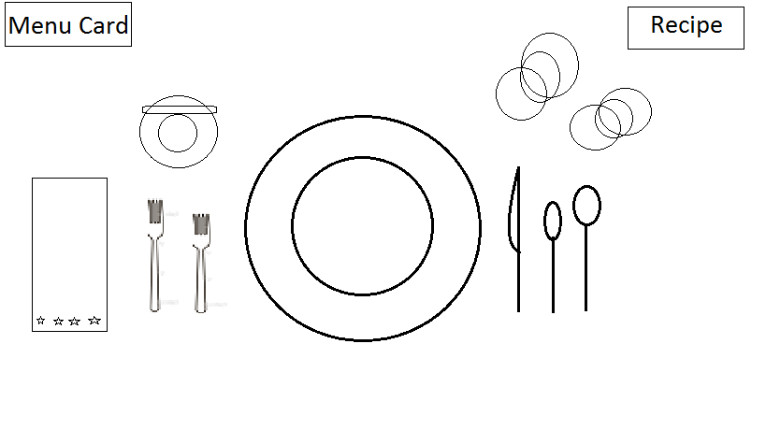**Junior, Intermediate, Senior Divisions**

*From Left to Right:*

Napkin with fold open to the fork, Dinner Fork, Dessert Fork with Bread plate and Butter knife above, Dessert Plate (with a single serving of dessert displayed) on top of Dinner Plate, Dinner knife, Dessert spoon, Soupspoon, with water glass and cider glass above. Menu and Recipe cards should be displayed.

*Dishes and flatware may be adjusted according to your menu. For example, you might have no soup and have a salad so you would eliminate the soupspoon and add a salad fork. Remember the order of the place setting works from the outside in.

**All of your place setting should reference your menu. For example, if you have fruit cocktail, the dishes used for that should be placed in your setting. If you have a coffee cup, you must have tea or hot coffee on your menu.

**Dessert Setting for Primary Members (Clovers)**

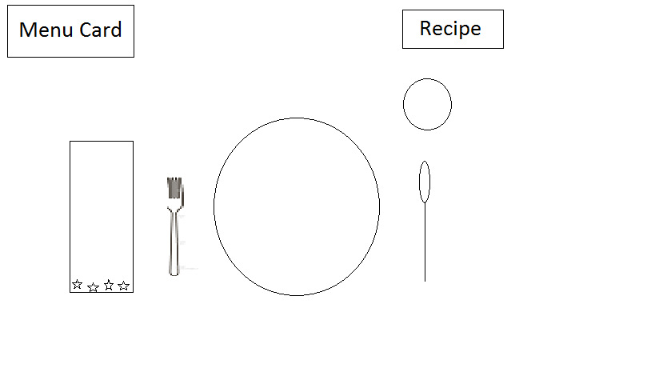Clovers are required to set only for their dessert setting as shown.

*From Left to Right:*

Napkin with fold open to the fork, Dessert Fork, Dessert Plate with single serving of dessert displayed, Dessert spoon, beverage glass above spoon. Menu and Recipe cards should be displayed.

**Food Safety for Favorite Foods Day**

It's very important for ALL 4-H members to follow these rules when preparing exhibits for Favorite Foods Day.

**Keep Hands Clean:** Wash hands and fingernails thoroughly with soap and water before and during food preparation. Members should always wear clean apron/clothes when preparing and serving food.

**Keep Food Clean:** Food can be infected by coughs and sneezes, handling, dirty equipment, animals, and waste. It should be protected during storage, preparation, transporting, and serving.

**Keep Utensils Clean:** In food preparation, do not cross-contaminate. Use a separate utensil for each step in food preparation. After each use, wash the utensil in hot soapy water and rinse. Utensils include cutting boards and any other items or surfaces in contact with the food.

**Keep Foods at the Right Temperature:** Cold temperatures (40 °F or below) stop germs from growing and enough heat kills them. Cold foods should be kept chilled. Try nesting dishes in bowls of ice or using small serving trays, and replacing them often. Hot foods should be kept hot (140 °F or above). Try chafing dishes, slow cookers, or warming trays. Never leave prepared food standing at room temperature longer than 1-2 hours.

**Members Preparing Food Should Be Healthy:** Diseases may be passed to others in food. People with infected wounds, sore throats, and nose infections, should not prepare food or handle foods.

**Transport Food Safely:** *(See Categories below)* All foods that meet Category 2 or 3 must be kept HOT (140 °F or above) or COLD (40 °F or below) at all times. If left at room temperature for longer than 2 hours (1 hour if temp is above 90 °F), the food must be re-heated to an internal temperature of 165 °F or disposed of.

Use insulated containers to transport cold foods; add ice packs. Wrap hot food in towels and newspaper or place in insulated container and keep there until judging begins. If your food has not been at the correct temperature, alert the judges.

**Category 1:** Foods that are almost always safe.

Dry and high sugar foods. You can safely offer breads and rolls, cakes without cream filling, fresh fruit, cookies and crackers, candies, and dried food such as raisins and granola. Prepare food in a clean workspace with clean utensils. Cook foods at proper temperature. Keep dry foods separate from wet foods. Wrap foods for transportation.

**Category 2:** Foods that are sometimes problematic.

Cooked fruit and vegetables. Be cautious with cooked vegetables, fruit salads, green salads, and cheese. Never use the same utensils for preparing meat to prepare these foods. Maintain proper temperature of food during transportation.

**Category 3:** Foods that are potentially hazardous.

All foods of animal origin and cooked starchy foods. Exercise extreme caution with meats, potatoes, cooked rice, custards, puddings, whipped cream. This includes pies and gravies containing these foods. Also desserts containing milk and egg. These foods require separate utensils when prepping and cooking. Cook to proper temperature. Maintain temperature of food during transportation.

**What Is Foodborne Illness?**  
Foodborne illness often presents itself as flu-like symptoms (such as nausea, vomiting, diarrhea, or fever); therefore many people may not recognize that bacteria or other pathogens in food caused the illness.  
  
Thousands of types of bacteria are naturally present in our environment. Not all bacteria cause disease in humans. For example, some bacteria are used beneficially in making cheese and yogurt.  
  
Bacteria that cause disease are called pathogens. When certain pathogens enter the food supply, they can cause foodborne illness. Millions of cases of foodborne illness occur each year. Most cases of foodborne illness can be prevented. Proper cooking or processing of food destroys bacteria.   
  
Age and physical condition place some persons at higher risk than others, no matter what type of bacteria invades our food. Very young children, pregnant women, the elderly, and people with compromised immune systems are at greatest risk from any pathogen. Some persons may become ill after ingesting only a few harmful bacteria; others may remain symptom free after ingesting thousands.  
  
**How Bacteria Get in Food**  
Bacteria may be present on products when you purchase them. Plastic-wrapped boneless chicken breasts and ground meat, for example, were once part of live chickens or cattle. Raw meat, poultry, seafood, and eggs are not sterile. Neither is fresh produce such as lettuce, tomatoes, sprouts, and melons.  
  
Foods, including safely cooked, ready-to-eat foods, can become cross-contaminated with bacteria transferred from raw products, meat juices or other contaminated products, or from food handlers with poor personal hygiene.   
  
**The "Danger Zone"**  
Bacteria multiply rapidly between 40 °F and 140 °F. To keep food out of this "Danger Zone," **keep cold food cold and hot food hot**.

* Store food in the refrigerator (40 °F or below) or freezer (0 °F or below).
* Cook food to a safe minimum internal temperature.
  + Beef, veal, and lamb steaks, roasts, and chops may be cooked to 145 °F.
  + All cuts of pork to 160 °F.
  + Ground beef, veal and lamb to 160 °F.
  + All poultry should reach a safe minimum internal temperature of 165 °F.
* Maintain hot cooked food at 140 °F or above.
* When reheating cooked food, reheat to 165 °F.
* Perishable food should not be left out longer than 1 hour when the temperature is above 90 °F.

**Always start with cleaned and rinsed foods, hands, surfaces, and utensils. Properly cook and prepare foods according to directions to keep yourself and others healthy.

**Judging:**

The Judges will evaluate your table setting display, dessert, recipe, menu, and placement of all utensils. Then the Judges will ask you questions about your theme, dessert, selection of menu items, basic nutrition, and how to properly and safely handle and prepare food. Judges may ask questions like which of your menu items belongs in a particular food group, what is cross-contamination, and what are ways to prevent salmonella.

**What the judges will look for**

**Menu:**

1. Is the menu nutritionally well planned? a variety of meats and vegetables; a variety of preparation, not all vegetables in sauces.

2. Texture contrasts: a variety of crunchy and soft types of food.

3. Color contrasts: color variety makes for interest and nutrition.

4. Flavor contrast: not all spicy or all bland foods; balance of salty, sweet, tangy, and savory food.

5. Food Preparation suitable for age: a menu that you can prepare with only appropriate supervision.

6. Dessert is appropriate for theme and compliments rest of the menu.

7. Menu card is correctly written: neat, clear, following rules and example.

**Dessert Recipe:**

Recipe card is correctly written: ingredients first, then instructions, accurate measurements, and methods. Serving size and cooking instructions given.

**Dessert Preparation:**

1. Eye appeal: does the recipe look good or tempting?

2. Flavor: how does it taste?

3. Texture: is it too hard, too soft, falling apart, too juicy? Or perfect crispness, chewiness?

4. Doneness: overdone, underdone, or properly made?

5. Seasoning: does your recipe have too much or too little seasoning, sugar, salt?

6. Complexity of Preparation: does the recipe fit the ability of the participant? not too easy but reasonably challenging.

**Table Setting:**

1. Neatness.

2. Proper placement of utensils, and all other items in setting.

3. Attractive total effect: do all the utensils and arrangements look attractive when placed together.

4. Appropriate decorations: no arrangements that will fall into food or take away from the food. The food should be the main attraction. Decoration should be suitable for the space provided.

5. Theme is conveyed in entire presentation.

**Your Attitude and Appearance!**

Judges want to see your skills, passion, and confidence! Be sure your appearance, including attire, face and nails, is neat and clean. Remember to have hair out of your face, and, if it is long, pulled back. The judges will ask questions about your entry. Stand up straight, make eye contact, smile, speak loud and clear, and give your best answers. You are the expert on your entry.

**Introduction**

Introduce yourself by giving your name, age, club name, and theme to the judges. Then tell judges about your favorite dessert entry.