Stanislaus County 4-H
Rabbit Proficiency Program
Level 3
____________________________________________________________________________________

Project Leaders must initial and date each item for credit. When the level is completed and signed off, it is to be turned into the County Office .

Name: _______________________________ Year in Project: ________ Age: ______

Club: ________________________________ Project Leader: ___________________

________ 1. Identify all the body parts of a rabbit.

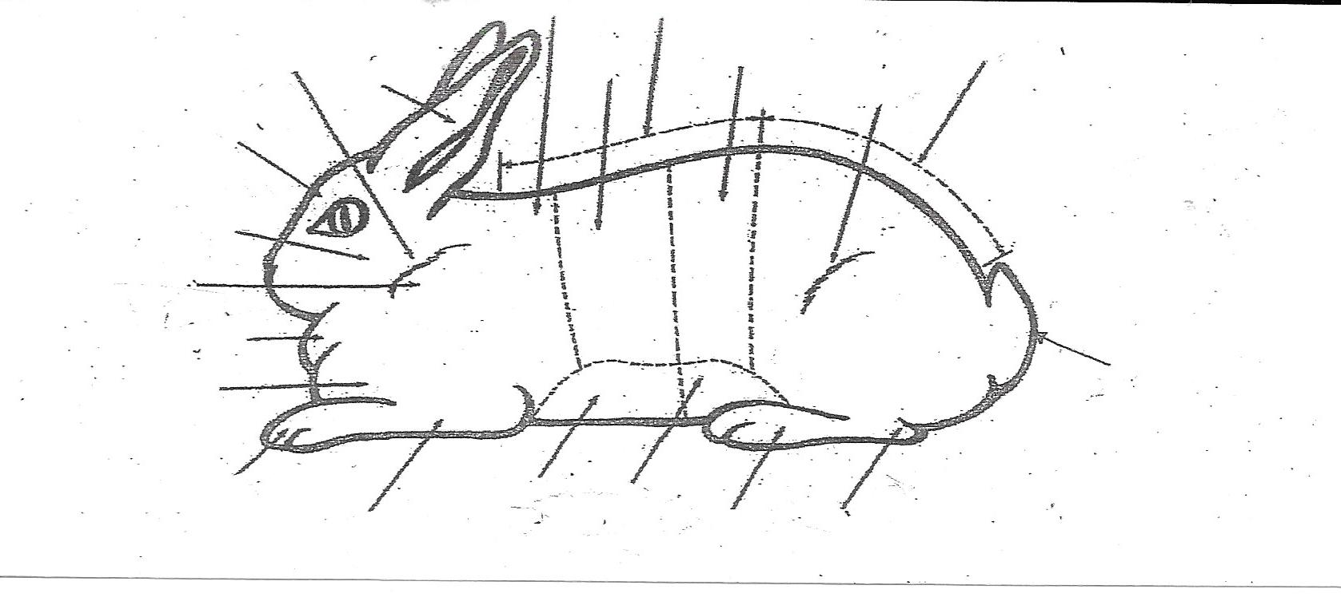

________ 2. Complete one year as a junior or teen leader in the rabbit project.

________ 3. How many rabbits make up a meat pen? What are the minimum and maximum weights for each rabbit in the pen.

________ 4. Explain the difference between a fault and a disqualification. List 5 general faults and disqualifications.

Faults Disqualifications

1. ______________________ 1. ____________________
2. ______________________ 2. ____________________
3. ______________________ 3. ____________________
4. ______________________ 4. ____________________
5. ______________________ 5. ____________________

________ 5. Participate in a rabbit judging contest.
(at Club meeting, skills day or other rabbit activity)

________ 6. Prepare and give a speech or presentation pertaining to the rabbit project
outside your project group.

________ 7. What do the following abbreviations stand for?

BOV _____________________ N/S ____________________
BOSG ____________________ DQ ____________________
RIS ______________________ BOG ___________________
BOSV ____________________ BIS ____________________

________ 8. What are the 4 meat classes; include ages and weights.
1. _________________________________________________
2. _________________________________________________
3. _________________________________________________
4. _________________________________________________

________ 9. Using the following information, complete the attached Fair entry form.
* When entering, remember to use the current year’s Fair dates for your County Fair. (July for Stanislaus County Fair)
A. Enter the showmanship class for your age and division.
B. Enter 1 Satin Buck (DOB 01/12/of previous year)
C. Enter 1 Californian Doe (DOB 05/02/of current year)
D. Enter 1 Holland Lop and 1 Jersey Wooly in Fur Class
E. Enter 1 New Zealand Meat Pen
F. Enter 1 Silver Marten Buck (DOB 1/15/of current year)

Entry Fees
Showmanship $5.00 Fur Classes $2.00 Breed Classes $3.50
Meat Pens $5.00 Single Fryers $3.00

Divisions: Classes:
300: Californian 1: Senior Buck
301: Satin 3: Intermediate Buck
302: New Zealand 5: Junior Buck
303: French Lop
304: Champagne D’Argent 2: Senior Doe
305: Palomino 4: Intermediate Doe
306: American Sable 6: Junior Doe
307: All Other Heavy Weights

Divisions: Classes:
308: Holland Lop 1. Senior Buck
309: Mini Lop 5. Junior Buck
310: Dutch
311: Mini Rex 2. Senior Doe
312: Netherland Dwarf 6: Junior Doe
313: Polish
314: Havana
315: All Other Light Weights

Division 325: Single Fryer
Division 326: Meat Pen of Rabbits

Divisions: Classes:
330: Fur Animals 1: Normal (white and colored)
2: Rex (white and colored)
3: Satin (white and colored)
4. Wool (white and colored)
Showmanship:
Division 400: Novice Showmanship (9 and 10 years old)
Division 401: Intermediate Showmanship (11-13 years old)
Division 402: Advanced Showmanship (14 and older)

________ 10. Identify and describe 10 ARBA recognized rabbit breeds.
BREED BODY TYPE FUR CLASS
(4 or 6)

1.__________________________________________________________
2.__________________________________________________________
3.__________________________________________________________
4.__________________________________________________________
5.__________________________________________________________
6.__________________________________________________________
7.__________________________________________________________
8.__________________________________________________________
9.__________________________________________________________
` 10.__________________________________________________________

________ 11. How old should a meat pen of rabbits be at the time it is exhibited?
___________________

________ 12. Name three breeds of rabbit that allow the exhibit of pre-junior rabbits.
1. _____________________ 2. _____________________
3. _____________________

________ 13. What is the term used for a hair shaft that has 3 or more color bands with a definite break between color. ___________________

________ 14. List 5 breeds of rabbit that would be ideal to use as meat pen or fryer rabbits for your Fair.
1. _________________________ 2. ______________________
3. _________________________ 4. ______________________
5. _________________________
________ 15. A rabbit has a total of _______ teeth.
____ Incisors ____ Upper Cheek Teeth ____ Lower Cheek Teeth
(molars and premolars) (molars and premolars)

________ 16. Explain how to select a meat pen of rabbits.

________ 17. What does ARBA stand for and what are the benefits of being a member.

________ 18. Have an organized binder with resource information, breeder contacts, equipment and supply contacts, your rabbit pedigrees and any other information that will assist you in advancing your knowledge of the rabbit project.

By signing below I am agreeing that each of these items has been
completed, therefore completing Level 3 in Rabbit Proficiency.

________________________________ _________________________________
4-H Member Signature Project Leader Signature

________________________________ _________________________________
Parents Signature Date Completed

