Stanislaus County 4-H
Rabbit Proficiency Program
Level 4
____________________________________________________________________________________

Project Leaders must initial and date each item for credit. When the level is completed and signed off, it is to be turned into the County Office .

Name: _______________________________ Year in Project: ________ Age: ______

Club: ________________________________ Project Leader: ___________________

________ 1. Describe two commercial processes related to rabbits in detail.
(for example, how to dress out a meat rabbit; how to tan a hide;
how to process wool; laboratory uses)

________ 2. Match each word with the correct definition.

_____ Wry Neck _____ Moon Eye _____Sore Hocks
_____ Smut _____ Racy _____ Pneumonia
_____ Cannibalism _____ Pigeon Breast _____ Peg Teeth
_____ Pedigree _____ Blemish _____ Guard Hair
_____ Hernia _____ Mastitis _____ Molt
_____ Loin _____ Lactate _____ Dewclaw
_____ Condition _____ Gestation _____Vent Disease

a. An extra, functionless digit on the inside of the front leg.
b. To produce milk.
c. Slim, trim, alert and Hare like in appearance.
d. The genealogy of the male and female ancestors, showing
date of birth, parents, grandparents and great grandparents
as well as color, variety, weight and registration numbers.
e. Any defect or fault that distracts from the appearance of the rabbit.
f. The portion of the back on each side of the vertebrae, from last rib
to hip joint.
g. A protrusion of an organ or part of an organ (or intestine) through
the connective tissue or the wall of a cavity which is normally enclosed.
h. A dark sooty appearing surface color found on the usable portion of
the fur of a rabbit. Usually appearing in pointed patterned rabbits.
i. An ulceration of the foot pad; either front or hind feet.
j. The longer, coarser protruding hair of the coat.
k. An inflammation of the mammary gland.
l. Difficulty breathing, due to infection
m. A milky film over the surface of the cornea.
n. When a doe removes appendages, or consumes the entire kit.
o. The length of time between conception and birth.
p. The overall physical state of a rabbit.
q. A narrow chest with a protruding “v” shaped breast bone.
r. The small residual incisors behind the normal top incisors.
s. A venereal disease in rabbits, affecting both the bucks and does.
t. The carriage of the head at an angular plane.
u. The act of shedding or changing fur coats.

________ 3. You enter the area that your rabbits are housed, and you hear and then see a rabbit sneezing and coughing, you notice mucus coming out of the rabbits nose, what do you do next.

________ 4. Identify and label the parts of the digestive system.

Colon Functional Caecum Stomach Salivary Glands
Liver Small Intestines Esophagus Caecal Appendix
Pancreas Rectum Anus

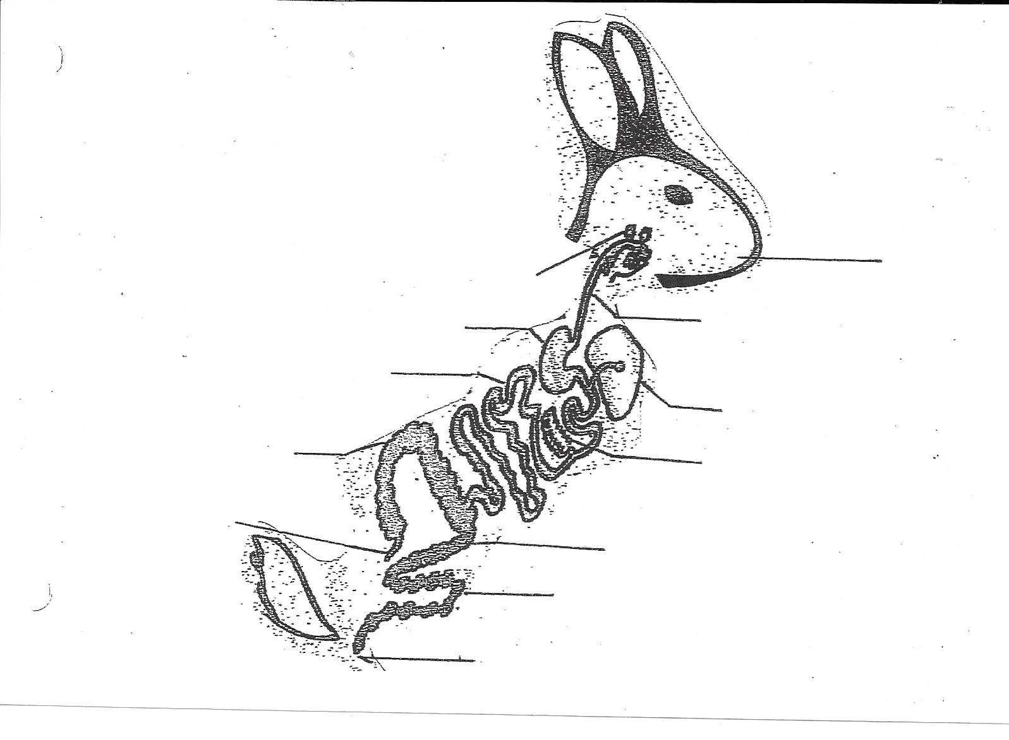

________ 5. What is “coprophagy” and how does it benefit a rabbit.

________ 6. What is the difference between genotype and phenotype?

________ 7. Using the proper terminology, explain a breeding program, including how
to choose a mate, gestation and any equipment needed to carry out the project.

________ 8. Explain the development of a rabbit from birth to adulthood.
Include the care of the rabbit through each stage of life as well as the care of the nursing doe until weaning.

________ 9. Explain how to clean and sanitize a cage and a nest box. How often should this be done?

________ 10. An intermixing of two colors of fur on a rabbit, without a definite pattern is called _________________.

________ 11. Give the symptoms of the following conditions, and the treatment.
Sore Hock:______________________________________________
______________________________________________
Ear Mites: ______________________________________________
______________________________________________
Conjunctivitis: ___________________________________________
______________________________________________
Vent Disease: ___________________________________________
______________________________________________
Snuffles: _______________________________________________
______________________________________________
Abscess: _______________________________________________
_______________________________________________
Malocclusion: ___________________________________________
_______________________________________________
Mastitis: _______________________________________________
_______________________________________________

________ 12 . Describe the nutrient requirements and feeding program as it relates to
breeding rabbits, show rabbits and meat pen rabbits.

________ 13. Plan, organize and carry out a project meeting or event for your rabbit project group or another Clubs project group. (explain what you did)

_______ 14. Does are “polyestrous”. Explain.

________ 15. When breeding you take the;
____ buck to the doe cage
____ doe to the buck cage

Why?

________ 17. You are raising a large breed meat rabbit, and you are unhappy with the fullness of the hindquarter. You decide to cross breed to another breed of rabbit to improve your stock. Explain which two breeds you might use; how you would choose your breeding stock; how you would select stock to continue breeding and how many generations it will take to complete your project.

By signing below I am agreeing that each of these items has been
completed, therefore completing Level 4 in Rabbit Proficiency.

________________________________ _________________________________
4-H Member Signature Project Leader Signature

________________________________ _________________________________
Parents Signature Date Completed

