Creating a Resilient California through a Community Resilience Network

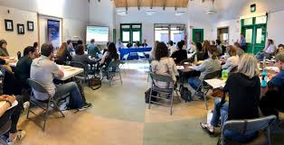
Community resilience is the sustained ability of communities to withstand, adapt to, and recover from adversity. Communities are increasingly buffeted by environmental challenges (e.g., fire and climate change) economic oportunity, food and water access and issues of health and wellness. Building true resilience in communities therefore requires attention to a broad array of basic needs and services from environmental systems and infrastructure to community capacity. Instead of pursuing asepcts of resilience in isolation and based on the last crisis, a more proactive and an integrated approach is proposed. We will build on our existing network of trusted community-based professionals to accelerate the pace and scale of community empowerment by building individual skills and community linkages to cumulatively provide a strong foundation for safe, healthy and resilient communities. The proposed “Resilience Network” will support economic development and wellness and build healthier environments and communities for all Californians, each and every day.
Building true resilience takes efforts to build community capacity across a broad range of needs.

A Focus on Resilience
There is a new urgency for community resilience. From COVID-19 to catastrophic fires to water shortages to struggling workforce engagement, the fragility of our communities is ever more apparent. Sudden changes disrupt multiple aspects of our economic educational, food and health systems. Mixed responses to an increasing array of community shocks has highlighted that basic health and safety can no longer be taken for granted. Increasingly we stressed communities where basic health access and wellness are either not available, poorly understood or incorrectly supported. From food access to educational access (including Wi-Fi access) to health basics, our system has seen people slip into often dangerous and unhealthy situations. Our current systems often struggle to deliver the right information, in the right form, at the right place and time to communities. Further communities often lack the foundations to absorb and access the needed resource and information to appropriately respond. As a result, too many Californian communities are struggling; often losing the struggle – missing opportunities, falling ill, or becoming food insecure. A Resiliency Network can play a major role to build community resilience by reinforcing and adding a strong community outreach dimension that builds our economic, health, food and education systems.

Opportunity and the Outcomes
Building a resilient system requires inclusion of multiple players and delivery of science-based information that results in widespread adoption by communities. However, behavior change is complex, and relies heavily on the development of trust. UC ANR has a trusted statewide network of skilled and respected personnel active in the communities across al 58 counties. We will build on our existing community and school activities our broad array of community efforts (including our advisors, our CalNat environmental program, our extensive 4-H youth programs, our talented CalFresh Healthy Living and EFNEP “army” of community-based educators, UC Master Gardeners, UC Master Food Preservers, UC IPM). Of particular relevance is that our programs already have excellent experience in building community capacity.

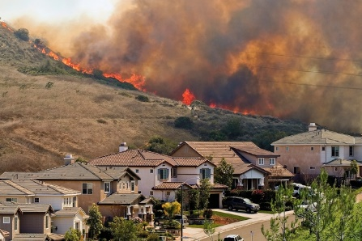
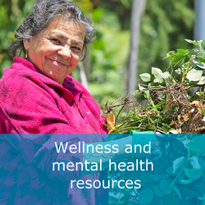
The topic of resilience is large – so where can one practically start? An empowered cohort of UC ANR community liaisons and resilience educators will build a set of basic community skills and awareness. As a cohort, the UC ANR Resilience Network of educators will
Resilience involves multiple elements from fire to food access to health and wellbeing training.

- Assess needs (for action). The approach will train community members to assess community resilience using the Community Resilience Assessment Tool. Opportunities to introduce assessment can start with existing respected programs (e.g., 4-H, CFHL, CalNat, etc.).
- Refine community priorities. Based on the baseline assessment, community members will be empowered to engage in refinement of community vulnerabilities and assets relevant to resilience, and help communities’ access resources to address priority resilience needs.
- Build skills to support community resilience. Based on emerging resilience priorities, community members will have the opportunities to build their capacities from a toolkit of options. Efforts (with the right level of support) can be implemented with and through individuals, schools, non-profits and after community groups. (See Appendix 1 for more on the approach.)

The need for partnerships. Resilience is best built on partnerships operating at the community, county and state level. While UC ANR already offers an established home and network for the community level educators, establishment of a successful resilience network will require effectively linkages to other key partners across the state level.

Impacts
The effort will strengthen multiple foundational tenets required for broader community resilience and reduce California’s social vulnerabilities. A resilience network ensures Californians grow in health, wellness and economic resilience. The long term consequence of a Resilience Network is improved community health, reduced health care costs, a vibrant local economy, enhanced youth and adult education, enhanced economic opportunities and improved quality of life.

Why UC ANR
UC ANR with its network of UC Cooperative Extension (UCCE) experts has proven expertise to build stronger and resilient communities through leadership, outreach and technical skills in natural resources, agriculture, nutrition, youth development and community health. The UC ANR network is embedded with county governments and communities throughout California and provides direct access for communities to the extensive, world renowned and impactful research of the full University of California system. As a trusted long-term partner (>100 year history), UC ANR provides educational delivery that empowers communities at every level. UC ANR evaluates and develops practices, disseminates new research and innovations through trainings and guidance documents, provides coordination and capacity for local and state-level collaborative implementation and policy efforts, and helps identify and promote appropriate policies. UC ANR has an existing network of professionals to provide guidance, expertise, and coordination on food systems throughout the state. This effort will offer much needed support to bolster those efforts and fill critical needs.

Appendix 1. How the program would be developed

CA Adaptation Planning Guide 2.0 framework for organizing the actions. Outlines how different ANR programs and initiatives can support the resilience network.
APG Step | Action | Relevant ANR Programs
Explore, Define, and Initiate | 1. Education and Outreach | 1. CalNat Climate Stewards (whole course)
Assess Vulnerability | 2. Vulnerability Assessment | 2. Vulnerability Assessment using online data (IGIS/CalAdapt; Climate Stewards/CalEnviroScreen) and community and citizen science efforts.
Define Priorities and Strategy | 3. Community Planning | 3. Led by the county but with our CESs, local partner organizations, volunteers, and other clientele at the table.
Implementation | 4. Food security  5. Physical Infrastructure  6. Community Capacity  7. Ecosystems | 4. CalFresh Healthy Living and EFNEP; Master Gardener  5. Home Hardening; Broadband & Cellular Access; Emergency shelters (livestock shelters)  6. Support Networks: 4-H; etc.  7. Wildland Fire Education; California Naturalist; Project Learning Tree
Monitoring & Evaluation | 8. Ongoing assessment | 8. Community Resilience Assessment Tool; Community and Citizen Science projects including community asset mapping
Flow chart showing how a community resilience network can get started. Would be initiated by programs working with a community that want to move the idea forward and then bring in others from ANR to provide the necessary support.
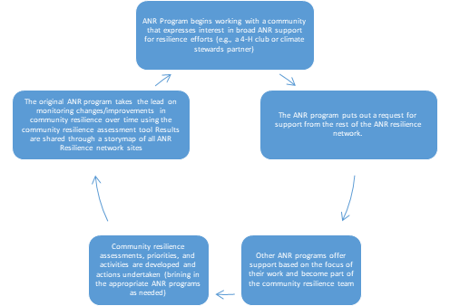

Cost consideration.

The scale of effort determines budget required.

To show cost building blocks:

- 1.0 FTE coordinator who works directly with external partners to identify messages and modes of delivery. This coordinator also works with our SWP directors and counties to coordinate
  - Additional CES capacity needed for more deliberate, coordinated approach
    - Perhaps buying out time for existing CES who are not 1.0 FTE (4-H, EFNEP, CFHL), to avoid hiring delay
    - Could add additional CES.
    - Could focus on rural areas, urban areas, or both
    - As a point of reference, a $1M investment (plus any IDC) would get a coordinator plus 7.5 to 9.0 CES time for a year. That could provide programming and impact for a large part of the state if existing employees already have connections. If hiring is required, working through EFNEP and CFHL could cover a lot of ground.

