2018 CROP PRODUCTION GUIDELINES

Oli G. Bachie

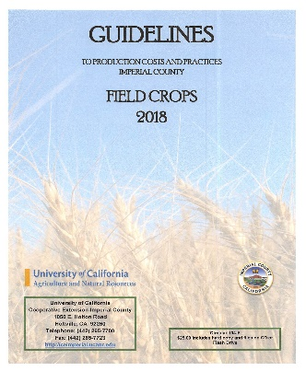
The new 2018 Guidelines to Production Costs and Practices in Imperial County- Field Crops is available from the Cooperative Extension. The information presented in the field crops guidelines allows one to get a "ballpark" idea of field crop production costs and practices in the Imperial County. Most of the information was collected through verbal communications, office visits and personal phone calls. The information does not reflect the exact values or practices of any one grower, but are rather an average of countywide prevailing costs and practices. Exact costs incurred by individual growers depend upon many variables such as weather, land rent, seed, choice of agrichemicals, location, time of planting, etc. No exact comparison with individual grower practices is possible or intended. The budgets do reflect, however, the prevailing industry trends within the region.

Overhead usually includes secretarial and office expenses, general farm supplies, communications, utilities, farm shop, transportation, moving farm equipment, accountants, insurance, safety training, permits, etc. Eleven to 13% of the total of land preparation, growing costs and land rent was used to estimate overhead. Hourly rates vary with each crop depending on the workman’s compensation percentages Since all inputs used to figure production costs are impossible to document in a single page, we have included extra expense in man-hours or overhead to account for such items as pipe setting, motor grader, water truck, shovel work, bird and rodent control, etc. Whenever possible we have given the costs of these operations per hour listed on the cultural operations page. Some custom operators have indicated that they are instituting a “fuel surcharge” to reflect “spikes” in fuel cost.

Not included in these production costs are expenses resulting from management fees, loans, providing supervision, or return on investments. The crop budgets also do not contain expenses encumbered for road and ditch maintenance, and perimeter weed control. Presented within are three crop budgets for alfalfa (flat, bed, seed). All others crop budgets can be determine by substituting costs relevant to each individual farm enterprise using the prevailing rates tables. Sample Excel sheets for the remaining major field crops are included in this document. The user needs to input production data appropriate to their individual operations to estimate production costs.

Where applicable we have used terminology that is commonly used in the agricultural industry. These terms are compiled in a glossary at the end of the circular. We feel that an understanding of these terms will be useful to entry-level growers, bankers, students and visitors.

This circular (104-F) is available on USB thumb drive. The text files are in Microsoft Word format. The spreadsheet files (i.e., production costs tables) are in Excel format. Please note that these are files and not the programs to run them. One advantage of having electronic versions of the crop production files is that they may be loaded into a spreadsheet program and the values altered to fit your needs. You can build a spreadsheet for your individual crop inputs while retaining the formulas for instantaneous recalculation of the whole page. For example, how would overall costs be affected if land rent were $50 per acre less, or if you chose a less expensive variety? The answer is right at your fingertips! You can see your cost projection instantly at any given price and yield level, plus a break-even price.

The cost of the USB thumb drive, or electronic version of Guidelines to production costs and practices for Imperial County Field Crops circular (104-F) is $25. This includes the hard copy of the Guide, one of the above electronic choices, and shipping costs. If ordering by mail, please make checks payable to: UCCE-Imperial County and mail to Nannette Kniffin, UCCE, 1050 E. Holton Rd. Holtville, CA 92250. Please specify if you want a CD or USB thumb drive in addition to the hard copy. Please feel free to call (442-265-7700) or email (obachie@ucdavis.edu) if you have any questions.

