

**[name] county’s   
annual**



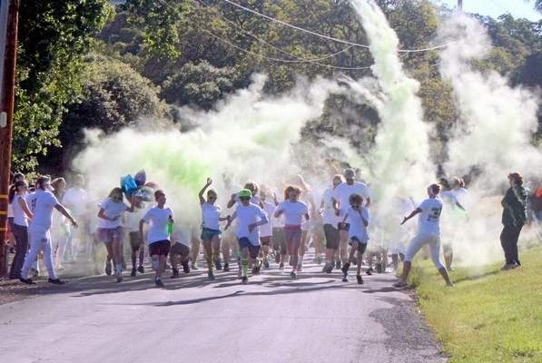****



*It is the policy of the University of California (UC) and the UC Division of Agriculture & Natural Resources not to engage in discrimination against or harassment of any person in any of its programs or activities (Complete nondiscrimination policy statement can be found at* [*http://ucanr.edu/sites/anrstaff/files/215244.pdf*](http://ucanr.edu/sites/anrstaff/files/215244.pdf) *) Inquiries regarding ANR’s nondiscrimination policies may be directed to John I. Sims, Affirmative Action Compliance Officer/Title IX Officer, University of California, Agriculture and Natural Resources, 2801 Second Street, Davis, CA 95618, (530) 750-1397.*

**Be a lean, green running machine!**

UCCE [Name] County 4-H Program | Address | City | CA | Zip Code  
Phone | Email | Website

5K Run is here!

Saturday, XX, 2015  
Location  
Time

Event description and more information (registration details, etc.)