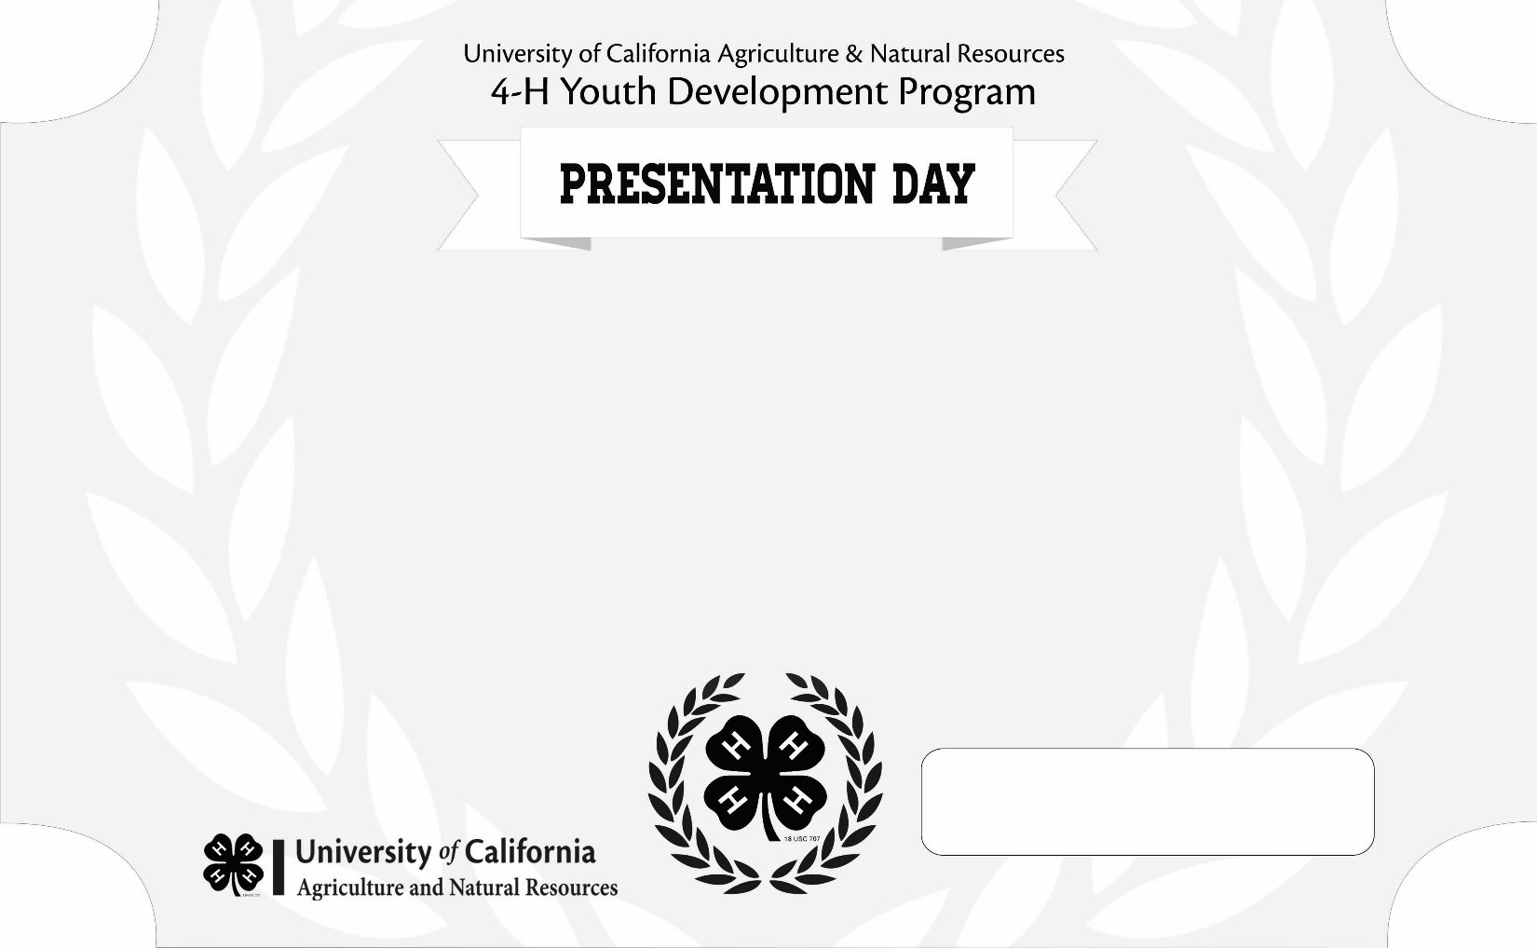

This certificate recognizes the participation of

Recipient Name

in the [insert county or section] Presentation Day.

**Date**

**4-H Coordinator**



This certificate recognizes the participation of

Recipient Name

**Date**

**4-H Coordinator**

in the [insert county or section] Presentation Day.