4-H Volunteer Leader Presentation Outline

Objectives:
- Provide background of Healthy Kids Out of School principles.
- Present the 4th H for Health Challenge.
- Identify the strategy and successes of the program implementation (referencing 4-H clubs who have already completed the Challenge – thousands of 4-H’ers across the country – and the evaluation conducted in New England showing success in creating healthy club meetings)
- Introduce the materials, showing how to lead the activities.
- Show the connection to other volunteer leaders in community youth activities and how this amplifies individual efforts.

Intro
Introductions, review the materials

Basic background:
- Impetus for our work - childhood obesity epidemic and its health impact
  - 1/3 children overweight or obese
  - Quadrupling of obesity rate in 5 – 12 year old children over the past 50 years
  - Obese children/teens have a 70-80% chance of becoming obese adults
  - Challenge of changing a habit as adults (smoking, waking up early, losing weight) – much easier to start out with these healthy habits when we’re young
  - “For the first time in two centuries, the current generation of children in America may have shorter life expectancies than their parents” NEJM 2005

- Cultural Shift – children have not changed in these past 50 years, but there have been many environmental changes that decrease physical activity and increase food intake. Ask for examples. (PA: screen time, less outside play, less P.E. at school; Food: portion sizes, food rewards, grocery store options and fast food). Our goal is to change the environment where it’s possible/where we have the opportunity – during club meetings.

- Obesity stats/health concerns - can feel overwhelming. Connect each club’s efforts to the efforts of other out-of-school time (OST) partners, to stress the impact of a consistent message and cumulative health behavior potential. Healthy Kids Out of School works with other OST organizations (e.g. Scouts, youth soccer, YMCA, etc.) who’s leaders are also making these healthy changes to meeting times/practices. (Children are growing; easier to impact health during this time period.)

4th H for Health Challenge:
- Program helps establish healthy habits during 4-H. The 4th H is Health – keep it front and center during meeting times – establish an understanding of healthy eating (without stigmatizing foods) and a love for PA at an early age. Opportunity to make these healthy behaviors the norm for all 4-H’ers. “This is how we run club meetings”.
- Club Meeting Focus; Simple, achievable and fun; sustainable. Establishing a New Norm; Re-enforcing/role-modeling at meetings; comfortable environment to have fun and try new things. 4-H’ers may feel more comfortable being active in a group of friends and they may feel more supported to go outside of their comfort zone to try new things.

Three Healthy Behaviors: Background for, and Demonstration of, the Three Principles
*3 evidence-based principles – we know that these three changes (water, fruits and vegetables as snacks, and more physical activity) can make a big impact in promoting health.
- Sugar Quiz/Beverages: About half of the added sugars in diets of Americans come from sugar sweetened beverages (soda, energy drinks, sports drinks, highly- sweetened coffees and teas, and fruit drinks). These drinks are an easy target since they offer no nutritional value, cost more than the alternative of water, and are proven to impact undesirable weight gain. There is an association between consumption of these beverages and weight.
Do Sugar Quiz activity – Make poster (see below) or just bring empty sugary beverage containers to pass around. Has anyone seen or done this before? Purpose is to show people how much sugar is in common beverages. Have leaders guess which beverage has the most sugar, pass around bottles to discuss how to find grams of sugar, servings per container, size of bottles, etc. Ask leaders what other beverages they see youth drinking.
Note: Sugar Detective handout in their packets so they can do this activity with their club!
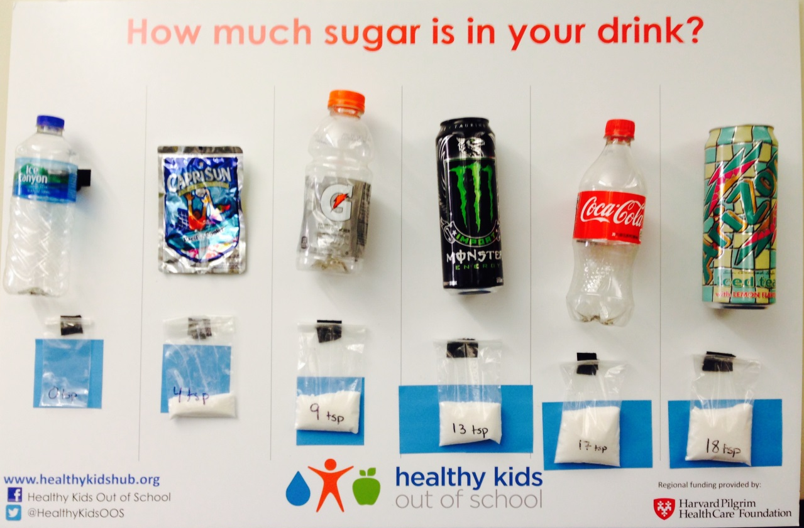
- PA Handouts/Physical Activity: It is recommended that children have 60 minutes of physical activity (PA) per day, yet 75% of children do not meet this goal! Girls are less likely to get the recommended 60 mins of PA per day than boys.
- PA can be achieved throughout the day; does not need to happen all at once.
- Adding 15 minutes of PA can help children achieve the recommendation of 60 minutes per day.
- You can expose children to new types of physical activity and encourage participation for all. We hope that all children will find a physical activity that they enjoy – to develop a lifelong habit.
- PA can be used as a gathering activity before the meeting begins – benefits of getting their energy out for improved focus during meetings. Walking to club meeting, starting outside for PA.
- Make game time non-competitive, fun, and inclusive. Let 4-H’ers rotate leading the activity whenever possible.
- Select games that keep kids moving. Turn music on and dance, use props (hula hoops, balls, etc.) or one of the active games we’ve included in your packet. If doing relays, encourage the waiting teams to be engaged in active cheering for the competing teammate by following the cheering motions of the first child in line.
*If possible, demonstrate several exercises- Guess that Number and Rock, Paper, Scissors, as feasible
- Snacks: We know that in general children aren’t eating enough fruits and vegetables - 63% do not eat enough fruits; 78% do not eat enough vegetables. Children may be more open to trying foods within a group of their peers, especially if the activity is interactive and fun.
- Taste test is a great way to expose kids to new fruits or vegetables. Research shows that repeated exposure/tasting of new foods increases acceptance (up to 15 times!).
- Community building activity – each club member contributes one item, fruit or vegetable. Can have girls bring in a food item from their culture. By working with the food girls are more likely to try it. Can share the story of Stone Soup to tie into values of community building while introducing healthy foods.
4th H for Health Challenge
Introduce the 4th H for Health Challenge – walk them through each piece of the Leader Packet. Focus on the Tracker (page 2). Share that the priority is to establish this new norm during the club meetings, the activities provided can help get 4-H’ers on board and excited.

After as few as 9 meetings tracking achievement activities, a new norm can be established for physical exercise at meetings and healthy snacks/water when refreshments are served.
- Snacks: if you don’t regularly serve snack, consider other gatherings where food is served or completing one of the suggested activities.
- Note the importance of re-enforcing habits and role modeling at meetings
- Acknowledge variation in club meetings (dairy clubs might drink milk during club meetings– can still track their water intake); discuss with members how this fits.
- Highlight where leaders can find the leader materials and how they can obtain a certificate (or pin on the 4-H mall) once they’re done.

Feedback/Discussion/Wrap-up
- Feedback on what you heard?
- How can you get started?
- How do you currently get parents involved? How would this impact your meetings? How would you communicate this?
- Are there any challenges/barriers you think you’d face? Does anyone in the group have suggestions for overcoming these barriers? (Group problem-solving)

Materials:
4th H for Health Leader Packet
Optional materials (found on Healthy Kids Hub website here:
- 4th H for Health Challenge Overview video
- 4th H for Health FAQ sheet
- Letter to Club Parents
- 4th H for Health Challenge Certificate

