UC 4-H Presentation Program

2021 4-H Presentation Cycle

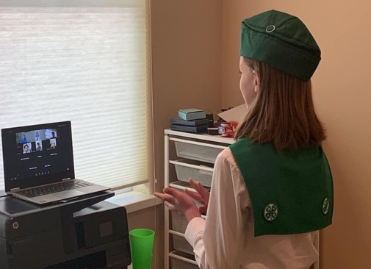
Events
County 4-H Presentation Event
[Insert date and time]
Contact
Contact Person
Phone number

Regional 4-H Presentation Event
Registration due April 20
Youth present between April 10-20

State 4-H Presentation Event
Registration due April 30
Youth present between May 8-22
Awards announced May 23 @ 6pm
4hsfd@ucanr.edu

Virtual Presentations
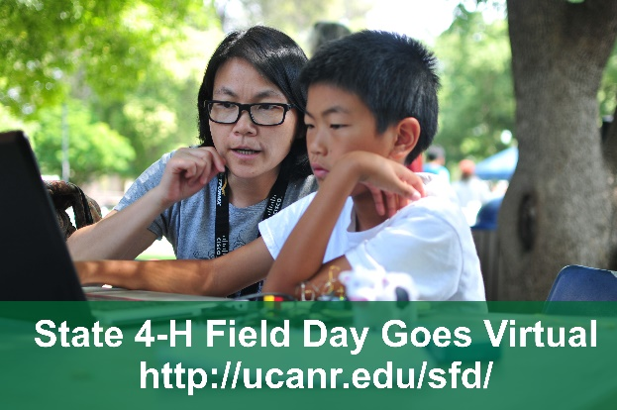
Public speaking continues to be a cornerstone of UC 4-H. Due to the pandemic, regional and state 4-H presentation events will be held virtually in 2021. Learning to present virtually is becoming an important skill in the workplace. Youth will need to adapt their presentations to take advantage of the technology, including designing slides, keeping the audience’s attention, and handling technology problems. The revised UC 4-H Presentation Manual (2020) offers tips for youth presenters on presenting virtually
(page 11). Other significant changes include:
- Youth who earn a blue or gold award are eligible to progress from county to regional and regional to state.
- Costumes may be worn in all presentation formats. Youth should wear attire that is neat, clean, acceptable in repair and appearance.
New State 4‐H Public Speaking and Communications Committee
Chair: Vera M. Bullard
Co-Chair: Steven Worker
- Provide leadership to regional and state 4-H presentation events.
- Manage the 4-H Presentation Manual.
- Develop and manage presentation evaluator orientations.
Impromptu categoreies avaialble at the 2021 State 4-H Field Day webpage.
Find more on the 4-H public speaking webpage and the
2021 State 4-H Field Day webpage.

