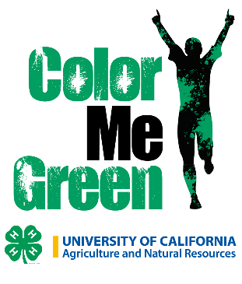
Walk a Thon
Benefit’s 4-H members
Disneyland Educational Event

4-H Youth Disneyland Educational Event is on March 13^{tt} to 15th, 2020.
Your donation is sponsoring a 4-H youth member. The donations will support the youth travel & conference expenses. They are attending a Disneyland Educational classes in STEM or Art featuring the designing of a Disney story. Youth have fun learning about assembly and engineering of roller coasters, physics, art and design. These are many life skills youth will use later in life. We appreciate your support of our 4-H youth in our county.
Walk a Thon: January 5th
Donate by the mile or flat fee (minimum of $10)
FEIN #94-3067788 Donation to 4-H Youth Development Program, University of California
Make check payable to San Benito 4-H Council
Name | Phone | Email | Donation | Miles
4-H Member Name: Club:

