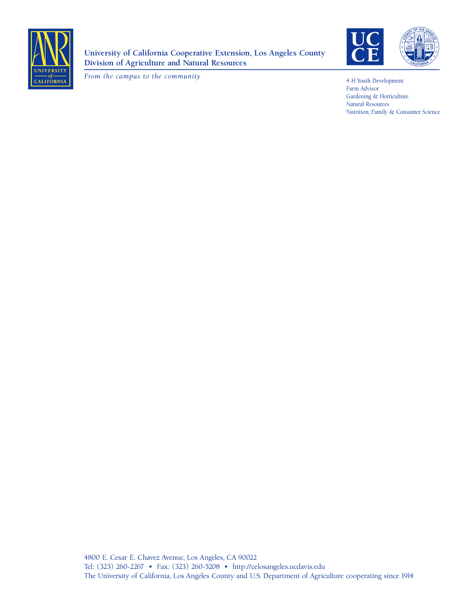
Materials to Avoid in the Compost Pile
Monterey Bay Master Gardeners
April 1999, Alan Schlenger
One of the composting issues that always gets lots of discussion is what materials are to be avoided in the pile. I'll cover most of these and give some caveats for other materials that could go in if properly handled.
Certain manures. Manure from carnivores contain harmful pathogens and takes a long time to break down. Cat feces are especially dangerous for pregnant women and children. They can carry either a bacteria called toxiplasma gondii or a roundworm called tocara catiboth of which can cause brain injury or eye diseases. Dog feces can carry parasites that affect humans. Droppings from birds have also been identified as sources of diseases and often contain seeds that we don't want to propagate.

Coal or barbecue ashes. These contain sulfur oxides, which are harmful to plants. However, fireplace ashes are ok in the pile in limited quantities. They are also a good source of potassium and can be used directly in the soil.

Meat, fish, dairy, and fats. All of these are slow to break down and are the primary sources of unwanted visitors (e.g. rodents, skunks, raccoons, opossums, flies, ants, etc.) to a compost pile. The amount of oils and fats that come with kitchen scraps is not a problem.

Certain leaves. Black Walnut, Red Cedar, and Laurel (bay) leaves contain toxins that inhibit plant growth. Pine and eucalyptus leaves are acidic and slow to break down. They should be used sparingly in the compost pile.

Diseased Plants. This is a conditional category. A hot compost pile will kill most pathogens. The Cornell University compost web site says that to kill pathogens a pile must maintain 104 degrees for five days and 130 degrees for four hours. The hot pile must be turned a few times and then reheated to these temperatures to make sure that all materials have been subjected to this high temperature. I find it safer to dispose of diseased plants, which is in my case includes roses(mine always have the usual assortment of rose diseases), and leaves and branches of certain fruit trees (i.e., apples, pears, plums).

Weeds. As with diseased plants, a hot pile can kill unwanted weed seeds, but getting all the seeds takes some effort and attention to detail. However, if you pull the weed before it flowers and avoid putting rhizomes in the pile, then you can put it into the pile. Highly invasive plants such as Bermuda Grass and Ivy are better left out of the pile.

Large or dense materials. Items such as corn stalks and cobs, avocado skins and seeds, pits, and shells, will take years to break down , but that is okay. Just move them from your old pile to the new. They are useful because they will be covered with beneficial bacteria that will inoculate the new pile.

