WHAT TO GROW IN CONTAINERS

Starting a container garden doesn’t mean you’ll have to limit the varieties of plants you grow.
Listed below are flowers, vegetables and herbs that do well in containers.
The species are coded for quick reference to life span, cultural requirements and recommended
Containers.

Vegetables
- – Annual  - - Bienial  - - Perennial Vegetables | 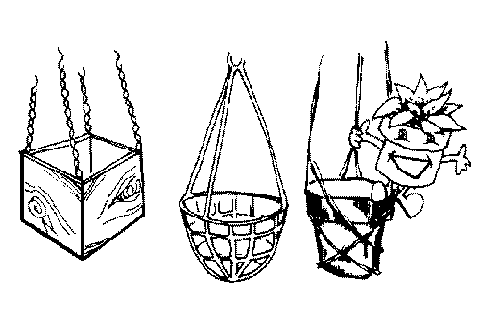  Hanging  Basket | Tub or  2-5 gal.  Container | Large  Container  8-12 inch pot | Small  Container  4-6 inch pot | Full  Sun | Part  Shade | ●  Full  Shade | High  Yield | Transplant | Water  Sparingly
Beans  (Bush or vine type) (A) |  | X | X |  | X |  |  | X
Beets (A) |  |  | X |  | X |  |  | X
Carrots (A) |  |  | X |  | X |  |  | X
Cucumbers  (Bush or vine type) (A) | X | X |  |  | X
Eggplant (A) |  | X | X |  | X |  |  |  | X
Onions  (especially bunching) (A) |  |  | X |  | X
Peas (Vining) (A) | X |  | X | X | X
Peppers (A) |  | X |  |  | X |  |  | X | X
Radishes (A) |  |  | X |  | X
Spinach (A) |  |  | X | X | X
Squash  (summer & winter types) (A) |  | X |  |  | X
Swiss chard (A) |  | X |  | X | X
Tomato (A) |  | X | X |  | X |  |  | X | X
Tomato (Cherry)  (A) | X | X | X |  | X |  |  | X | X
Turnips (A) |  |  | X |  | X
Lettuce (A) |  |  | X | X | X | X |  | X

Tips About Vegetables! Don’t Think of Vegetable container gardens as “Plain Janes” that are only sources of food – they can be sources of visual pleasure, too! Brightly colored kale, red leafy lettuce, eggplant and peppers and colorful and beautiful.

Tips About Vegetables! To get the most out of your limited space, choose high-yielding varieties. These include beans, beets, carrots, lettuce, peppers, radishes and some varieties of summer squash and tomatoes.

Tips About Vegetables! Many vegetables can be grown successfully in 3 to 5 gallon containers, including corn, broccoli, cabbage, kale, leeks, melons and the new seed-grown potatoes. More new compact varieties are being developed every year.

