We Request the Honor of Your Presence

The future of Alameda County 4-H?

The program is in jeopardy! The sustainability of 4-H in Alameda County hinges on many factors… Please plan to attend a
VERY IMPORTANT meeting on
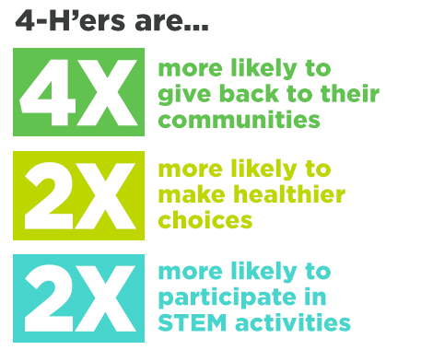
November 19, 2019 at 7:00 PM

Canyon Middle School
19600 Cull Canyon Road
Multipurpose Room
Castro Valley, CA 94552

Exploring various ways to ensure that the 4-H Youth Development Program continues in Alameda County for many years to come is the purpose of this important meeting.

Your Input is important to us!

Please RSVP by 11/09/2019 to cyfraser@ucanr.edu or 510-670-5639

