Favorite Foods Day

4-H Field Day for Cooking and Baking Projects

Judging of favorite foods, posters, and table settings

You do not need to be in a cooking project to submit an entry.

Registration and information located at
Favorite Foods Day or http://ucanr.edu/favoritefoodsday

Sunday, March 15, 2020
Doors open at 11:00 am
Judging begins at 11:30 am
Hale Hall
1600 Bancroft Ave. San Leandro
(First United Methodist Church of San Leandro)
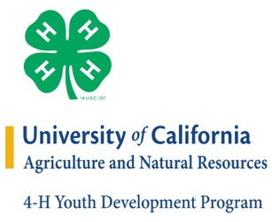
It is the policy of the University of California (UC) and the UC Division of Agriculture & Natural Resources not to engage in discrimination against or harassment of any person in any of its programs or activities (Complete nondiscrimination policy statement can be found at http://ucanr.edu/sites/anrstaff/files/215244.pdf)
Inquiries regarding ANR’s nondiscrimination policies may be directed to UCANR, Affirmative Action Compliance & Title IX Officer, University of California, Agriculture and Natural Resources, 2801 Second Street, Davis, CA 95618, (530) 750-1397.

