Favorite Foods Day

4-H Field Day for Cooking, Baking and Food-Related Projects

First United Methodist Church of San Leandro, Hale Hall
1600 Bancroft Ave. San Leandro
Sunday, March 15, 2020

Evaluations of favorite foods (Entrees, Appetizers, Desserts, Preserved Foods) decorated foods, table settings and presentations*

Registration and information located at
Favorite Foods Day or http://ucanr.edu/favoritefoodsday

Doors open at 11:00 am
Judging begins at 11:30 am

Additional activities planned include decorated cookies, cupcakes and more and a community service project

*You do not need to be in a cooking project to submit an entry or participate

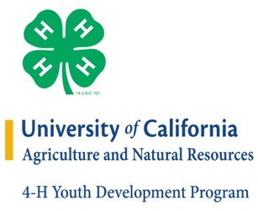
It is the policy of the University of California (UC) and the UC Division of Agriculture & Natural Resources not to engage in discrimination against or harassment of any person in any of its programs or activities (Complete nondiscrimination policy statement can be found at http://ucanr.edu/sites/anrstaff/files/215244.pdf)
Inquiries regarding ANR’s nondiscrimination policies may be directed to UCANR, Affirmative Action Compliance & Title IX Officer, University of California, Agriculture and Natural Resources, 2801 Second Street, Davis, CA 95618, (530) 750-1397.

