Alameda County 4-H Horse Field Day

Sunday, March 15th, 10 AM – 4 PM

Alameda County Fairgrounds, Pleasanton

Livestock Barn (enter through Gate 12)

C:\Users\cm1862\AppData\Local\Microsoft\Windows\Temporary Internet Files\Content.IE5\8CT1ZCWH\MC900325600[1].wmf 

University of California

Division of Agriculture and Natural Resources

**Horse Field Day** will be held on Sunday, March 15th, 10-4, at the Alameda County Fairgrounds, Pleasanton, in the Livestock Barn. If you wish to take the Horse Medal test please arrive by 10 AM. The test will be administered from 10-11 this year. Registration for all other attendees will begin at 11.

We will begin with a showmanship demonstration at 11 AM by members of the UC Davis Equestrian Team. After the demonstration each attendee will have the opportunity to practice a pattern where coaching will be provided (horses will be provided - do not bring your own). Also, this year we are working on information and demonstration sessions by a vet and a farrier. We will end with stick horse barrel and pole racing timed events. Awards to be provided.

Lunch will be offered at a nominal cost as a fund raiser with all profits benefiting the 4-H/FFA horse show hi-point awards.

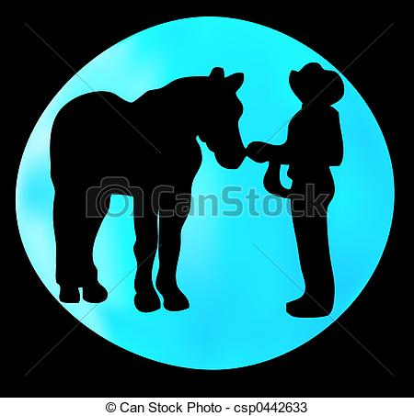

***Please RSVP by March 1 to*** [***cm1862@att.com***](mailto:cm1862@att.com)

It is the policy of the University of California (UC) and the UC Division of Agriculture & Natural Resources not to engage in discrimination against or harassment of any person in any of its programs or activities (Complete nondiscrimination policy statement can be found at <http://ucanr.edu/sites/anrstaff/files/215244.pdf>)

Inquiries regarding ANR’s nondiscrimination policies may be directed to UCANR, Affirmative Action Compliance & Title IX Officer, University of California, Agriculture and Natural Resources, 2801 Second Street, Davis, CA 95618, (530) 750-1343.