Alameda County 4-H Fashion Revue
At the Projects & Pancakes Field Day
Saturday, April 4th 2020
Sew or purchase an outfit to participate! Two competitions will be available:

- Consumer Science Competition: Purchase an entire coordinated outfit (including shoes) for under $40. Must provide receipts from the current 4-H year for all items worn by member . ALL 4-H members are invited to participate in this category
- Traditional: garment or outfit sewn by 4-H member. Member must be enrolled in a sewing-related project to participate in this category
*Participants will be encouraged to give a short oral presentation about their outfit. For juniors and intermediates, the time limit is 30 seconds; for seniors the time limit is 1 minute. The evaluators will also ask questions and look at the outfits. State Fashion Revue guidelines will be followed. For more information on guidelines, please see California State 4-H Website.

* Members can enter in one or both categories. County Winners will qualify to participate in the State Fashion Revue on May 30, 2020.

To Register for event: https://ucanr.edu/survey/survey.cfm?surveynumber=29325
To Volunteer for event: https://ucanr.edu/survey/survey.cfm?surveynumber=29380

Pre-registration is REQUIRED. Deadline for Registration: March 29th at 10:00pm
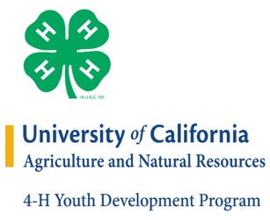
It is the policy of the University of California (UC) and the UC Division of Agriculture & Natural Resources not to engage in discrimination against or harassment of any person in any of its programs or activities (Complete nondiscrimination policy statement can be found at http://ucanr.edu/sites/anrstaff/files/215244.pdf)
Inquiries regarding ANR’s nondiscrimination policies may be directed to UCANR, Affirmative Action Compliance & Title IX Officer, University of California, Agriculture and Natural Resources, 2801 Second Street, Davis, CA 95618, (530) 750-1397.

