For Computer
We will be using zoom.us for our virtual meetings. For the first meeting, plan to give yourself 15 minutes to download and run the zoom software.
- Sign into your email and open the email with details for the meeting. In the body of the email there is a section that says “Join Zoom Meeting” and lists a hyperlink like “https://ucanr.zoom.us/j/[meetingid]”. Click the link to be redirected to the Zoom website.

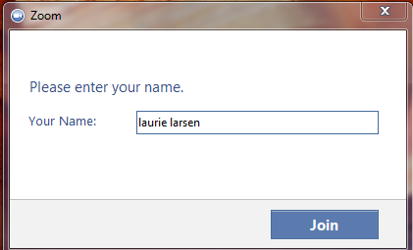
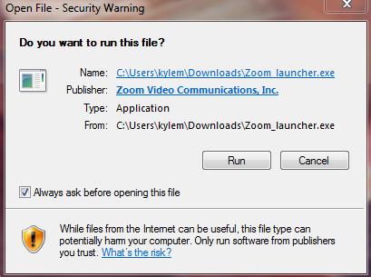
- If this is your first time joining a meeting you will be asked to download their software “ZoomInstaller.exe”. You can manually download at https://zoom.us/download. After the download is complete you will need to click on the file. Once clicked, you will receive the messaged displayed to the right. Next, run the file and wait a moment for it to set up the application. You may be asked to give this program permission to make changes to your computer, click “yes” if this occurs.
If you have been in a zoom meeting before, the software will be launched after you click the join link in the email.
- The first time you use zoom, you will be prompted to enter your name. Keep in mind that this is how your screen name will appear in the meeting (this can be edited in meeting if you wish). Once your name is entered click “Join” and you will be connected.

- If no microphone has been detected, a message box will appear asking if you would like to call into the meeting using a phone and give you a number to call. When you call, it should ask you to enter your participant ID that is listed in your message box. You can mute or un-mute your microphone and start or stop video by clicking the button in the bottom left corner of the window. To keep background noise down, we suggest keeping your microphone muted when you are not speaking and using a headset.

For phones

- Download and install the zoom application for your Android or Apple device using the QR codes below. The applications can be downloaded in advance of the meeting, but you will need an invitation for the other steps. The Android version requires that you have version 2.3.3 or higher, and Apple requires IOS 5.0 or higher.
play.google.com/store/apps/details?id=us.zoom.videomeetings

Android

itunes.apple.com/us/app/zoom.us-cloud-video-meetings/id546505307

Apple
- Once the download is completed and you have received an email confirmation that your meeting is in progress, open up your Zoom app (an image of the icon is to the right).

- The application will ask if you would like to enable it to use your contacts, so that you may invite them for a meeting. This is a feature that you will not need for our meetings.
- Select the “Join” icon on the home screen of the app. You will then be prompted to enter the nine-digit meeting ID that was listed in the email notification you received earlier. Alternatively, you can use your phone to access your email account and follow the link.

- You should now be in the meeting! If you would like to access any of the meeting controls or settings, simply tap the screen of your device to bring up a tool bar.

