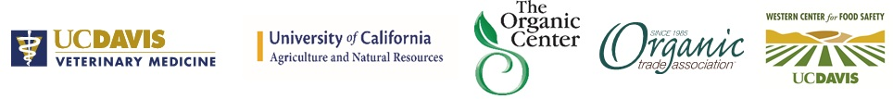

Needs Assessment for Small-scale Farms and Urban Livestock & Poultry owners
What’s in the survey?
- Evaluate and characterize the current practices and needs of urban, peri-urban and small-scale livestock & poultry owners

Why conduct a survey?
- This survey will serve as a benchmark for designing effective education programs to train farmers, backyard producers and veterinarians working with livestock

Who should participate?
- Urban, peri-urban and small-scale livestock and poultry owners in the West (California, Colorado, Oregon and Washington)

Where can I find the survey? http://ucanr.edu/survey/survey.cfm?surveynumber=15917

You can visit the survey using this QR code:

Please feel free to contact Alda Pires (530) 754-9855; apires@ucdavis.edu with any questions

Needs Assessment for Small-scale Farms and Urban Livestock & Poultry owners
What’s in the survey?
- Evaluate and characterize the current practices and needs of urban, peri-urban and small-scale livestock & poultry owners

Why conduct a survey?
- This survey will serve as a benchmark for designing effective education programs to train farmers, backyard producers and veterinarians working with livestock

Who should participate?
- Urban, peri-urban and small-scale livestock and poultry owners in the West (California, Colorado, Oregon and Washington)

Where can I find the survey? http://ucanr.edu/survey/survey.cfm?surveynumber=15917

You can visit the survey using this QR code:

Please feel free to contact Alda Pires (530) 754-9855; apires@ucdavis.edu with any questions

