Directions on how to enroll in:
Using SPSS

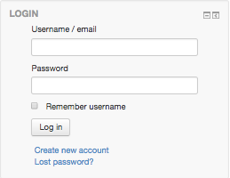
How to enroll in the online course
Go to http://campus.extension.org and look to the left to find a login box.
If you do not have an account, click on Create new account and fill in the information requested.

You should receive an email confirming the account creation within an hour. Follow the instructions in the email to confirm the account. If you do not get a confirmation email, please send a request for help by email to:
campushelp@extension.org
If you do have an account, then log in with your username and password.

After you have logged in, look for the search box and enter “Using SPSS.” Then click the Go button.

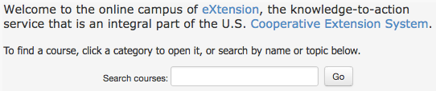

When you get the results of the search, click on the title of the course to enroll. You will then need to enter an enrollment key for this course: EVAL17.
How to come back to the course
Once you are enrolled, the course title will appear on a list under “My Courses” in the Navigation block at the top left side of your screen the next time you log in. You can then click on the course to go back to any part of the course. The enrollment key will no longer be needed.

Where to get help and assistance
campushelp@extension.org

