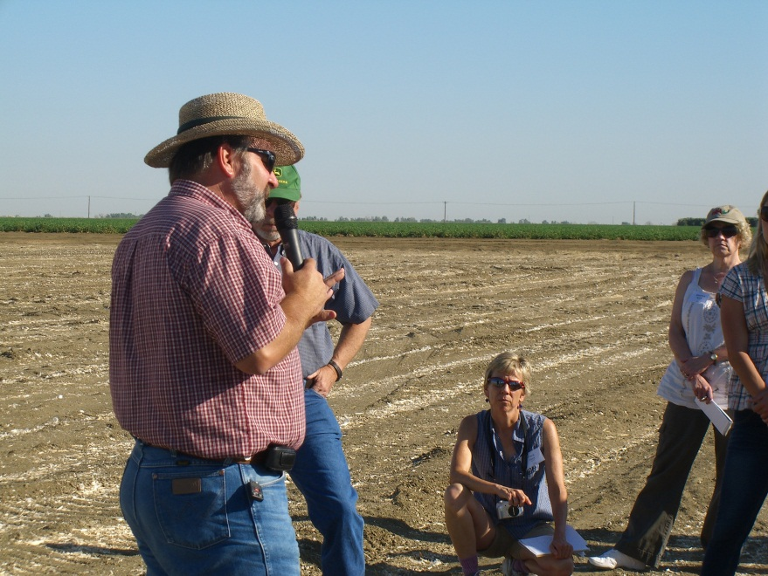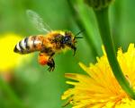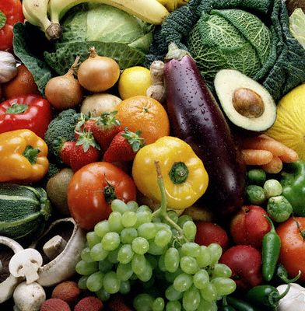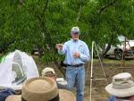

California Specialty Crops Tour: August 6-10, 2018

Purpose: To increase knowledge, dialogue and linkages with stakeholders in California agriculture

The 2018 California Specialty Crops Tour Will Address the Following Topics:

- IPM – On-farm visits with farmers, pest control advisors and research scientists
- Invasive Pests – Learn about ACP, impacts on trade, and critical importance of managing new pests
- Worker Protection - Observe workers and field practices
- Sustainable Agriculture - Water, air, soil, natural resources conservation, secondary standards
- Volatile Organic Compounds and Air Quality – Current issues and proposed regulations
- Endangered Species Act – Impacts and concerns
- Application Technology and Drift Mitigation - In field demonstrations
- Post Harvest Pest Management – Critical storage issues and techniques
- Fumigant Issues, Methyl Bromide and Alternatives – Field research and new fumigant technologies
- Biopesticides and Biological Control – New active ingredients
- Food Safety – Field to fork issues, food safety initiatives and commodity programs
- International Trade Issues – How field based decisions impact export opportunities (e.g. MRLs)
- Honey Bees and Pollination – Hive health, colony collapse disorder, pollination needs
- Water Situation in California - Acreage trends, impacts on environmental quality and communities
- Cross Agency Networking, Regulatory Issues and Research Needs of Specialty Crops

WHEN | Mon. 8/6 | Tues. 8/7 | Wed. 8/8 | Thurs. 8/9 | Fri. 8/10
WHAT | Travel Day with  Orientation Dinner | Tour | Tour | Tour | Travel Day  Return Home
WHERE | Arrive into Visalia/Fresno | Visalia | Visalia to Salinas | Salinas to Sacramento | Depart out of Sacramento
TOPICS  (DRAFT) | TRAVEL  Plan on early PM arrival  Tour Event begins with Reception  and Orientation Dinner at 4:30 PM  California/Local Ag  Overview | Stone fruit, raisin grapes, spray drift mitigation,  quarantine  pre-plant fumigation, pre-shipment fumigations (QPS), international trade,  invasive spp., environmental stewardship,  air quality  Dinner on own in Downtown Visalia | Garlic, onions, carrots vegetables, leafy greens,  Sensitive aquatic site treatments,  worker issues, organic and sustainable production,  food safety  Dinner and discussion | Methyl bromide & MB alternatives, melons,  strawberries, area-wide IPM, honey bees and pollination, pheromones, post- harvest disease control, cherries,  pears, water quality, vertebrate pests  Tour ends late afternoon. | TRAVEL for out-of-state participants  Depart at any time

Crops We Plan to See:
Pears, carrots, onions, garlic, prunes (dried plums), cherries, melons, leafy greens, and others!

Travel Plans: Plan to arrive into Fresno or Visalia by early afternoon on Monday, 8/6; the tour officially begins with a reception, orientation dinner, and overview of California/Local Agriculture on Monday evening. For those traveling out of Sacramento, the tour bus will depart from the Farm Bureau parking lot early in the afternoon of 8/6 (12:30 pm) and we will return late afternoon of 8/9. Parking at the Farm Bureau is provided free of charge. Flight departures out of Sacramento need to be after 7:00 PM on Thursday, 8/9 or anytime on Friday, 8/10.

Costs: Tour bus transportation, most meals, and all tour materials are provided. Costs for out-of-state participants are estimated to be ~ $500 for 4 nights of lodging and 3-4 meals (participants provide air transportation to and from tour). Costs for in-state participants are estimated to be ~ $350 for 3 nights of lodging and a few meals. Some in-state attendees may incur hotel expense for the night of August 9 depending on their origination location. Hotel reservation details will be provided separately for participants but must be made by Friday June 8. Please note that space is limited, and we need confirmation of attendance by June 1.

Logistics and Routing Throughout the State: The 2018 tour will cover a wide cross section of geography and crops in three distinct growing regions of the state. The tour group will travel via bus on a route that originates in Visalia; we will have speakers on the bus to maximize the use of our travel time and opportunites for exchange. The tour will continue to Salinas, and then will end in Sacramento.

Attendance and Exchange – Tour Participants: All participants are expected to attend all 3.5 days of this event and be prepared to give a short description of how their official duties fit into the practice of IPM, Worker Protection, Environmental Stewardship, Resource Conservation, International Trade, Food Safety and/or Ag Sustainability pertaining to specialty crops.

For Further Information: Please contact Gary W. Van Sickle (CSCC Executive Director) at gary@specialtycrops.org

