

Director, Lindcove Research and Extension Center

Open call for applications to all ANR academics and AES faculty

The Position
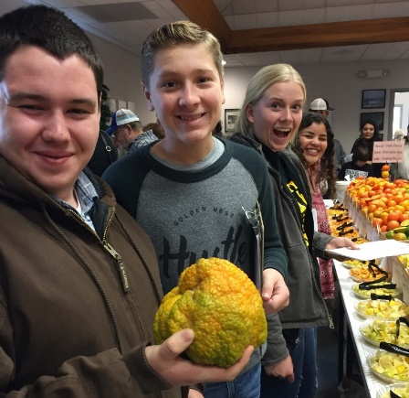
University of California Agriculture and Natural Resources has an opening for the Director of the Lindcove Research and Extension Center (LREC). The Director of LREC is expected to 1) provide leadership for planning, coordinating and priority setting for LREC; 2) expand the number and scope of research and extension projects, and 3) act as a liaison between the University of California and the citrus industry. This opportunity is open to UC academics currently serving as CE Specialist, CE Advisor, Academic Administrator, or Academic Coordinator. The position requires a 40% commitment in time, and is eligible for an administrative stipend. Appointment is for 2 years, and renewable after performance review. The incumbent will be required to relocate their primary office to the Center located in Exeter, CA.

Major Duties and Responsibilities
- Provide leadership, planning and priority setting. As Director, the incumbent will oversee the budget, personnel, and facilities of the Center, as well as support research and extension activities by the various scientists that utilize the Center. The Director will strive to maximize the number of research and extension projects, expand funding and facilities, develop policies, increase the visibility of LREC to commodity organizations and the general public, and develop long-range plans for LREC.
- Provide vision and set a high standard for excellence by example; innovate and foster positive change; model and support a good team-working environment by following UC-ANR Principles of Community; encourage new ideas and innovative changes; and provide active, ongoing advocacy and support for UC ANR programs.
- Facilitate interactions between agricultural groups, state agencies, federal agencies and consumer groups. If called upon, serve on committees such as the Citrus Research Board, the California Citrus Nursery Board, the California Citrus Quality Council, the Citrus Pest and Disease Prevention Program, California Department of Food and Agriculture, and USDA-ARS.
- Understand and uniformly apply UC administrative policies; provide useful and timely feedback; if necessary take timely disciplinary action within UC procedures; and work with staff in advance of deadlines for required records and reports.
- Successfully secure resources and outside sources of support; effectively manage and equitably allocate resources among programs and established priorities; and monitor the use of resources and comply with all relevant policies.

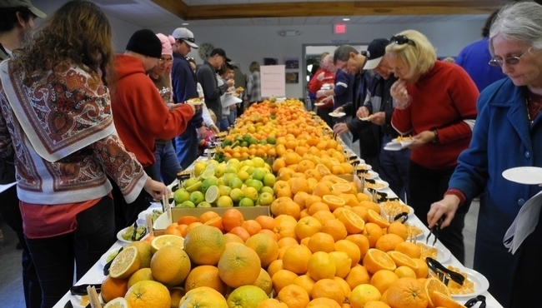
The Qualifications
Education and/or relevant experience in horticulture, agronomy, entomology, plant pathology, or related discipline. The incumbent should be currently employed by the University of California Agriculture and Natural Resources. The incumbent should possess leadership skills, the ability to communicate and interact with colleagues and administration in a constructive and empathetic/sympathetic manner, organizational skills and ability to conduct group processes, and understand the nuances of university administration.

The Application
Candidates should submit their CV and Letter of Interest to Joan Warren (jtwarren@ucanr.edu) no later than April 24, 2020. Your letter should highlight how your passion, skills, and past experiences will contribute to the future success of LREC. Applications will be evaluated by the search committee, and a recommendation made to the Vice Provost of Research & Extension.
University of California Research & Extension Centers


