Save the date!

Workshop on Identifying Spatially Explicit Reference Conditions for Forest Landscapes in the Lake Tahoe Basin

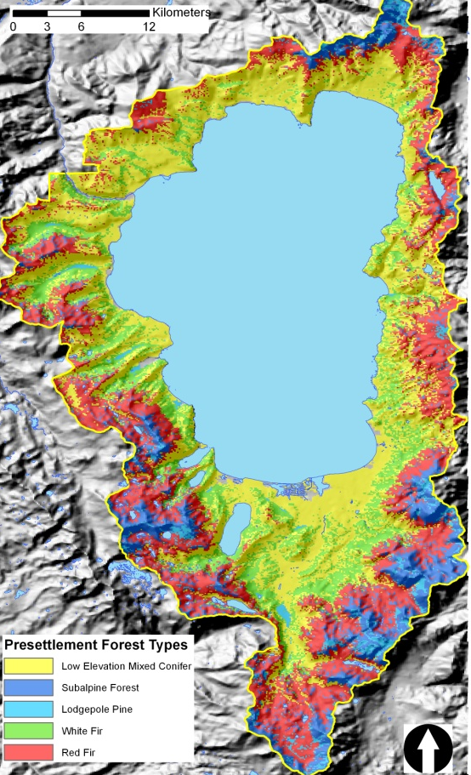
Date: March 9th, 2012
Time: 9:00 am – 12:00 pm
Place: US. Forest Service, Lake Tahoe Basin Management Unit, Forest Supervisor's Office
35 College Drive
South Lake Tahoe, CA 96150
Phone: (530) 543-2600

Investigators: Dr. Alan Taylor, Penn State
Carl Skinner, USFS-PSW
Dr. Hugh Safford, USFS-PSW

Presenter: Dr. Stockton Maxwell,
Penn State University

Workshop Goal: Inform managers about pre-settlement forest condition, demonstrate products to users, and receive feedback on project

Project Summary: In this workshop, we will present the findings and products of our project “Identifying Spatially Explicit Reference Conditions for Forest Landscapes in the Lake Tahoe Basin”. The goals of this project were to: 1) identify the relationships among spatial variability in pre-settlement forest structure (composition, density, basal area, size structure), topographic variables, and spatial variability in fire regimes (fire return interval, season of burn) in the lower and upper montane forest zones of the Lake Tahoe basin; and 2) develop a spatially explicit reconstruction of the pre-settlement forest landscape conditions and associated fire regimes for the Lake Tahoe basin that can be used by land managers in restoring forest ecosystems. To achieve these goals, we have sampled forest structure, collected increment cores and fire-scarred cross sections, and measured fuel loadings in the remaining old-growth stands in the basin. Combined with data from previous studies, we have dendro-ecologically reconstructed forest conditions and disturbance history in plots to pre-fire suppression conditions. Next, we implemented a random forest model predicting forest type and structure using eco-physiographic variables. This model has been applied across the basin to produce a basin-wide map of forest conditions prior to major human disturbance.

Supported by: Southern Nevada Public Land Management Act, Lake Tahoe Basin Management Unit
For More information: Contact Susie Kocher, University of California Cooperative Extension, (530) 542-2571, sdkocher@ucdavis.edu

