Estimating the GHG impacts of fuels treatments in California forests

Bill Stewart and Carlin Starrs, UC Center for Forestry, September 2015

**The Challenge:** California’s forests have experienced an increase in large and often severe wildfires over the past few decades. Numerous projections have suggested that conditions could increase the area of large wildfires over the next few decades. Fuels reduction projects are promoted by state and federal agencies to reduce the size and severity of future wildfires. There has been recent interest in exploring whether the benefits of fuels reduction projects could justify additional expenditures from funds for greenhouse gas reduction actions. Many published reports and articles are based on complex models with very specific set of assumptions. We developed the ‘Fuels Treatment and Carbon’ spreadsheet tool[1] to allow users to use a basic mass balance approach to estimate outcomes for a set of projects with assumptions that can easily be modified by the user on forest growth, different treatments, future wildfire losses and how harvested products will be used in California. **While there is a high probability that most forests in California will be affected by a wildfire over the next century, our initial analysis concludes that simply trading future avoided emissions for planned current emissions will not have a positive climate benefit during the project period unless some of the harvested products are used and/or the treatments reduce the severity of future wildfires.**

The lack of clear benefit is partially a product of using current conditions as a baseline for assessing potential change in carbon stocks. Current forests have greater overall carbon stocks compared to historical forest conditions (i.e., prior to fire suppression, widespread timber harvesting, and natural regeneration). Furthermore, the distribution of live tree carbon in current forests is shifted towards smaller, less fire tolerant trees. Beyond the widespread changes in forest structure, current fire frequencies are considerably depressed relative to historical frequencies. This is due to efficacy of fire suppression agencies. These changes have allowed for an uncharacteristic accumulation of carbon in current forests that, despite having high potential for loss to fire (i.e., hazard), actually have relatively low risk due to the extremely low probability of fire occurrence over the last 50+ years. However, maintaining these low fire probabilities into the future is unlikely given recent climate projections. Additionally, when fire does impact high carbon density stands it not only has the potential for greater proportions of overstory mortality relative to historical levels, it likely will reduce to ability to accumulate carbon through regrowth for several decades.

The figure below illustrates the numerous steps and assumptions required to go from a carbon pool profile of a forest type and then considering how different treatments, biomass utilization, and future wildfire severity factors to finally generate a range of estimate GHG outcomes.

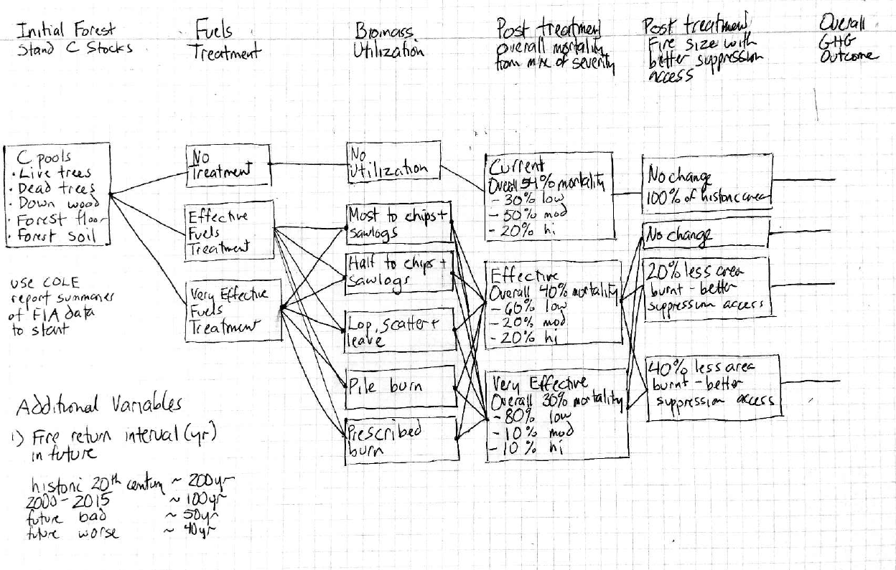

Figure 1: Flow chart to estimate climate/carbon benefits of fuels treatment projects

The photo was taken inside the perimeter of the 2014 King Fire illustrates what can happen to different forest carbon pools. In the foreground, 100% of the live trees had all of foliage and branches consumed in the fire. The boles of the trees have been transformed from live tree carbon to dead tree carbon. In addition, all snags and down wood in the forest was totally consumed. The holes in the ground are old stumps (belowground dead wood) that were also totally consumed. All forest floor carbon is gone. Finally, what was once an organic-rich forest soil lost large quantities of soil carbon and now has the consistency of ground up pottery. While the carbon in the newly dead trees will stay on site until the snags fall and eventually are consumed by microorganisms, the carbon pools other than what had been live trees represent the bulk of the carbon losses from the wildfire. The forest in the background retained foliage and branches, likely the result of intense surface fire rather than crown fire. Regardless of fire type, overstory mortality is nearly complete, and with it a near complete transition from a live, aggrading sink of carbon to dead, emitting pool.. The challenge is how to generate a reasonable and comprehensive estimate of the carbon signatures of no treatment (e.g. some probability of a future King Fire or less severe fire) versus fuels reduction treatments.

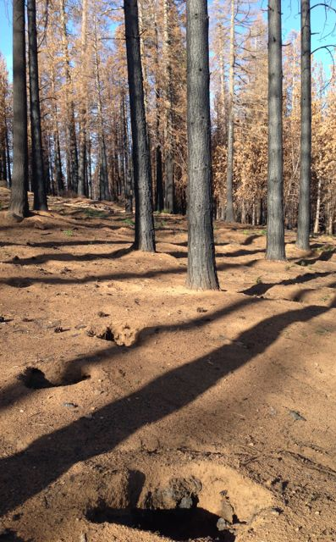

Figure 2: King Fire impacts on carbon pools

To construct a simple model of the potential carbon benefits of a fuels treatment project to accompany our models for estimating the carbon benefits of timber harvest operations (<http://ucanr.edu/sites/forestry/Carbon_Sequestration_Tool_for_THPs/>), we begin with specific data for different forest types (e.g. mixed conifer, ponderosa pine) by using FIA data processed with the online COLE reporting system[2]. We then apply a number of explicit assumptions to generate our estimated carbon signatures for different projects. One advantage of simple spreadsheet models is that most of the coefficients can be changed by users and they can immediately see how the final results are changed.

**Assumptions**

1. Forest carbon stores at risks for eventual emission related to wildfire are roughly ½ in live trees and ½ in dead trees, down dead wood, and upper half of forest soil. All pools must be considered to provide an unbiased estimate of carbon flux from the forest. Carbon in live trees killed in wildfire will initially be converted mainly to dead tree carbon that will fall and decompose. Published estimates of all carbon pools for different forest types can be obtained from the COLE reports (example below) based on FIA plot data.
2. Forest growth and harvest modeling – COLE’s empirical model that summarizes FIA plot based measurements of total forest stand carbon in tonnes, not just the commercial timber yield in board feet of lumber that only considers some of volume of the tree bole. We assume the application of two fuels treatments over a 40 year project period. The treatments are assumed to remove ~20% of total live tree and shrub biomass each entry and the resulting stand is estimated to have ~20% less total live tree biomass. The probable post-project benefits of lower non-fire mortality and hence more net carbon sequestration are NOT INCLUDED in this analysis.
3. Fuels treatments will do three major things to forest stands.
   1. Alter the future mix of severity, mortality, and carbon losses from future wildfires.
   2. Convert live tree carbon into a) offsite products (sawlogs and energy logs), b) lop and scattered additions to down dead wood that will slowly decompose, and/or c) emissions from on site burns .
   3. Increase the vigor of the remaining trees as there will be less competition for a fixed amount of water, nutrients and sunlight available at the site.
4. Biomass utilization – Some fuels management projects will remove commercial sized sawlogs that can be used to make building products with some of the material that does not go into building products being used for bioenergy. Smaller diameter trees and branches can be chipped and sent to bioenergy plants as long as the plants receive a sufficient CPUC regulated rates for wholesale power to justify the purchase of biomass feedstocks. When harvested products can not be marketed they are left on site as a temporary source of carbon sequestration or are burned. Each use has a different carbon sequestration profile over its lifetime.
5. A range of fuel treatment effectiveness can be simply represented with an ‘effective treatment’ that achieves some reduction in future wildfire severity and carbon loss and a ‘very effective treatment’ scenario that is assumed to achieve even greater reductions in future wildfire severity and carbon loss. The actual effectiveness of treatments can be summarized from the literature and would benefit from validation from well measured experiments under a range of conditions.
6. Future wildfires will be started by lightning strikes, vehicles, or other human causes and grow based on fuels and weather conditions as well as suppression actions. Wildfire suppression resources will be allocated to most fires outside of Wilderness and designated reserve forest areas. While wildfire probabilities in forest types based on data from 1950 to 2000 were low (0.2%year)[3], a more recent analysis of wildfire occurrence in the Sierra ecosection from 1995-2004 at FIA plots estimated a wildfire probability of 0.90%/year[4]. For this scenario, we use a default wildfire probability of 1.0% per year for conifer forests in the Sierra Nevada.
7. Wildfires burn with a range of overstory mortality (severity) with most of the area burning at moderate or low severity. Estimates of carbon loss as a function of fire severity are based on recent fires in California[5]. For simplicity, we model mortality and carbon loss as a being linearly related to severity (see table 5).
8. Prescribed burns also release carbon from the consumption of some of the carbon in dead trees, down wood, forest floor and forest soil. For simplicity, we model the impact of a prescribed fire on the non-live tree carbon pools as being similar to a low severity wildfire that will consume.

**Example for estimating no-treatment and fuels treatment scenarios for a California Mixed Conifer forest over a 40 year project period**

Carbon stocks at risk taken from COLE report for California Mixed Conifer, private lands are shown in the screenshot of a COLE output shown in Table 1. This includes the live trees, dead standing trees, downed wood, duff and leaves on the forest floor, and the organic carbon in the upper section of the forest soil profile.

1. Table 1: Screenshot from COLE report for CMC-private lands used to estimate all forest carbon pools that could be totally or partially consumed by wildfire.

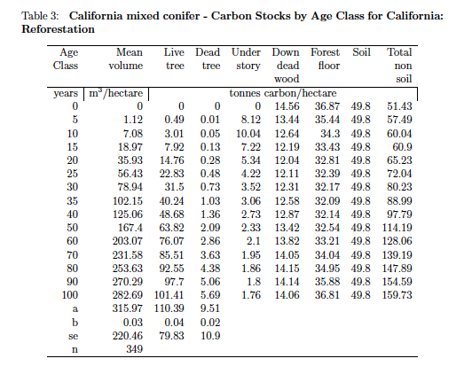

Source: GCOLE 2015 <http://www.ncasi2.org/GCOLE3/gcole.shtml> . This example is for California Mixed Conifer forest type in private ownership

The use of a 1.0%/yr wildfire probability based on Christensen (2008) as the reasonable estimate of fire probability for Sierra mixed conifer forests leads to a 40% project level probability of a wildfire during a 40 project period. We estimated that treatments will be effective for 20 years, so two fuels treatments over the 40 year project period are modeled.

Table 2: Model assumptions of expected wildfire probability and average carbon inventories of treated and untreated forest stands

|  |  |  |  |  |  |  |
| --- | --- | --- | --- | --- | --- | --- |
| Annual fire probability |  | 1.0% |  | Based on FIA (Christensen et al 2008) | | |
| Analysis window |  | 40 | years |  |  |  |
| Treatment effectiveness period (in years) | | 20 | years | Based on vegetative regrowth | | |
| Number of fuels/forest health treatments | | 2 |  |  |  |  |
| Probability of fire during analysis period | | 40% | calculated |  |  |  |
| Average C inventory at fire loss risk | | Live Tree | Dead, down, forest floor | Soil C @ risk (50% of COLE) | Products removed |  |
| No fuels treatment |  | 75 | 50 | 23 | 0 | MgC/ha |
| Fuels/Forest Health Treatment | | 60 | 50 | 23 | 20 | MgC/ha |
|  |  |  |  |  |  |  |

The COLE model based estimates of carbon stocks in the untreated and treated stands are shown in the following figures 3 and 4.

Figure 3: All carbon pools in California Mixed Conifer Forest – 1 ha.

Figure 4: No treatment and treated estimates of live tree carbon per ha

Different fuels treatments (Table 3) will be applied within any project depending on access, safety, costs, potential revenue, and resources. Various treatments are projected to have different impacts on how much live tree carbon and dead tree/floor/soil carbon are removed or burned. Table 4 summarizes the assumptions used in a model run. Changing any of the coefficients in this table within the worksheet will change all the summary calculations.

Table 3: Carbon signatures of different harvest practices

|  |  |
| --- | --- |
| Full product utilization | Most volume is chipped and used for bioenergy with a minor portion of the volume used for lumber |
| Partial Utilization: 1/2 remove, 1/2 lop and scatter | More accessible areas have products removed while less accessible areas have harvested volume processed in place |
| Lop, scatter and leave | All harvested trees and chipped and scattered on site. The carbon is added to the down wood that will burn in a wildfire |
| Pile burn | All harvested trees is collected and burned |
| Full Rx burn 2x tmts | Prescribed fire burns many small live trees, as well as some of dead wood and forest floor. |

Table 4: Estimate allocation of carbon to different pools from treatments

|  |  |  |  |  |  |  |
| --- | --- | --- | --- | --- | --- | --- |
|  | No tmt | Full Rx burn | Pile burn | Lop, Scatter, and Leave | Partial Utilization | Full Utilization |
| live tree to sawlogs | 0% | 0% | 0% | 0% | 15% | 30% |
| live tree to chips | 0% | 0% | 0% | 0% | 30% | 60% |
| live tree to decomposition | 0% | 20% | 20% | 100% | 50% | 5% |
| live tree burned | 0% | 80% | 80% | 0% | 5% | 5% |
|  |  |  |  |  |  |  |
| dead C burned in Rx fire | 0% | 20% | 0% | 0% | 0% | 0% |

Improvements in post fire measurements have documented the wildfires burn at differing levels severity within the fire perimeter. Higher fire severity is associated with higher immediate rates of carbon loss during the fire as well as with mortality to live trees. Table 5 contains the modeling assumptions on the percent of area within no-treatment wildfires and post-treatment wildfires in terms of the area burned at different severities and the associate immediate/short term emissions. The model assumes the same relationship between fire severity and eventual loss of carbon but after treatments, changes the proportion of area within the fire that burns at high severity. The % loss of carbon is applied to all at risk carbon pools from the live trees to the upper portion of the forest soil.

Table 5: Estimated fire severity and resulting loss of carbon for 1) no treatment stand, 2) effective treatment , and 3) very effective treatment

|  |  |  |  |  |  |  |
| --- | --- | --- | --- | --- | --- | --- |
| **Estimated Fire Severity and Mortality Percentages** | | | | | | |
| (in the event of a natural wildfire) | | | | | | |
|  | No treatment | | Effective treatment | | Very effective treatment | |
| Fire Severity | % area | % mortality | % area | % mortality | % area | % mortality |
| high | 30% | 100% | 20% | 100% | 10% | 100% |
| moderate | 50% | 40% | 20% | 40% | 10% | 40% |
| low | 20% | 20% | 60% | 20% | 80% | 20% |
| **Overall fire mortality** | **54%** | | **40%** | | **30%** | |

A full comparison of the carbon benefits of different types of fuels treatments with a no treatment alternative requires tracking the changes in all forest stand carbon pools over a project period (we use a 40 year project with an estimated 1%/year fire probability) where wildfire severity is assumed to be reduced by the treatments. For the no treatment baseline, we assume that the wildfire will burn the whole site with the distribution of natural wildfire severity shown in table 5. To bracket the potential impact on wildfire severity of the treatments, we model two levels of treatment effectiveness as well as three levels of area burned (same as with wildfire, 20% less area burned, 40% less area burned). Very optimistic scenarios often assume large reductions in both fire severity and burned area after treatments. The purpose of using a wide range of outcomes is to provide a bracket of the potential impacts and to highlight the role of different assumptions on the effectiveness of different treatments. The best way to improve the accuracy of the model is to design, implement and measure projects to provide improvement to the coefficients that are currently taken from the literature and expert opinions.

Comparison of no treatment and basic treatment assuming that the future wildfire burns 100% of both areas. The basic logic is that the higher the fire severity, the greater to loss of carbon in live trees, dead trees, down wood, forest floor and the soil. The assumption is that treatments reduce the severity of future wildfires and therefore reduce the carbon losses from the multiple pools tracked in this model.

The summary of six different effectiveness estimates across six different treatments illustrates the potential range of outcomes based on the same set of assumptions. The initial forest stand 75 tonnes of carbon in live trees and 73 tonnes of carbon in dead trees, forest floor and soil at risk of loss to wildfires. In all cases except for very effective treatments in terms of both fire severity and fire area, the reduced amount of carbon burned in a future wildfire on a treated area plus the carbon removed in the treatments is still less than what was estimated to be lost if no treatments had been applied. This conforms to other modeling exercises where none of the harvested material was productively used offsite[6]. The net climate benefits during the project come from using the products as a biomass feedstock/sawlogs or from the treated material adding to dead wood carbon on site. Post project benefits may also come if the treated stands have lower density dependent mortality and therefore higher net carbon sequestration rates.

Table 6: Results for scenario with 1% annual fire probability and no reduction in area burnt after treatments

|  |  |  |  |
| --- | --- | --- | --- |
|  | Assumption 1: Treatments do not change wildfire impact area (100% area burned) | | |
| No treatment | Effective Treatment | Very Effective Treatment |

C loss from fires and treatments

|  |  |  |  |
| --- | --- | --- | --- |
| C loss from fire (MgC/ha) | 32.0 | 21.3 | 16.0 |
| C loss from fuels removal | 0 | 20 | 20 |
| Total | 32.0 | 41.3 | 36.0 |
| Difference from no tmt |  | -9.3 | -4.0 |

C gain/loss from utilization of removed biomass

|  |  |  |  |
| --- | --- | --- | --- |
| Full Rx burn | 0 | -6 | -6 |
| Pile burn | 0 | 1 | 1 |
| Lop,scatter, leave | 0 | 5 | 5 |
| Partial utilization | 0 | 11 | 11 |
| Full utilization | 0 | 18 | 18 |

Net C change for different projects

|  |  |  |  |
| --- | --- | --- | --- |
| Full Rx burn | 0 | -15 | -10 |
| Pile burn | 0 | -8 | -3 |
| Lop,scatter, leave | 0 | -4 | 1 |
| Partial utilization | 0 | 1 | 7 |
| Full utilization | 0 | 9 | 14 |

Assuming that treatments could also reduce the areal extent of future fires significantly increased the net benefits of all treatments. This assumption is based on findings from previous studies demonstrating not only lower spread rates in treated stands, but greater efficacy of fire control efforts relative to untreated conditions. The following table averages the many scenarios to create two common scenarios where treatments are assumed to reduce the areal extent of wildfires in treated stands by 20%. The even mix of treatments tries to capture the reality of the diversity of micro-sites within an ownership and the fact that a range of treatments may be used. The ‘commercial thin + fuels treatment’ is modeled after practices undertaken by larger timber companies in areas with good access and no very steep areas.

Table 7: Estimated net carbon/climate benefits in tC/ha for an even mix of treatments (use products, lop and scatter, burn) and a commercial thin + fuels treatment project

|  |  |  |  |  |
| --- | --- | --- | --- | --- |
| **Carbon benefits summary with assumption of 20% reduction in post treatment wildfire burned area** | | | | |
|  | Average net C change (MgC/ha) | | Climate benefit gain as % of initial forest stand carbon | |
| Effective treatment | Very effective treatment | Effective treatment | Very effective treatment |
| Even mix of treatments | 1 | 5 | 1% | 3% |
| Commercial thin +fuels treatment | 13 | 18 | 9% | 12% |

**Estimating future wildfire return intervals significantly impacts the estimated change in forest carbon sequestration**

The following figure shows the impact of assumptions on future wildfire return intervals on estimated changes in carbon sequestration. Under historic fire return rotations, well over 100 years, climate benefits were only realized when most of the harvested products were used for bioenergy or wood products. As the fire return interval was reduced, the net benefits increased even if few products were harvested and utilized. Since treated stands had less carbon that could burn up and were assumed to have lower mortality if they did burn, the relative advantage of fuels treatment increased significantly when shorter fire return intervals were assumed.



Figure 5: change in carbon inventory as percent of initial inventory for commercial thin+fuels tmts (upper line) or even mixt of fuels treatments (burn, leave, remove) as a function of predicted future fire return interval

This scenario tool provides a broad set of estimates of changes in carbon sequestration from different fuels treatments based on a well defined set of assumed changes that the treatments make on fire severity. Under the base set of assumptions, significant net carbon/climate benefits require removing much of the biomass treated in the fuels treatment. Pile burning or simply scattering the fuels appears to have limited climate/carbon benefits even if the treatments will have other benefits in terms of reduced suppression costs and losses of private timber assets. Prescribed burns will restore many of the ecological functions of these forests with no or limited ecological impacts but are not projected to provide carbon/climate benefits over the project period[7]. The full utilization scenario is based on the projects used by Stewart and Nakamura (2012) in their 17,000 acres of treatments on private lands in a region with many sawmills and energy plants that bought the products[8]. Across the whole Sierra Nevada, a more realistic estimate of the overall effect of treatments currently applied could be an even mix of all project types. The following table summarizes those results in terms of climate/carbon benefits as a percentage of the average at risk forest carbon pools.

The pessimistic assumption that fuels treatments have zero effect on future wildfire severity illustrates the need for better documentation on fire severity in treated and untreated stands. If no change in fire severity is achieved, the only treatment with a positive carbon/climate outcome is the one where harvest products are effectively used.

**Conclusion**

Wildfire area and severity are increasing in California. While we can not predict what will happen over the next 40 years, we can use robust current information to make informed predictions to guide forest management actions. This analysis illustrated how the key assumptions affect the final outcome. Much of the benefits come from the reduced emissions from less severe burning of the dead wood, forest floor and soil carbon that are often missed in analyses that only track carbon as measured in board feet in live trees. The utilization of harvest volume for bioenergy and products can significantly add to the net climate benefits while also providing significant ecological and social co-benefits. **While there is a high probability that most forests in California will be affected by a wildfire over the next century, simply trading future avoided emissions for planned current emissions will not have a positive climate benefit during the project period unless the harvested products are used and/or the treatments reduce the severity of future wildfires.** Utilization of harvested products from fuels treatments have been successfully integrated into fuels reduction projects in many sites in California[9]. Examples of improved suppression effectiveness in areas with fuels treatment projects has been commonly cited for California but is not that well documented.

The existence of a growing but complex and often contradictory literature on the climate benefit impacts of fuels treatments in different ecosystems of California has not led to a shared understanding among state and federal agencies that regulate and finance (fully or with grants or cost share programs) fuels treatment, fire suppression, and habitat improvement programs. The tool described here can improve the analysis of whether certain projects would or would not be effective climate change mitigation actions. Many different actors (e.g. forest managers, harvested log and energy chip purchasers, fire suppression agencies, state and federal agencies with cost share programs, environmental regulators) could benefit from using common analytical tools. Logical next steps would be to 1) improve the documentation of different coefficients based on literature and field sites in California and 2) conduct a systematic monitoring and measuring program on a range of treatments to improve the accuracy of the estimates of the carbon/climate benefits for a wide range of fuels treatment projects. The use of a shared scenario tool where users can see the potential impacts of different assumptions that may not have been implemented and documented in the field could help create a more broadly shared strategy for a path forward.

1. http://ucanr.edu/sites/forestry/Carbon_Sequestration_Tool_for_THPs/
2. http://www.ncasi2.org/GCOLE3/gcole.shtml
3. FRAP Assessment (2003) , p 94)
4. Christensen et al. (2008). P 70
5. Miller, J.D., H. D. Safford, M. Crimmins, A. E. Thode. 2009 Quantitative Evidence for Increasing Forest Fire Severity in the Sierra Nevada and Southern Cascade Mountains, California and Nevada, USA. *Ecosystems*, **12**, 16-32. Miller, J.D., Skinner, C.N., Safford, H.D., Knapp, E.E. and Ramirez, C.M. 2012 Trends and causes of severity, size, and number of fires in northwestern California, USA. *Ecological Applications*, **22**, 184-203.Stephens, S.L., Collins, B.M. and Roller, G. 2012 Fuel treatment longevity in a Sierra Nevada mixed conifer forest. *Forest Ecology and Management*, **285**, 204-212.
6. Campbell, J.L., Harmon, M.E. and Mitchell, S.R. 2011 Can fuel-reduction treatments really increase forest carbon storage in the western US by reducing future fire emissions? *Frontiers in Ecology and Environment*, **10**, 83-90.
7. Stephens, S.L., McIver, J.D., Boerner, R.E.J., Fettig, C.J., Fontaine, J.B., Hartsough, B.R. *et al.* 2012 The Effects of Forest Fuel-Reduction Treatments in the United States. *BioScience*, **62**, 549-560.
8. Stewart, W.C. and Nakamura, G. 2012 Documenting the full climate benefits of harvested wood products in Northern California: Linking harvests to the U.S. Greenhouse Gas Inventory. *Forest Products Journal*, **62**, 340-353.
9. Hartsough, B.R., Abrams, S., Barbour, R.J., Drews, E.S., McIver, J.D., Moghaddas, J.J. *et al.* 2008 The economics of alternative fuel reduction treatments in western United States dry forests: Financial and policy implications from the National Fire and Fire Surrogate Study. *Forest Policy and Economics*, **10**, 344-354. Stewart, W.C. and Nakamura, G. 2012 Documenting the full climate benefits of harvested wood products in Northern California: Linking harvests to the U.S. Greenhouse Gas Inventory. *Forest Products Journal*, **62**, 340-353.