CAL FIRE NEWS RELEASE

California Department of Forestry and Fire Protection

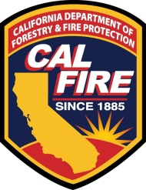 | CONTACT: | Guy Anderson  Forestry Assistance Specialist  (559) 243-4109  Guy.Anderson@fire.ca.gov | RELEASE  DATE: | July 28, 2026

CAL FIRE, NRCS and UC Extension will be hosting a Reforestation Workshop for forest land owners and foresters on February 11th 2017, from 10AM - 3 PM at the Intermountain Nursery, 30443 North Auberry Road Prather CA.

Please RSVP no later than Wednesday January 31th to Guy Anderson via email or phone. (559) 243-4109.

Presenters Include:
Ray Laclergue – Intermountain Nursery, Owner
Jodi Axelson - Forest Health Extension Specialist, UC Extension
Stewart McMorrow – Stewardship Forester, CAL FIRE
Dorus Van Goidsenhoven – L.A. Moran Reforestation Center, CAL FIRE
Guy Anderson – Forestry Assistance Specialist (Southern Region), CAL FIRE
Topher Henderson - Forestry Assistance Specialist (Southern Region), CAL FIRE
Matt McNicol – Area 3 Forester, NRCS

Topics include: forest ecology following heavy tree mortality, reforestation basics, preparing the ground for planting, selection of nursery stock, treating competing vegetation and land owner assistance programs currently available. There is no cost for this workshop.


