**Goldspotted Oak Borer**

**•Research**

**•Education**

**•Outreach**

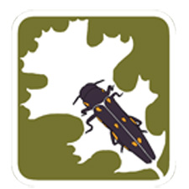

**www.GSOB.org**

**Email: gsobinfo@ucdavis.edu**

**GSOB Audio Public Service Announcement Scripts**

**15-Second script**

The goldspotted oak borer is killing native oak trees.

The losses are significant – the cost is substantial.

Oak trees throughout California are at risk.

The threat to YOU is real.

For details, go to G-S-O-B.org.

**30-Second script**

The goldspotted oak borer is here.

This invasive beetle has killed tens of thousands of oak trees in San Diego County affecting parks, woodlands and residential areas.

Local recreational places; cultural practices, natural ecosystems, property values and community safety are impacted.

The losses are significant – the cost is substantial.

Oak trees throughout California are at risk.

The threat to YOU is real.

Discover what you can do to spread this news, not the pest.

For details, go to G-S-O-B.org.

::::LOGOS:GSOB_Agency_logos:AWM logo_50x65.eps