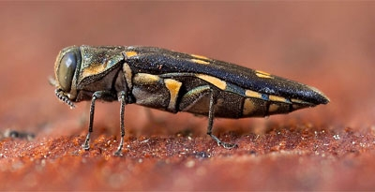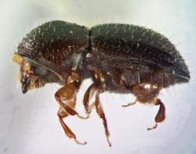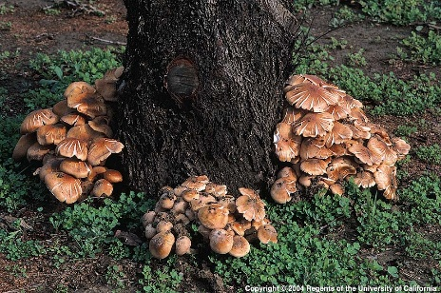

**Urban and Wildland Tree Pests and Diseases Workshop**

*Co-Sponsored by Santa Barbara County Agricultural Commissioner’s Office and University of California Co-Operative Extension*

**Description:**  
This workshop will provide current information on the insects and diseases threatening urban and wildland trees in this region, identification, research and management strategies.

**Who Should Attend:**  
Public land managers, parks and campground personnel, arborists, pest applicators, roads and utilities staff and others concerned about tree health will benefit most from this training.

**Date:** Friday May 6, 2016

**Place:** Santa Barbara County Public Health Auditorium, 300 San Antonio Rd, Santa Barbara, CA 93110

[Map and Directions Link](https://www.google.com/maps/place/300+N+San+Antonio+Rd,+Santa+Barbara,+CA+93110/@34.443423,-119.7834437,17z/data=!3m1!4b1!4m2!3m1!1s0x80e915533c341c61:0xe5f65c5159391ad0?hl=en)

**Time:** 9:00 am – 12:00 pm *(Check in begins at 8:00 am)*

**Registration Deadline: Friday, April 29, 2016**  
There is no charge for this workshop but pre-registration is required. If you are registering for more than one person, please register each person individually. Space is limited. Handout materials, morning snacks and refreshments will be provided.

Please use this link to register on line

<http://ucanr.edu/survey/survey.cfm?surveynumber=17713>

**Continuing Education Units:**  
Continuing education unit (CEU) applications with the California Department of Pesticide Regulation (CA DPR) and the Western Chapter of International Society of Arboriculture (WCISA) are in process.

**Questions?**About the workshop? Contact Heather Scheck, [heather](mailto:heather)@agcommissioner.com  
About registration? Contact Jan Gonzales, [jggonzales@ucanr.edu](http://ucanr.edu/survey/mail%20to:jggonzales@ucanr.edu) or

Kendra Stites, [kstites@co.santa-barbara.ca.us](mailto:kstites@co.santa-barbara.ca.us) or Debbie Trupe [debbie@agcommissioner.com](mailto:debbie@agcommissioner.com)

 